Tutorial

Download [HIVE-Scripts Github Repository](https://github.com/GW-HIVE/scripts)

Unzip Scripts

Open input_file.yml

Replace sample values with your values

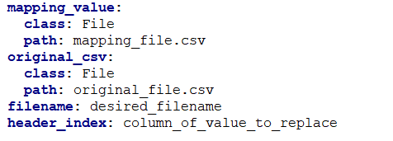

* Replace **mapping_value path** with path to mapping file [NOTE: must be relative to CSV_Combiner_Workflow]
* Replace **original_csv path** with path to the csv to sum [NOTE: must be relative to CSV_Combiner_Workflow]
* Replace **filename** with the desired file name [NOTE: .csv will be appended to the end of the filename automatically]
* Replace **header_index** with the column of the headers

Open your command line

Navigate into the scripts/Workflows/CSV_Combiner_Workflow

Run command

> cwl-runner sum_csv_file.cwl input_file.yml

Output will appear with designated filename in CSV_Combiner_Workflow folder