AI Air-Drum Pad: A Vision-Based Contactless Musical Interface with Hand-Landmark Strike Detection
Final Report
Authors: FILLME
Affiliation: FILLME
Date: 2026-05-26
Repository: air_drum_pad/ in git@github.com:GW-arch/deepx.git

Abstract
This report presents AI Air-Drum Pad, a real-time camera-based musical interface that converts hand and finger motions into playable drum and piano events. The system tracks hand landmarks from a USB camera, estimates downward fingertip velocity and finger-joint angular velocity, and triggers audio only when both motion cues indicate an intentional strike. Two musical modes are implemented on the same perception-and-strike-detection core: (1) a drum pad mode, where any fingertip may strike an on-screen rectangular pad, and (2) a piano mode, where notes are mapped to hand and finger identity. The final piano default layout maps the left hand from thumb to pinky as G4, F4, E4, D4, C4 and the right hand as C5, D5, E5, F5, G5. The implementation supports CPU MediaPipe, CPU TFLite baseline, hybrid CPU+NPU hand-landmark inference, and a low-latency NPU dual-halves mode. Evaluation utilities and unit tests validate strike detection, pad-zone parsing, piano-note mapping, ROI transforms, and benchmark helpers. Prototype measurements show that the low-latency NPU dual-halves backend can approach the 60 FPS frame budget, while the more accurate palm-detection pipeline is limited by CPU palm detection. The project demonstrates a practical path toward low-cost, contactless musical instruments on edge AI hardware, with clear remaining work in end-to-end audio-latency measurement, robust hit-accuracy evaluation, and user studies.
Keywords: contactless musical interface, hand tracking, gesture recognition, air drums, virtual piano, edge AI, NPU, real-time interaction

1. Introduction
Musical performance interfaces traditionally rely on physical contact: a drumstick contacts a drumhead, or a finger depresses a piano key. Contact provides both tactile feedback and a clear sensing event. However, camera-based hand tracking makes it possible to build contactless musical instruments that require no specialized controller beyond a camera and display. Such systems are attractive for prototyping, education, accessibility, public installations, and embedded AI demonstrations.
The main challenge is that visually recognizing a musical strike is harder than recognizing a static hand pose. A simple fingertip-position trigger produces false positives when the whole hand moves, while a simple velocity trigger may fire during non-musical gestures. AI Air-Drum Pad addresses this by combining two motion cues:
1. Fingertip downward velocity: the fingertip moves rapidly in the image direction associated with a striking motion.
2. Finger-joint angular velocity: the finger itself articulates, distinguishing a deliberate finger strike from arm-only translation.
This report summarizes the final implemented system, its two musical modes, generated visual assets, software architecture, testing strategy, and prototype performance measurements.
1.1 Contributions
The implemented project contributes:
• A real-time hand-landmark musical interface supporting both drum pad and piano modes.
• A common strike detector using fingertip velocity plus joint angular velocity.
• A pad-zone drum interface with configurable rectangular hit regions and visual flash feedback.
• A piano interface with a corrected default mapping: left thumb G4, left pinky C4, right hand C5–G5.
• Generated interface diagrams for both modes.
• Report figures generated by Python for system architecture, strike logic, and backend latency.
• A repeatable test and quality-check pipeline covering mapping, detector behavior, pad validation, ROI helpers, and benchmark helpers.

2. System Overview
Figure 1 summarizes the runtime pipeline. Frames are captured from a USB camera, processed by one of several hand-tracking backends, converted into per-hand landmark coordinates, passed to the strike detector, mapped to either piano notes or drum pad sounds, and finally played through pre-rendered PCM audio buffers.
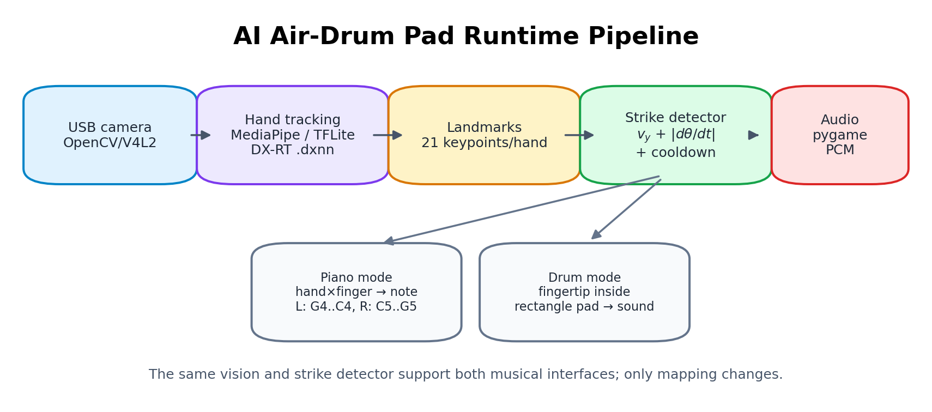
Figure 1. Runtime pipeline generated by tools/gen_report_figures.py.
The same vision pipeline and strike detector support both musical modes. The mapping layer changes according to mode:
• Piano mode: hand_id × fingertip_id → note name.
• Drum mode: fingertip position inside pad rectangle → drum sound.
2.1 Implemented Modes
Drum Pad Mode
Drum mode no longer uses a fixed per-finger drum mapping. Instead, it uses normalized on-screen rectangles. Any tracked fingertip can play a pad if the strike detector fires while the fingertip is inside that pad. The default layout has eight pads: kick, snare, hat, ride, tom_l, tom_m, crash, and clap.
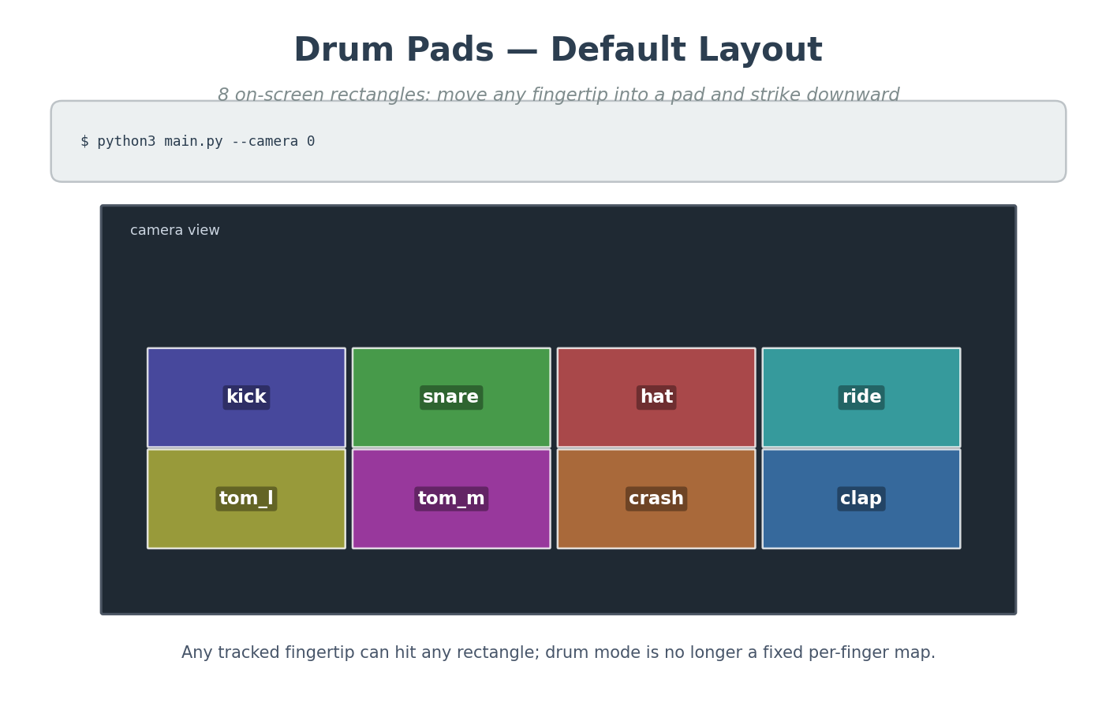
Figure 2. Default drum pad layout generated by tools/gen_instrument_diagrams.py.
A larger diagram lists all built-in drum sound keys available for custom pad layouts.
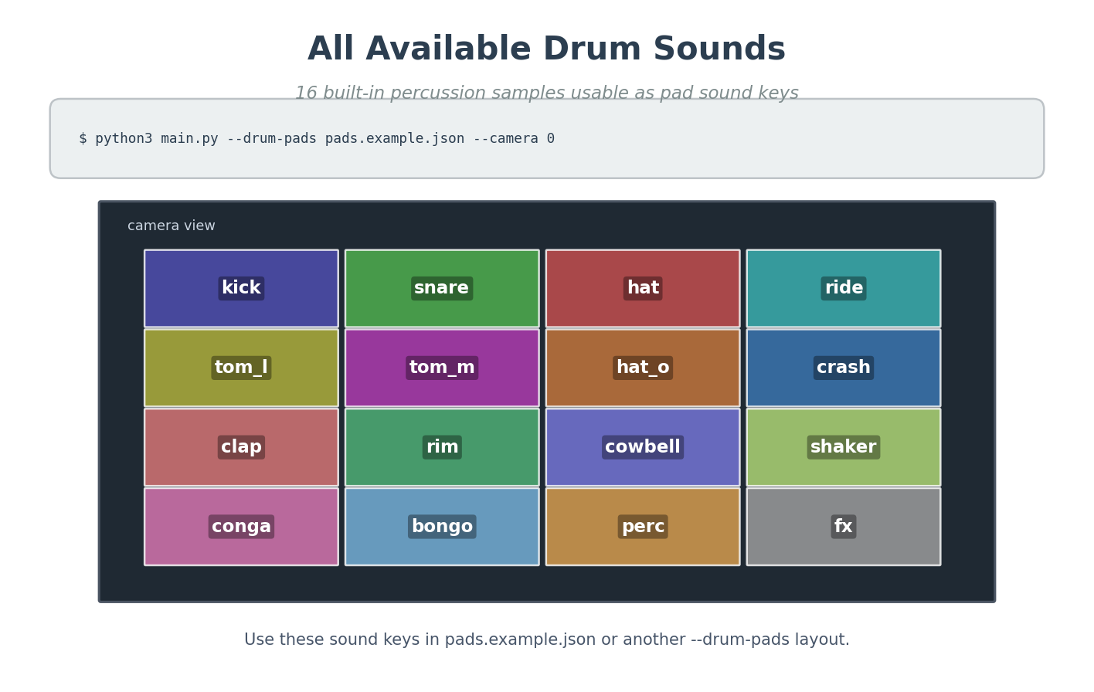
Figure 3. Built-in drum sound-key catalog generated by tools/gen_instrument_diagrams.py.
Piano Mode
Piano mode maps fingers to notes. The final default layout is:
Hand | Thumb | Index | Middle | Ring | Pinky
Left / Hand 0 | G4 | F4 | E4 | D4 | C4
Right / Hand 1 | C5 | D5 | E5 | F5 | G5
This preserves the user's intended left-hand orientation: the left thumb is G4 and the left pinky is C4, while the right hand remains ascending from C5 to G5.
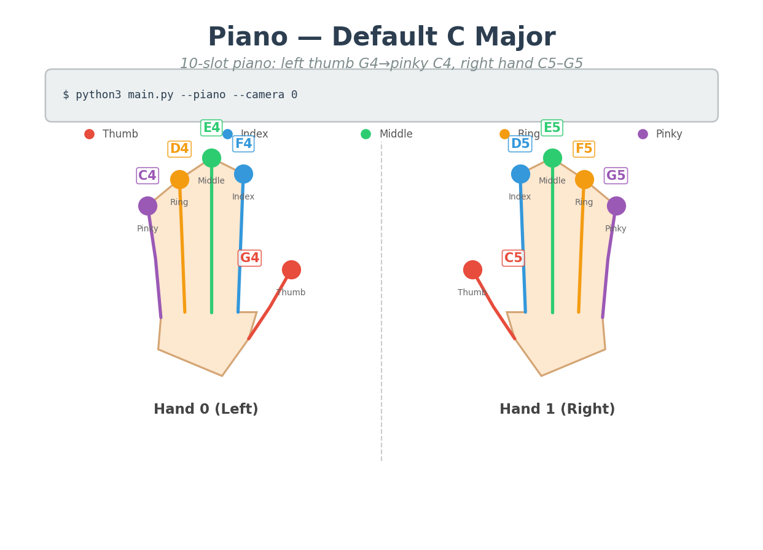
Figure 4. Default piano layout generated by tools/gen_instrument_diagrams.py.
A custom JSON piano layout example is also generated using the same default slot order.
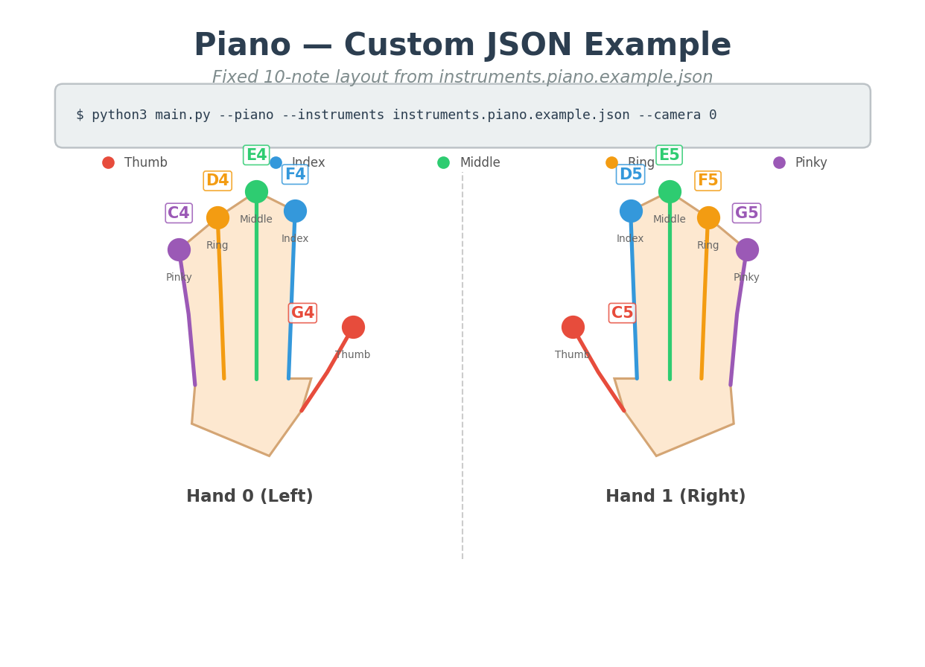
Figure 5. Piano custom-layout example generated by tools/gen_instrument_diagrams.py.
2.2 Manual Screenshots Still Required
Some figures require live hardware capture rather than offline generation. They are left as FILLME placeholders:
[FILLME image placeholder: FILLME: final live full-screen drum mode with camera feed, pad overlay, sidebar, and strike list.]
[FILLME image placeholder: FILLME: final live full-screen piano mode with camera feed, finger trails, sidebar, and strike list.]

3. Background and Related Work
AI Air-Drum Pad sits at the intersection of gesture-based musical interfaces, real-time hand tracking, and embedded edge AI. Prior gesture instruments often use depth cameras, wearable sensors, inertial measurement units, or vision-based pose estimation. Compared with wearable sensors, camera-only systems reduce setup cost and improve accessibility, but they must infer intent from noisy visual motion alone.
This project uses a hand-landmark approach similar to modern single-camera hand-pose systems: a palm or hand detector localizes the hand, a landmark network estimates keypoints, and application logic derives gestures from keypoint dynamics. The project also investigates CPU/NPU deployment trade-offs, because low-latency musical interaction requires both accurate perception and rapid audio response.
The implementation is intentionally modular: hand tracking can be swapped across backends, while strike detection and sound mapping remain independent of the model runtime.

4. Methods
4.1 Hand-Landmark Representation
Each detected hand is represented by 21 normalized landmarks. The application uses five fingertip indices:
Finger | Landmark index
Thumb | 4
Index | 8
Middle | 12
Ring | 16
Pinky | 20
For each fingertip, a three-point chain is selected for angular motion. For example, the index finger uses MCP-PIP-TIP landmarks. The thumb uses a thumb-specific chain involving the IP joint.
4.2 Strike Detection
A strike is emitted only when two independent conditions hold at the same time. Figure 6 shows the decision logic.
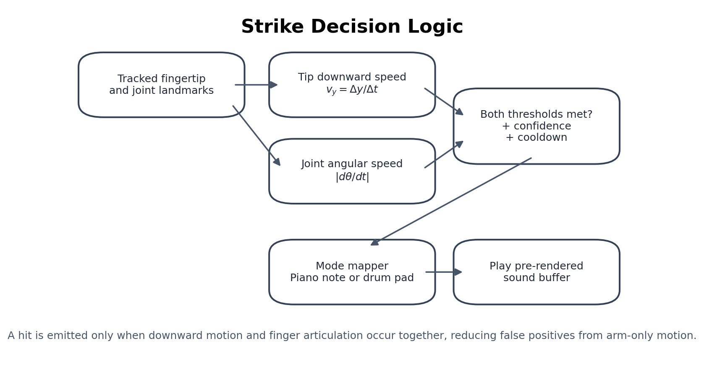
Figure 6. Strike-decision logic generated by tools/gen_report_figures.py.
Let \(y_t\) be the fingertip's normalized vertical image coordinate at time \(t\). The downward fingertip velocity is approximated by
\[ v_y = \frac{y_t - y_{t-1}}{t - t_{t-1}}. \]
Because image coordinates increase downward, positive \(v_y\) indicates downward motion. Let \(\theta_t\) be the angle at the selected finger joint. Joint angular speed is approximated by
\[ \omega = \left|\frac{\theta_t - \theta_{t-1}}{t - t_{t-1}}\right|. \]
A strike candidate satisfies
\[ v_y \ge \tau_v \quad \land \quad \omega \ge \tau_\omega. \]
The detector then applies confidence filtering, minimum displacement filtering, and cooldown logic. The middle finger has a lower internal threshold scale because its visual angular change is often smaller than the other fingers in camera coordinates.
4.3 Drum Pad Mapping
Each drum pad is a normalized rectangle
\[ (x_1, y_1, x_2, y_2), \quad 0 \le x_1 < x_2 \le 1, \quad 0 \le y_1 < y_2 \le 1. \]
If a fingertip strike occurs and the fingertip coordinate lies inside a pad, the detector returns that pad's sound key. Cooldown is tracked by pad label, allowing different pads to be played in rapid sequence.
Custom drum layouts are loaded from JSON:
{
"pads": [
{"label": "kick", "sound": "kick", "x1": 0.05, "y1": 0.35, "x2": 0.29, "y2": 0.59, "color": [80, 80, 180]}
]
}
4.4 Piano Mapping
Piano mapping uses a 10-slot tuple ordered as:
[Hand 0 thumb, index, middle, ring, pinky,
Hand 1 thumb, index, middle, ring, pinky]
The final default tuple is:
("G4", "F4", "E4", "D4", "C4", "C5", "D5", "E5", "F5", "G5")
This mapping is stored in both drumkit_audio.py and the default instruments.piano.example.json used by main.py when no custom piano JSON is provided.
4.5 Audio Generation
The system pre-renders synthetic drum and piano sounds into pygame.mixer.Sound objects to avoid synthesizing audio on every strike. Piano tones are approximately 0.5 seconds long. Short drum samples were lengthened so triggered sounds remain audible despite perception and output latency.

5. Implementation
5.1 Main Runtime Files
File | Role
main.py | Camera loop, backend selection, mode selection, drawing, sidebar UI, sound triggering
hand_tracker.py | CPU MediaPipe, CPU-baseline TFLite, NPU, and NPU-full tracker abstractions
strike_detector.py | Finger strike detector, pad strike detector, pad JSON validation
drumkit_audio.py | Synthetic drum samples, piano note synthesis, default piano slots
tools/gen_instrument_diagrams.py | Generates drum and piano mapping images
tools/gen_report_figures.py | Generates this report's architecture and result figures
tests/ | Unit tests for strike detection, mapping, ROI helpers, and benchmark helpers
5.2 Runtime Backends
The application supports four major backend configurations.
Backend | Palm detection | Hand landmarks | Intended use
cpu | MediaPipe internal | MediaPipe internal | Simple CPU-only baseline
cpu-baseline | CPU TFLite | CPU TFLite | Comparable pipeline without NPU
npu-full | CPU TFLite | NPU .dxnn | Accurate palm pipeline with NPU hand inference
npu | none / dual-halves approximation | NPU .dxnn | Fastest low-latency approximation
The NPU-full path is architecturally preferred for accurate hand localization, but CPU palm detection dominates latency. The dual-halves NPU mode is faster because it removes palm detection, but it is a geometric approximation and should be evaluated under the target camera setup.
5.3 User Interface
The runtime display contains the camera feed, hand/finger landmark trails, mode-specific overlays, and a sidebar. In drum mode, rectangles are drawn directly on the camera feed and flash briefly when hit. In piano mode, the sidebar shows the hand-to-note mapping and recent note events.
The generated diagrams are used both as documentation and as sidebar assets, keeping the report, README, and runtime UI consistent.

6. Experimental Methodology
6.1 Software Validation
The current quality gate is:
RUN_BENCH_SMOKE=0 ./scripts/check_quality.sh
This performs Python syntax checks, unit tests, and palm decode tests. The benchmark smoke test is skipped when model files or hardware-specific dependencies are unavailable.
6.2 Backend Latency Measurement
Prototype backend latency values are summarized from docs/EXPERIMENTS.md. Figure 7 visualizes the approximate end-to-end vision latency for each backend.
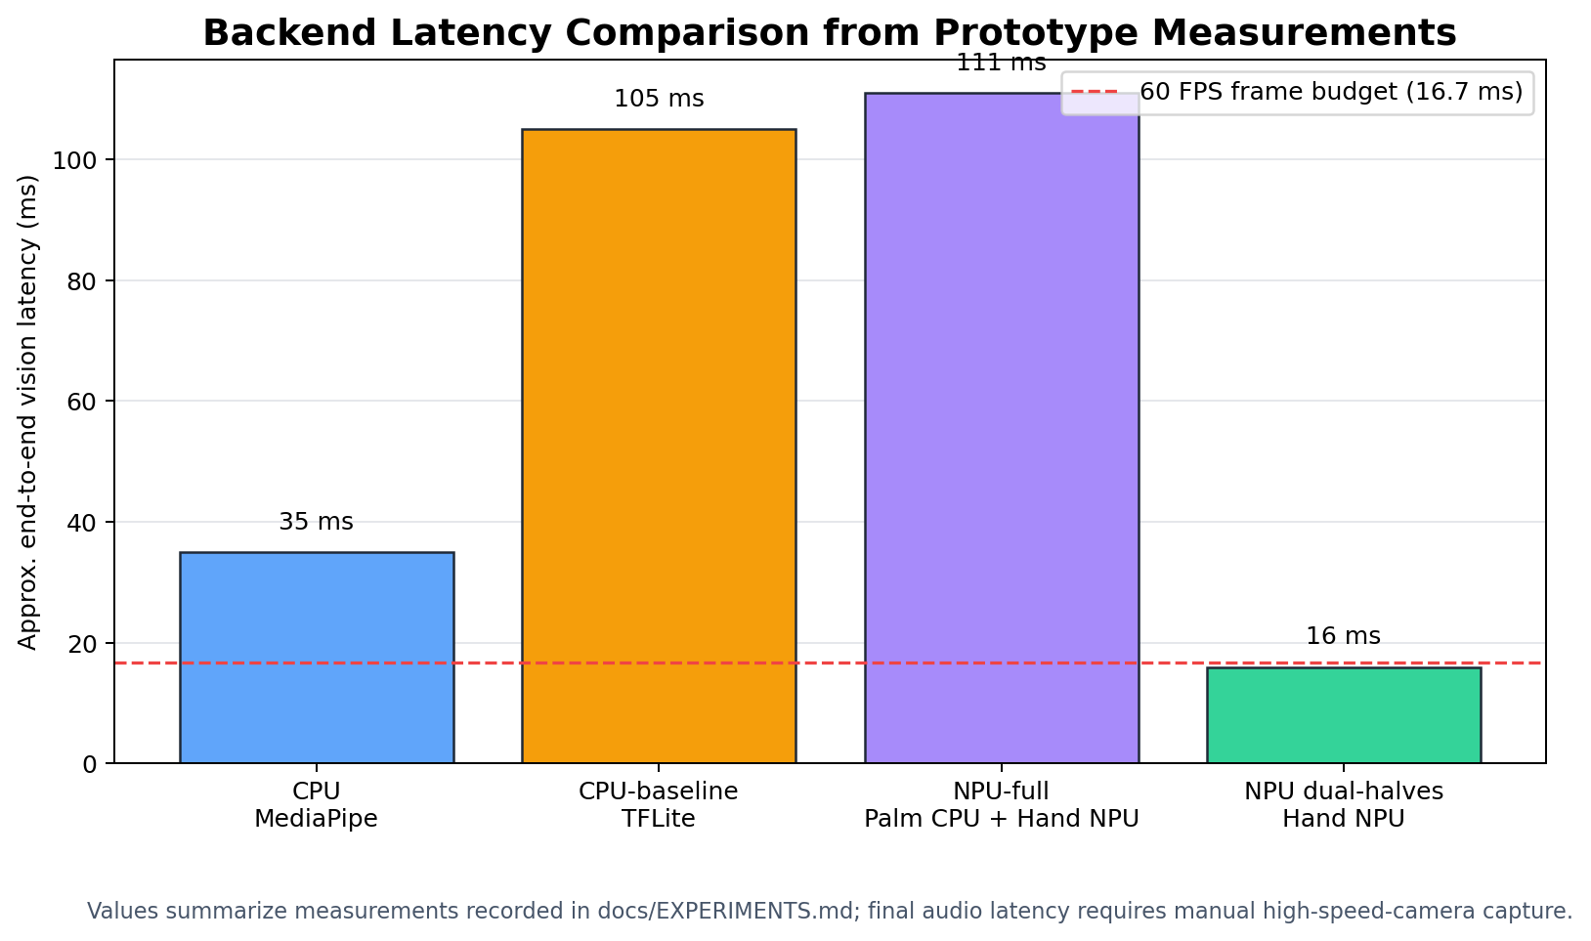
Figure 7. Backend latency comparison generated by tools/gen_report_figures.py.
6.3 Required Manual Measurements
A complete academic evaluation should include at least two manual measurements that are not fully captured in the current repository:
1. End-to-end audio latency: record hand motion and speaker output with a high-speed camera or synchronized audio/video setup.
2. Hit accuracy: count true positives, false positives, and false negatives over metronome-guided trials.
The report reserves placeholders for these data.
[FILLME image placeholder: FILLME: high-speed-camera setup showing hand motion and speaker/audio waveform for E2E latency measurement.]
[FILLME image placeholder: FILLME: plot or table image from manual hit-accuracy experiment across piano and drum modes.]

7. Results
7.1 Functional Results
The implementation satisfies the main functional goals:
• Detects hand landmarks from live camera input.
• Detects intentional strikes using fingertip and joint dynamics.
• Plays piano notes from hand/finger identity.
• Plays drum sounds from on-screen rectangular pad hits.
• Supports custom piano-note JSON and drum-pad JSON layouts.
• Shows generated mapping diagrams in documentation and runtime sidebar.
7.2 Current Test Results
The latest validation run produced:
Test group | Result
Python syntax check | Passed
Unit tests | 28/28 passed
Palm decode tests | 15/15 passed
Dataset benchmark smoke | Skipped intentionally with RUN_BENCH_SMOKE=0
The unit tests cover default piano mapping, synthetic audio duration, pad-zone generation, pad JSON validation, instrument slot validation, strike detector thresholds, middle-finger sensitivity, cooldown behavior, ROI helpers, benchmark helper functions, and dataset capture indexing.
7.3 Backend Performance Summary
Prototype measurements from the repository's experiment log are summarized below.
Backend | Approx. latency | Notes
cpu | ~35 ms | MediaPipe CPU path; simple and robust
cpu-baseline | ~105 ms | Palm+hand TFLite CPU comparison baseline
npu-full | ~111 ms | CPU palm detection plus NPU hand landmark; palm dominates total time
npu dual-halves | ~16 ms | Fastest path; no palm detector; geometric approximation
The results indicate that the fastest NPU-only approximation is suitable for low-latency demonstrations, while the more accurate palm-based pipeline requires further optimization or a reliable accelerated palm detector.
7.4 Offline Dataset Benchmark Summary
The experiment notes include a 90-frame offline benchmark. In that benchmark, npu-full reduced hand landmark time compared with a CPU-baseline pipeline, but overall runtime was still dominated by palm detection. NPU landmark affine correction reduced mean landmark error on the same dataset, but a hold-out set is required before claiming generalization.

8. Discussion
8.1 Why Two Motion Cues Matter
A virtual instrument should not trigger whenever a hand moves. The combined velocity-and-angle criterion improves musical intent detection because it requires the fingertip to move downward and the finger to articulate. This is especially important in piano mode, where individual finger identity matters, and in drum mode, where the same fingertip can cross pad boundaries during normal movement.
8.2 Drum Pad Mode vs. Per-Finger Drum Mapping
The project originally used per-finger drum mapping. The final drum interface uses rectangular pads instead, which is more intuitive because it resembles a physical drum pad controller. It also lets the performer use any finger for any drum sound. The trade-off is that pad layout now depends on camera framing and screen coordinates, so calibration and visual feedback become more important.
8.3 Piano Mapping Convention
The final piano mapping follows the user-specified convention: left-hand thumb is highest among left-hand notes (G4) and left-hand pinky is lowest (C4), while the right hand ascends from C5 to G5. This mapping matches common left-hand physical intuition when the left hand is viewed in a camera-facing diagram.
8.4 Edge AI Trade-Offs
The NPU accelerates hand landmark inference, but a full robust pipeline also needs palm detection. Current notes indicate that INT8 palm detection quality was insufficient, forcing palm detection to remain CPU TFLite in the accurate pipeline. Consequently, the most accurate NPU-full backend can be slower than expected because palm detection dominates. This suggests that future work should focus on either improving palm model quantization, replacing the detector, or reducing palm frequency while controlling drift.

9. Limitations
The current prototype has several limitations:
• No complete final E2E audio-latency measurement is included; a manual high-speed-camera or synchronized audio/video experiment is required.
• No formal user study has been conducted.
• No final hit-accuracy table is available for tempo-controlled trials.
• Depth ambiguity remains because the system uses a single RGB camera.
• Lighting and background sensitivity may affect landmark stability.
• NPU-full accuracy and latency remain limited by CPU palm detection.
• Tactile feedback is absent, so timing may feel different from physical instruments.

10. Future Work
Recommended next steps are:
1. Capture final live screenshots for the FILLME figures.
2. Measure E2E audio latency using a high-speed camera and synchronized audio waveform.
3. Run hit-accuracy trials for both modes at multiple tempos.
4. Add per-user calibration for pad positions, handedness, and strike thresholds.
5. Investigate palm detector alternatives suitable for NPU deployment.
6. Add optional MIDI output so the system can drive external instruments.
7. Add visual/audio metronome support for controlled evaluation.
8. Conduct a small user study comparing playability of drum and piano modes.

11. Conclusion
AI Air-Drum Pad demonstrates a complete camera-based musical interface that converts hand motion into playable drum and piano events. The final implementation includes a pad-based drum interface, a corrected piano note mapping, low-latency audio playback, generated documentation diagrams, and a repeatable validation suite. The project shows that edge AI hand tracking can support expressive contactless musical interaction, but also highlights the importance of robust strike detection, accurate hand localization, and careful latency measurement. With further evaluation and NPU optimization, the system can serve as a strong foundation for embedded AI musical interfaces and real-time gesture-control demonstrations.

Acknowledgments
FILLME: course, advisor, lab, hardware provider, or collaborator acknowledgments.

References
[1] Project implementation and documentation, air_drum_pad/ repository files: README.md, docs/ARCHITECTURE.md, and docs/EXPERIMENTS.md. [2] MediaPipe Hands / hand landmark model family, used through CPU MediaPipe and TFLite-derived pipeline paths. [3] OpenCV, used for camera capture, drawing, and display. [4] pygame, used for low-latency playback of pre-rendered PCM sound buffers. [5] DeepX DX-RT / DX-COM toolchain, used for .dxnn NPU hand-landmark inference experiments.

Appendix A. Reproduction Commands
Generate interface diagrams:
cd air_drum_pad
python3 tools/gen_instrument_diagrams.py
Generate report figures:
cd air_drum_pad
python3 tools/gen_report_figures.py
Run quality checks:
cd air_drum_pad
RUN_BENCH_SMOKE=0 ./scripts/check_quality.sh
Run default modes:
cd air_drum_pad
python3 main.py --camera 0
python3 main.py --piano --camera 0
Run custom drum pads:
cd air_drum_pad
python3 main.py --camera 0 --drum-pads pads.example.json

Appendix B. Important Source Paths
Path | Description
main.py | Main runtime application
strike_detector.py | Strike and pad detectors
drumkit_audio.py | Audio and piano note definitions
pads.example.json | Custom drum pad layout example
instruments.piano.example.json | Default/custom piano note example
tools/gen_instrument_diagrams.py | Generates mode diagrams
tools/gen_report_figures.py | Generates report figures
docs/figures/ | Report-only generated figures
instruments/ | Runtime/documentation mapping images

