The goal of these notes is to give you a very basic view of how a groundwater model is formulated as a matrix algebra problem. Some details are skipped in the interest of brevity. But, the basic approach outlined here is exactly what is done in any finite difference model.

|  |  |  |  |  |
| --- | --- | --- | --- | --- |
| 1 | 2 | 3 | 4 | 5 |
| 6 | 7 | 8 | 9 | 10 |
| 11 | 12 | 13 | 14 | 15 |
| 16 | 17 | 18 | 19 | 20 |
| 21 | 22 | 23 | 24 | 25 |

Consider a 5 by 5 grid with the cells numbered as shown. The mass balance for cell 12 is:

Q11-12 + Q7-12 + Q13-12 + Q17-12 + S12 = DV12/Dt

where Q11-12 is the flow from cell 11 to cell 12, S12 is the sink/source term [L3/T] in cell 12 with a positive value representing a source, V12 is the volume of water stored in cell 12, and t is the time step. Note that the right hand side increases if the net flow into cell 12 is positive.

If we assume that the layer thickness (into the page) is L and the cell widths are w in both directions (rows and columns), this can be rewritten in terms of fluxes as:

Lwq11-12 + Lwq7-12 + Lwq13-12 + Lwq17-12 + S12 = DV12/ Dt

q11-12 + q7-12 + q13-12 + q17-12 + S12/Lw = DV12/LwDt

Substituting Darcy’s Law for the flux gives:

-K11-12 (H12 – H11)/w - K7-12 (H12 – H7) /w - K13-12 (H12 – H13) /w - K17-12 (H12 – H17) /w + S12/Lw = -DV12/LwDt

K11-12 (H12 – H11) + K7-12 (H12 – H7) + K13-12 (H12 – H13) + K17-12 (H12 – H17) + S12/L = -DV12/LDt

Note above that the right hand side has become negative to account for the definition of the gradient in Darcy’s Law. Also, the w term has disappeared from the source and storage change terms because it is also part of the gradient and can be eliminated as a common term. Gathering terms gives:

H12 (K11-12 + K7-12 + K13-12 + K17-12 ) - H11K11-12 - H7K7-12 - H13K13-12 - H17K17-12 = - S12/L - DV12/LDt

Where K11-12 is the harmonic mean K between cells 11 and 12.

For now, let’s assume that the medium is homogeneous and isotropic, with all of the conductivity values equal to K. Then, this becomes:

(4H12 - H11 - H7 - H13 - H17)K = - S12 /L - DV12/LDt

(4H12 - H11 - H7 - H13 - H17) = - S12 / KL - DV12/ KLDt

A similar equation can be written for each cell. Gathering them together, you can express this as a matrix of multipliers that can be multiplied by the vector of H values to represent the model as a set of algebraic expressions in matrix form. The red box highlights the equation for cell 12 (the 12th row). There is a multiplier of -1 on H7, H11, H13, and H17 and a multiplier of 4 on H12. If you read this vertically, you would see that the equations in rows 7, 11, 12, 13, and 17 have nonzero multipliers on H12. From the figure above, these are the numbers of the cells for which the inflow across at least one face depends on H12. You will notice that the rows that include no flow boundary cells are different than those for internal cells – the head in that cell is multiplied by the number of nonboundary cell neighbors and there is a -1 entered only for the neighbor cells. This is explained in more detail below. The entire set of linear equations can be written in the following matrix form:



All of the empty cells in the yellow weight matrix are filled with zeros. This matrices on the right-hand side are divided by KL (not shown for clarity). Also, the change in storage is assumed to be over the model time step, Dt.

The final step is to relate the change in volume in a cell with time to the change in head in that cell from the previous solution time to the current time. We do this so that everything is expressed in terms of the variable for which we are solving, H. For example:

DV12 = SsLw2(H12 – H12’)

where H12 is the hydraulic head in cell 12 at the current time and H12’ is the hydraulic head at the previous solution time. At this point, the known values are K, L, w, [S], [H’]. Note that [H’] has to be defined for the initial condition to calculate [H] at the first time step. The unknowns are now all collected in the matrix [H] and the solution marches forward in time (thusly known, cryptically, as a forward time-difference solution).

To understand how boundary conditions are included, first consider how we would introduce defined head nodes. If, for example, the entire left boundary had H = 1, then the variables H1, H6, H11, H16, and H21 would be replaced by the value 1 in [H] and those variables would not have to be inferred. This could be done for a cell inside the domain, too, if you wanted to represent a lake within the domain (for example).

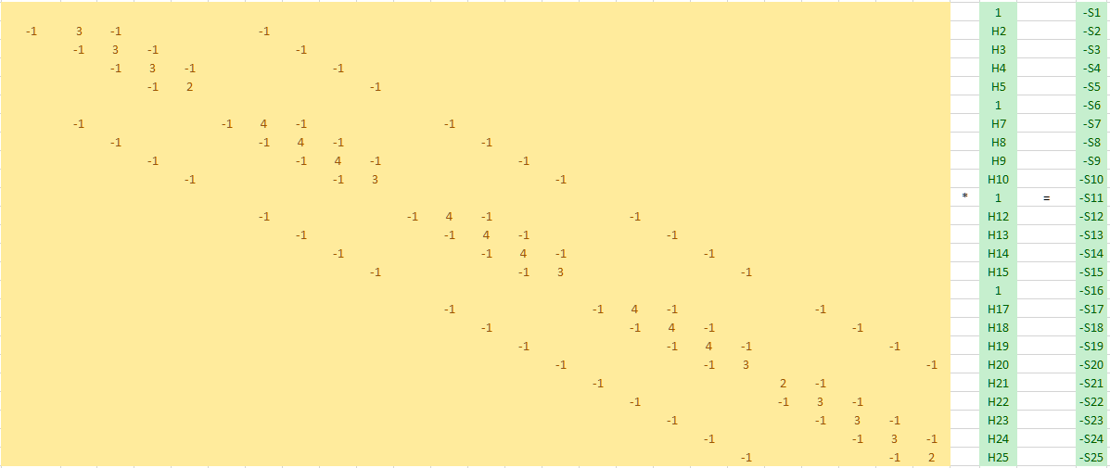

What about a constant flux boundary? Consider cell 11. If this is a no flow boundary, then the equation would begin as:

Q6-11 + Q12-11 + Q16-11 + S11 = DV11/Dt

Gathering the term as above gives:

(3H11 – H6 - H12 - H16) = - S12 / KL - DV12/ KLDt

This is exactly what is shown in row 11 of the weight matrix. That is, if you don’t define anything for a boundary cell, it defaults to a no flow boundary condition.

If the influx to cell 11 from outside of the domain was 1, then we would just add this to the mass balance equation:

1 + Q6-11 + Q12-11 + Q16-11 + S11 = DV11/Dt

Assuming homogeneous and isotropic conditions, when we introduce Darcy’s Law and gather terms, we end up with:

(3H11 – H6 - H12 - H16) = - S12 / KL - DV12/ KLDt – 1/KL

In other words, we can accommodate the applied boundary flux by subtracting a vector [BF] from the right-hand side (as for the source and storage vectors, these values are divided by KL), giving:



You can define either a nonzero boundary flux or a constant head for any cell.

That’s it, in a nutshell. The cells in the model are converted to matrices. The forward problem involves solving for [H] given the values of K, L, w, [S] and the initial and boundary conditions. The inverse problem involves solving for K (and/or other relevant parameters not included in this explanation) and/or [S] and the boundary conditions given other parameter values and some values of [H]. All of these problems can be solved using packages that have been developed by math geniuses for application to any matrix algebra problem. Of course, the matrices can get quite complex for heterogeneous and anisotropic media and irregular grid spacing. There may be other parameters to consider, especially spatially variable storage capacity or even head dependent K and storage capacity (unsaturated flow). In addition, the solution of the flow problem can be coupled with (one way or two way) the heat and/or solute transport problem or with geomechanical models to account for compaction. But, the underlying concepts are the same.

Next, we will have a look at how solvers work.