Dalia Portillo

HWRS582 GW Mod

1/18/21

Challenge #1

1. Steady state means constant head boundaries and constant flux – in other words the q values should be the same in each cell.

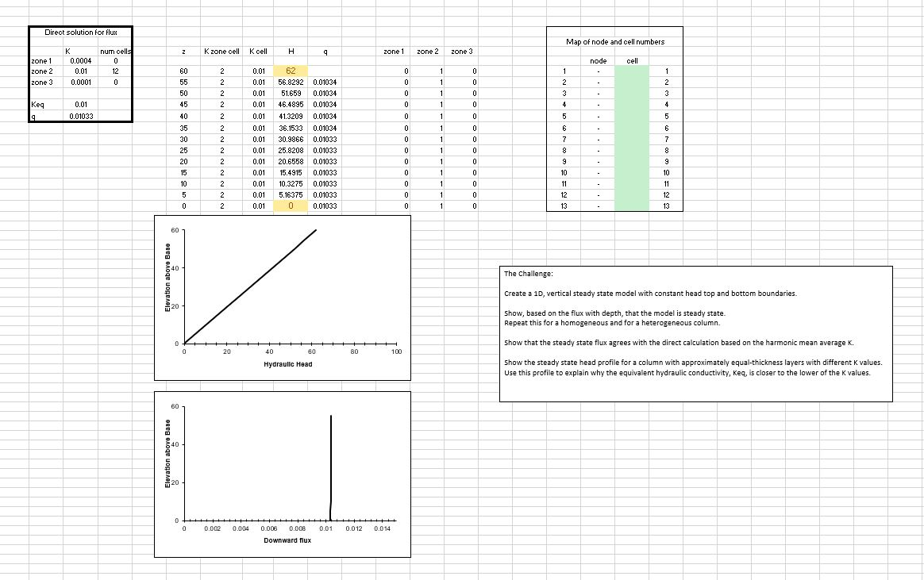

Figure Steady State Homogeneous Model

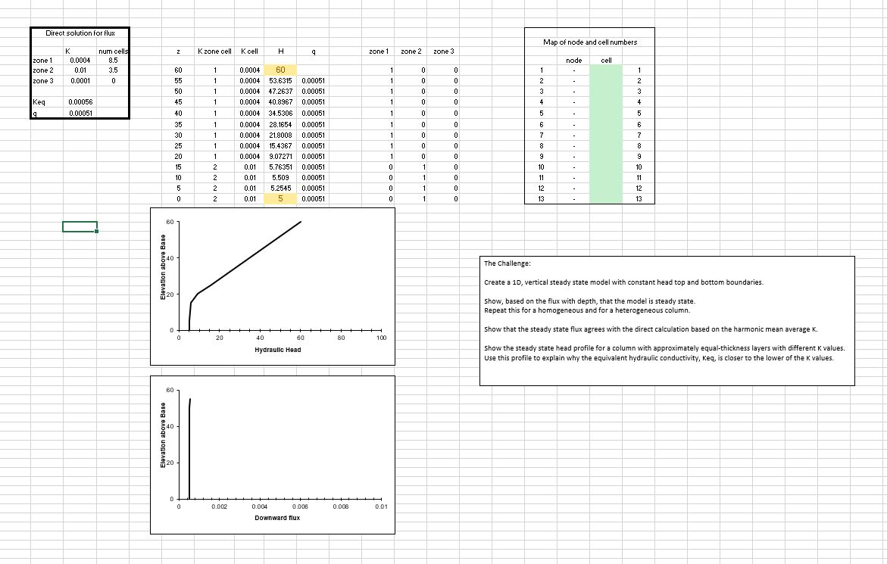

Figure Steady State Heterogenous Model

1. Harmonic mean average Kavg = L/((la/Ka)+(lb/Kb)+(lc/Kc)) in which low permeability dominates: $$K=\frac{L_{tot}}{\frac{l_{a}}{K_{a}}+\frac{l_{b}}{K_{b}}+\frac{l_{c}}{K_{c}}}=\frac{60}{\frac{60-20}{0.0004}+\frac{20}{0.01}+0}=0.00058 ≈0.00056$$

$$q=K*\frac{dH}{dz}=0.00058*\frac{60-5}{60}=0.000539≈ 0.00051 units/time$$

Using Figure 2 above, we see that the flux q can be calculated using the Harmonic Mean Average. The values are very close but not exactly the same.

1. Show the steady state head profile for an aquifer with equal thickness layers that have different K values. Use the head profile to explain WHY the equivalent hydraulic conductivity, Keq, is closer to the lower of the two K values.  
   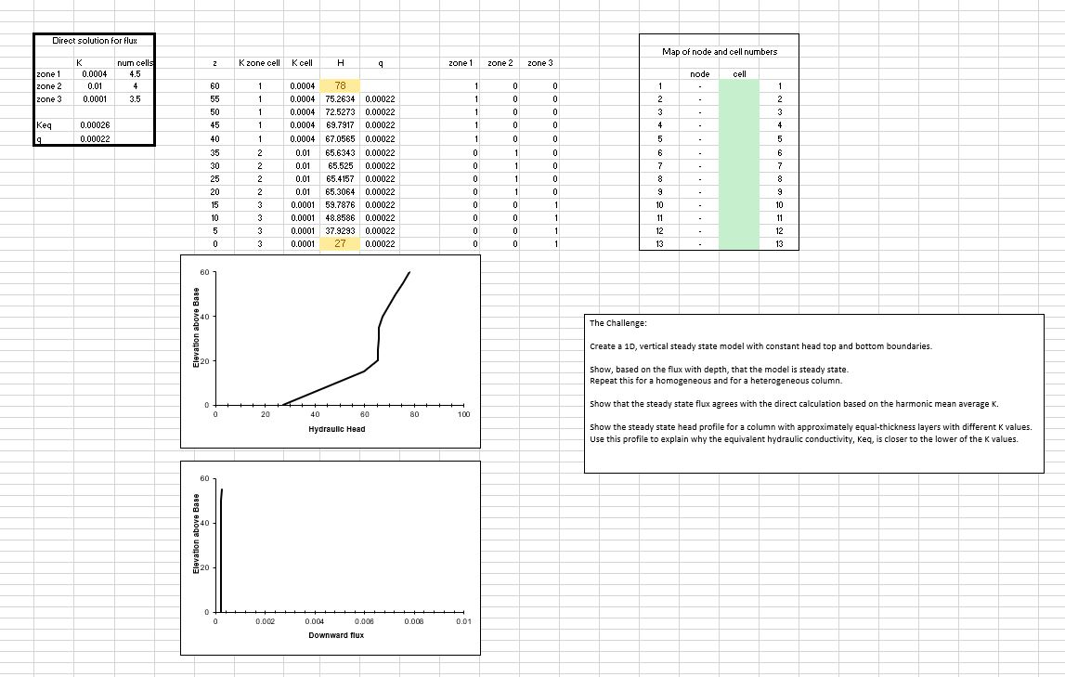

Figure Steady State with equal thickness layers

 

The equivalent hydraulic conductivity takes the harmonic average for a soil column in which flow is perpendicular to the layers. Because Keq is the average value over the entire soil column, Keq is smaller to represent the flow in the slowest zone/layer.

Discussion Points

In addition to The Challenge, start thinking about the following ideas

What are boundary conditions? Answer this both conceptually and mathematically.

What are model parameters? How do they (and don't they) represent the actual subsurface?

What are steady state conditions and how can they be identified from the Excel model results?

Can you imagine how the model inputs could be stored in separate files rather than other spreadsheet cells? Describe the flow of information from a file that describes the other files that contain model-specific information about the system.

What is an iterative solution? Can you explain it to a hydrologist who is not a modeler? Can you describe (or imagine) how Excel finds the solution?

What is a direct solution? What are its (dis)advantages compared to an iterative (numerical) solution?