Danielle Rehwoldt

Hw 2 Challenge Questions

*“Show, based on the flux with horizontal distance from a constant head boundary, that the model is steady state. Repeat this for a homogeneous and for a heterogeneous column for which zones of different K are placed in series with the direction of flow. Note that the best way to do this is to take the values from the .list file into Excel, combine them with the K values from the .bcf file, and calculate the flux at each point. Keep in mind that heads are calculated at the center of a cell (a node) and the K values are defined over each cell.*

*Show the steady state head contour in plan view for the heterogeneous (zones in series) condition. Use this plot to defend a contention that flow is 1D. Then, drawing on your Excel assignment, use the results to explain WHY the equivalent hydraulic conductivity, Keq, is closer to the lower of the two K values.*

*Build a model based on a homogeneous domain with a square region of lower K in the middle of the domain. What can you learn based on your explanation of what controls the effective K for a 1D flow system now that you are applying it to a 2D system? What do you think the Keq of this entire system would be compared to the high and low K values? Explain why it is much more difficult to develop a direct solution for this 2D system than it was for a 1D system (including the zones placed in series).”*

**Answers:**

**It cannot be shown that this model is steady state through time (not changing with time), we can see that the flow going in and out of the system is the same as the flux is constant. Transient flow would look more oscillatory and less blocky. With homogeneous flux properties (same conductivity through the whole medium) you can see a constant pattern along the flux contour. With heterogeneous, you can see a changing pattern** **as we set one half of the columns of the bcf file at one k value and the other half at another k value, but we still see a constant flux along the contour. This is expected with both homogeneous and heterogeneous systems.**

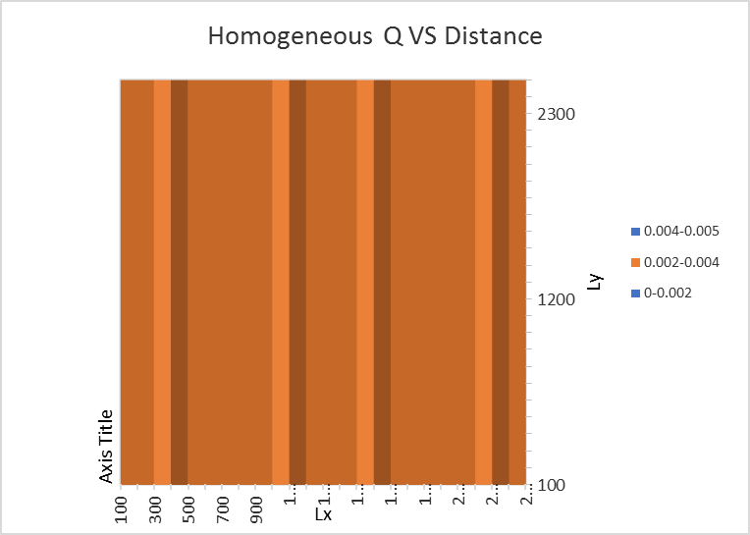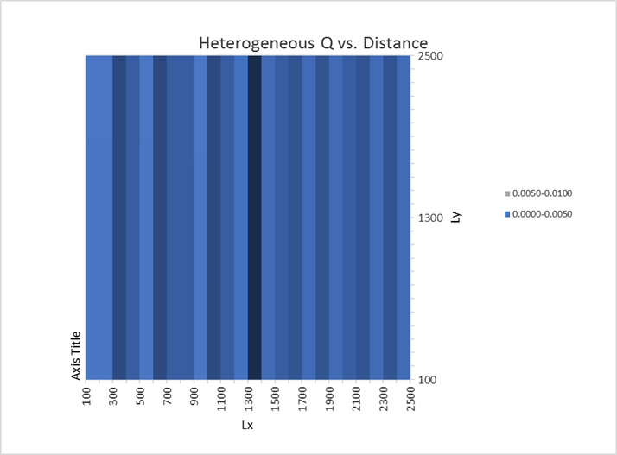

**Shown below are the steady state head contours in plan view for homogeneous and heterogeneous systems. Because we are looking at a steady state system, we would expect the same volume going into and out of the system. As we change K values in the heterogeneous system, we see that the Keq is leaning towards the lower K values as more energy is used to push the water through the smaller conductivity areas with the same volume being provided. The system is most sensitive to where the energy is used up the most. The flow of the heterogenous system is 1D as the head values change independently of flow in all directions but the horizontal direction as the K values change.**

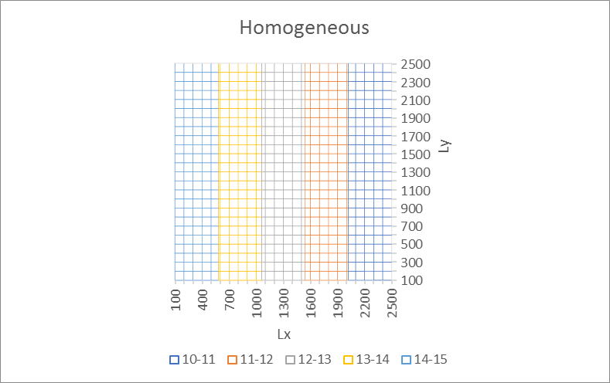

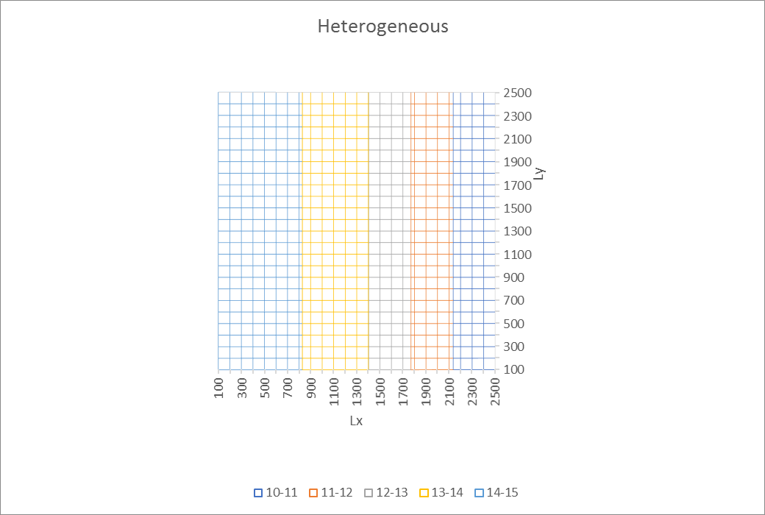

**When we use a 2-D model, looking at effective K gets a little more complicated. This is because the system is not independent in every direction, it becomes a matrix. Given this matrix, the magnitude and increased directions of flow would occur which would mean that the flow volumes would depend on the heterogeneous state more. Because “water is lazy,” and goes through the path of least resistance, the K values should increase overall as there are more directions for the water to go in a 2-D system compared to a 1-D system.**

