Danielle Rehwoldt

GWM21

HW 4 – correct figures, (NOT SURE IF I NEED TO REMOVE CENTER VALUES TOO)

With center values, [0,12,12] flux of -10 and centered (at 12):

With center values, [0,12,12] flux of -10 and not centered (at 11):

With center values, [0,10,15] flux of -8 and centered (at 12):

With center values, [0,10,15] flux of -8 and not centered (at 11):

With center values, [0,5,5] with flux of -10 and centered (at 12):

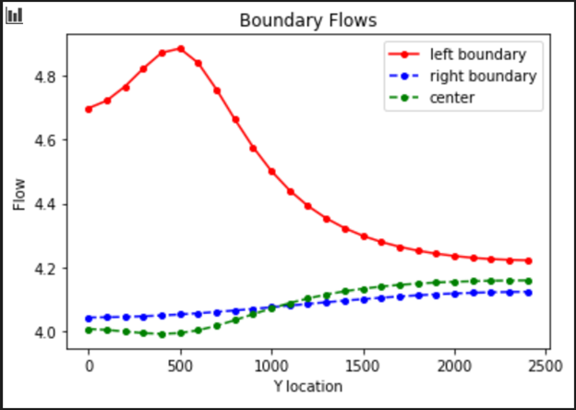

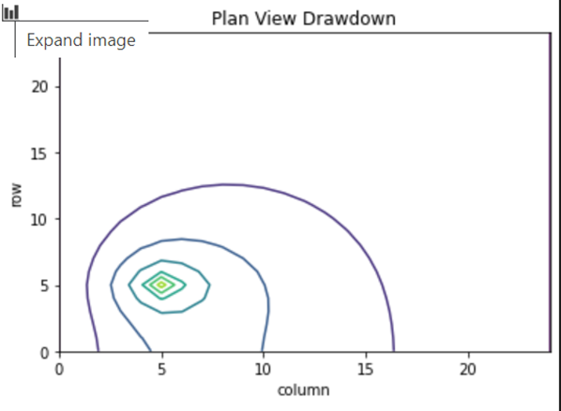

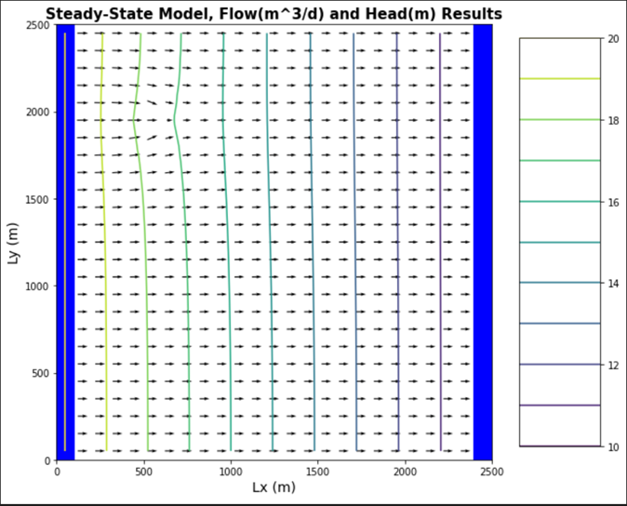

With center values, [0,5,5] with flux of -10 and not centered (at 11):

