Danielle Rehwoldt

HWRS 482

Figures and Questions

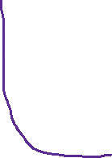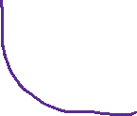

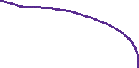

**a) The gradient is not uniform for the initial steady state conditions - discuss the influences of recharge and the unconfined condition on this nonlinearity.**

*Unconfined systems because nonlinearity as transmissivity is not seen as constant here. The radial gradient in pressure is a function of the transmissivity of the aquifer. With recharge involved, we see the steady state line (in red in the second graph) increasing slightly in the middle where the recharge is being placed in the system. This makes the steady state condition look nonlinear. With unconfined systems, MODFLOW models the unsaturated conditions through lowering the transmissivity. Therefore, with this change in transmissivity, we should see a change in head gradient as we have to account for the conservation of flow throughout the system. If it was fully confined, with recharge added, it would be nonlinear as well as each cell has a different input.*

**b) Determine if the system has reached steady state - consider a point at the well and another at the center of the domain.**

*Yes – eyeing the graph, through time, after time of about 65 years, the head starts to look constant when looking at those panels. This “constant” is when we are approaching 0 slope. Around 65 years for the well and 65 years for the midpoint I would start to call the system’s slope closer to 0, close to a steady-state characteristic.*

**c) Find the zone of influence of the well defined in two ways:**

**- Based on the drawdown from the initial steady state to the end of simulation time (end of final no-pumping stress period).**

**- Based on the drawdown from the end of the last pump-on stress period to the end of simulation time.**

*- = w*L = 380*500 m = 190,000 m^2*

*- = pi*r^2 = pi*(30^2) m^2 = 2827.4 m^2*

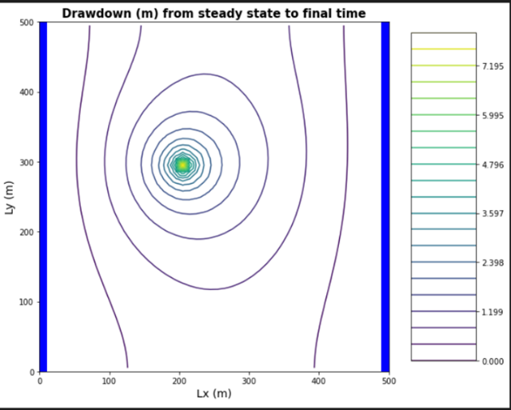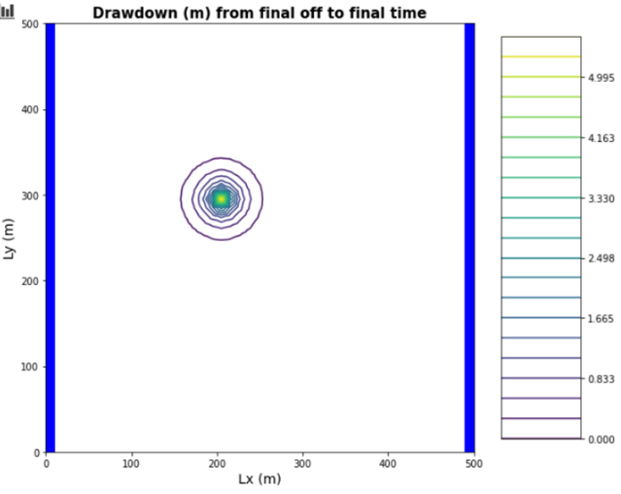

*Many groundwater systems are cyclical. As we go farther away from well, the extraction of storage does not extend as far. From steady state to final time, we see a wider zone of influence compared to the drawdown from final off to final time. We see a steady-state system outside of the well from final off to final time and a transient system in the center. From the steady state to final time, we see the “long-term” cyclical transient effects of the system.*

**d) How long does it take a point at the center of the domain to reach steady state. At that point, explain how you could divide the domain into a steady and transient part and solve each separately.**

*About 50 years. Divide domain in half and solve 0-50 years into a transient solution and then 50-100 years into a steady-state solution for modeling.*

**e) Find a constant pumping rate (same throughout the year) that matches the head time series at the middle of the domain.**

(500 m/d)/2 = 250 m/d

**f) Find a constant pumping rate (same throughout the year) that matches the head time series at the well, leaving only a regular, repeating seasonal residual. Are the two pumping rates the same?**

*Looking at the panel graphs, with 270 days no pumping, we approach a head value of about 38 m. Using our initial 250 m/d value, we can see that this pumping rate matches the head time series at the well and at the midpoint.*

**g) Discuss the sources of water captured by this well. If you're up for a challenge, calculate them for the final pump-on period!**

*Well, we first have recharge (assuming uniform recharge throughout domain), then residual water from water table with flow coming in from the left.*

*We see water captured from the left-hand boundary as well as the recharge being supplied in the center of the system. When you first turn on well, the water comes from storage. The capture zone will extend over time to reach the steady state capture zone (highlighted in yellow). The transient area of the capture zone (in green). There is no capture within the recovery times as the oscillatory nature of drawdown occurs over time. In the steady-state area, the particles “do not know that the transient state exists.” The particle would approach transient and as soon as it approaches it, the particle jumps in and stops, and so on.*

**h) Discuss how you would define the capture zone of the well. How is it different than our definitions of capture zone so far in the course?**

*The capture zone of the well seems to be wider/spread out. We know that the capture zone defines the set of points in the domain that contribute water to the well. Any particle of water within the capture zone will move throughout the rest of the capture zone until it reaches the stagnation point where water stays still at a 0 gradient. However, it seems that the boundaries here are more “relaxed.” The head values seem to not be following its path as much towards the well.*

*We know that the capture zone defines the set of points in the domain that contribute water to the well. Any particle of water within the capture zone will move throughout the rest of the capture zone until it reaches the stagnation point where water stays still at a 0 gradient. The capture zone used to be defined as steady-state throughout the system, but as explained before, we see transient properties intervening. Because of this, the capture zone will look different within different parts of the domain.*