Flow nets, flowlines, and equipotential contours, oh my!

When drawing the flowpaths of local or regional groundwater flow, we want to make sure our assumptions about our interpretation are true. One way is to visualize a flow net which shows 2D representation of 3D flow within the subsurface. To create a flow net, it is generally required to know general regional flow, the boundary conditions, and the spatial distribution of hydraulic conductivity throughout the region of focus. The simplest way to create a flow net is by looking at a homogenous, isotropic system.

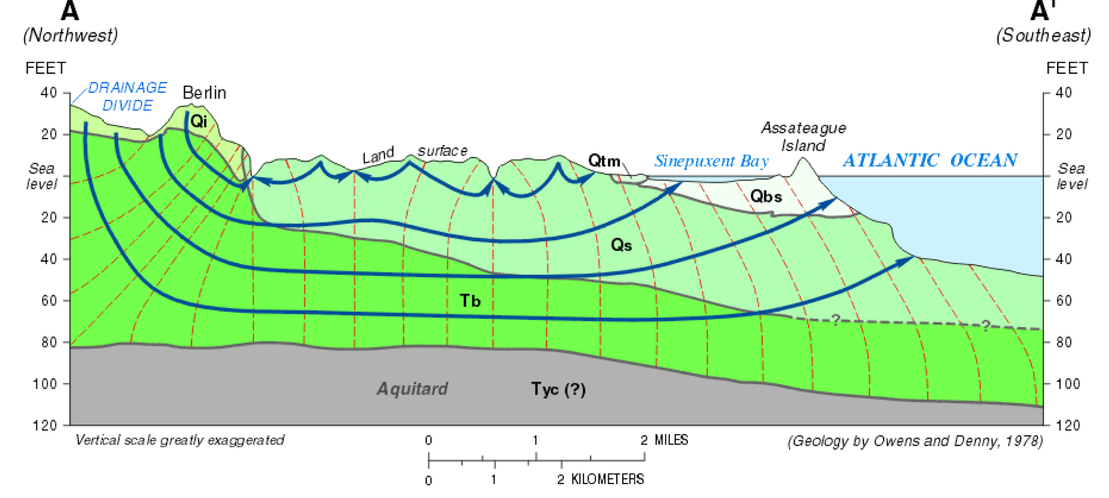

Figure 1 Model flow net for a vertical section of the surficial aquifer in coastal Maryland. The equipotential surfaces are indicated by the dashed contour lines, while the flowlines are shown by the orthogonal blue arrows. Note that rainfall is recharged on the small hills on the left, where it infiltrates downward, and then moves toward regions of lower head near the ocean. The freshwater can emerge, sometimes as springs, beneath the ocean surface. Image from <https://www.observationalhydrology.com/groundwater-.html>

We know under steady state flow and fully saturated conditions, there can be three types of boundary conditions: Type I (constant head head), Type II (no-flow/impermeable), Type III (head-dependetn flux). Additionally, we know that flow is parallel to impermeable boundaries and perpendicular to equipotential lines. Flowlines cannot intersect other flow lines otherwise packets of flow somehow have two velocities at a single point. Equipotential lines cannot intersect either because then flow would have more than one energy at a time, which makes no sense.

Using Darcy’s equation: Q = -KA dh/dx for a completely homogenous model, we can assume that the hydraulic conductivity is constant throughout and looking at figure 1 above, we also know that a lake is a constant head boundary. With this we can assume that the gradient dH/dx is constant and parallel to the lake while perpendicular to the aquitard at the bottom. The means we get a specific Q for a specific A – or through a ‘flowtube’ which is the spacing between each flowline. In figure 1 we can see these flow lines almost equally spaced. This suggests Q must be the same. To show that these are equal volumes of flow, lets say dH/dx = ______, K = _______, and A = ______. Then Q should be equal in each curvilinear square.

Now compare figure 1 to the figure 2 below. Symmetry is highly desirable when constructing flow nets. If we can apply flow on one side, then we can apply it on the other side the imaginary symmetrical line. Figure 2 below is a perfect example illustrating symmetrical flow lines.

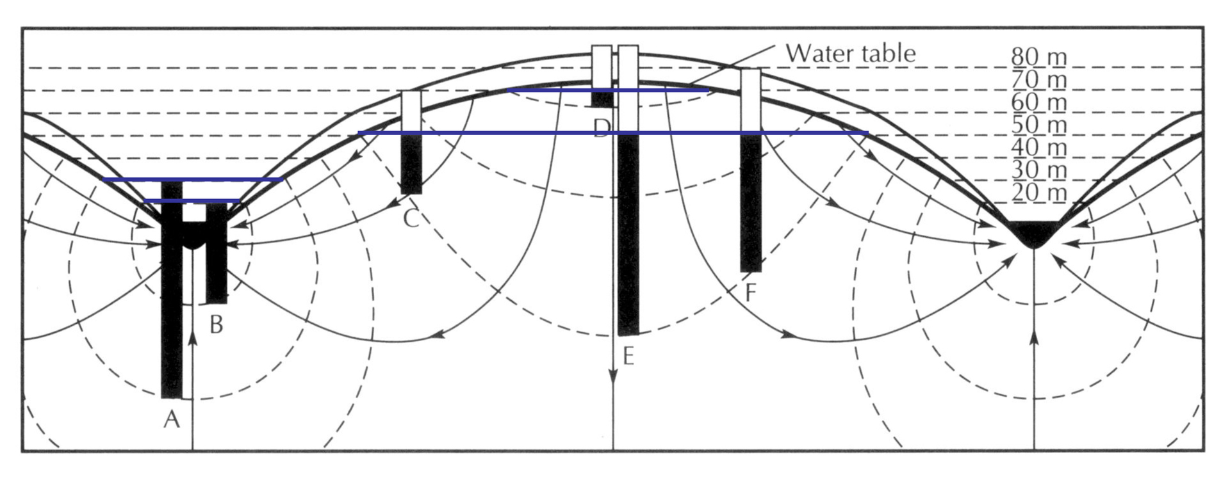

Figure Flow net beneath a hill bordered by two streams, and how flowlines (arrows) and equipotential contours (dashed lines). Vertical piezometers, open only at the top and bottom, have water levels indicated by black bars; note that the water rises to the el elevation where the head contour at the piezometer base intersects the water table. Fetter, after Hubbert (1940).

When looking to apply a flow net to a more complex systems such as heterogeneous anisotropic mediums, we need to consider the varying hydraulic conductivities between any two formations. Within a system, flow prefers the higher K area than the lower K resulting in faster flux through the higher K. Flow through varying K’s behaves similarly to light refracting as it travels from one medium to another. Under the same steady-state conditions, we know Q_in must equal to Q_out, so using Darcy’s Law we can find:

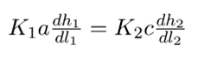 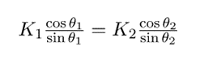 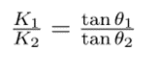

More complex heterogenous systems uses the “tangent law” as seen in the equations above. Knowing K1, K2, and θ1, one can solve for θ2 – the angle change of the flow path between geologic boundaries. For the case that we don’t know K1 or K2, but we know their ratio, then the system is in a reduced parameter space which simplifies how we can construct the behavior of the flow net. Below are additional examples of complex flownets.

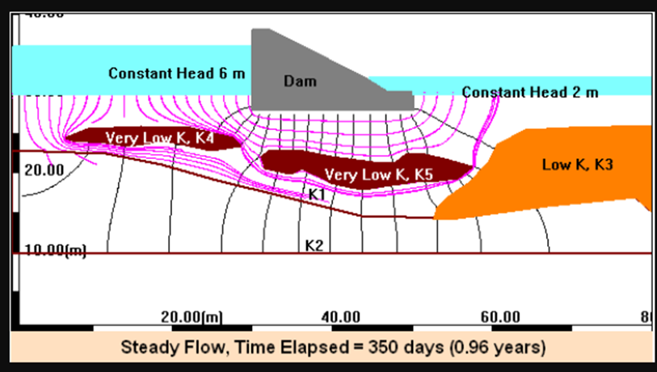

Figure Flownet

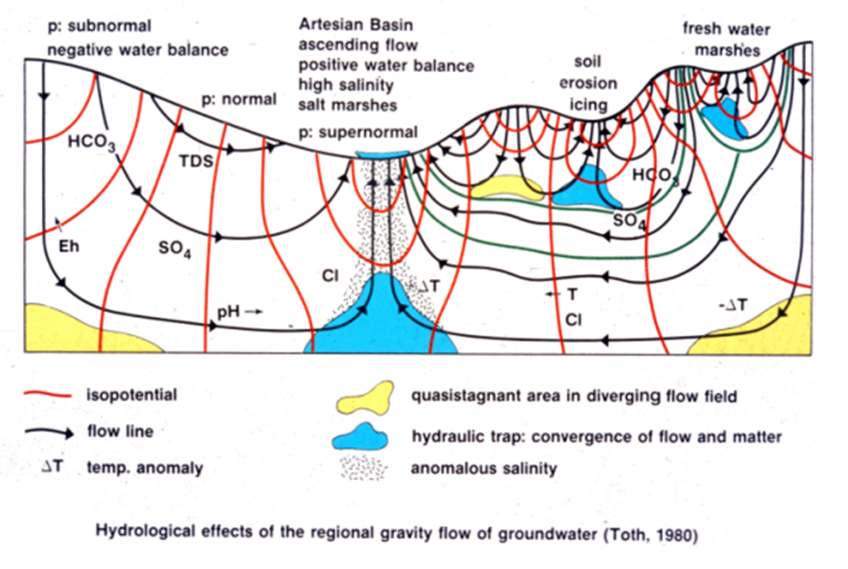

Figure <https://regionalgwflow.iah.org/regional-groundwater-flow>