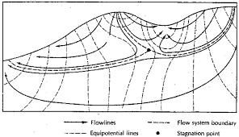

<https://encrypted-tbn0.gstatic.com/images?q=tbn:ANd9GcRBTfyhpRtsvVmzyNfsqjb5prVXxm6fCOz1dw&usqp=CAU>

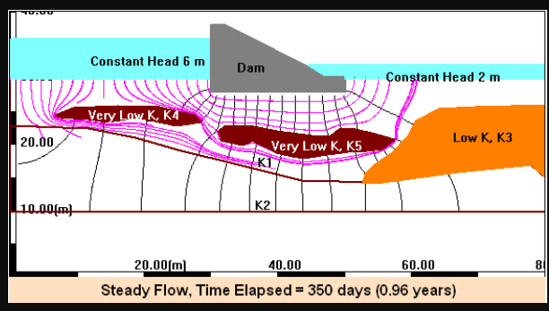

https://www.egr.msu.edu/igw/Digital%20Library/DigitalLibrary_final/6/dam4.gif