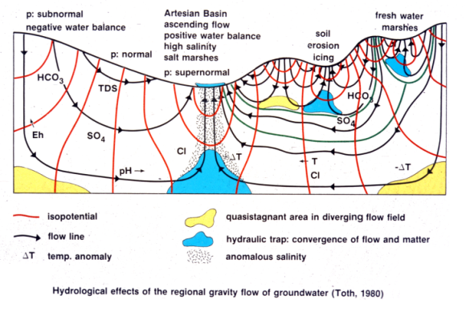

The first analytically calculated regional groundwater flow-model for complex topography: regionally sloping and sinusoidally undulating water table (Tóth, 1962/1963; courtesy T. Winter)

Such flow systems render moving groundwater a universal geologic agent.

As such, they are active ubiquitously and simultaneously to great depths in the Earth’s crust. Individual flow systems exert a polarizing effect of natural hydrological, physical, chemical, botanical, thermal, biological, etc., processes and phenomena between their recharge and discharge ends with transitional ones in between.

<https://regionalgwflow.iah.org/regional-groundwater-flow>

What are flow nets (Freeze and Cherry):

meaningful two-dimensional cross section can be chosen through the three-dimensional system, the set of equipotential lines and flowlines so exposed constitutes a flow net. The construction of flow nets is one of the most powerful analytical tools for the analysis of groundwater flow.

The solution requires knowledge of the region of flow, the boundary conditions on the boundaries of the region, and the spatial distribution of hydraulic conductivity within the region.

**Homogeneous, Isotropic Systems**

fully saturated. For steady-state flow in such a region, three types of boundaries can exist: (1) impermeable boundaries, (2) constant-head boundaries, and (3) water-table boundaries.

Floe parallel to no-flow/impermeable boundaries

Equipotential lines perpendicular

In effect, any flowline in a flow net constitutes an imaginary impermeable boundary, in that there is no flow across a flowline

In flow-net construction, it is often desirable to reduce the size of the region of flow by considering only those portions of the region on one side or the other of some line of symmetry -- -prefer symmetry

A boundary on which the hydraulic head is constant [Figure 5.1(b)] is an equipotential line. Flowlines must meet the boundary at right angles, and adjacent equipotential lines must be parallel to the boundary.

for a recharge case the water table is neither a flowline nor an equipotential line. It is simply a line of variable but known h.

The area between two adjacent flowlines is known as a streamtube or flowtube. f the flowlines are equally spaced, the discharge through each streamtube is the same

Under steady-state conditions, the discharge across any plane of unit depth (say, at AD, EH, or FG) within the streamtube must also be dQ. In other words, the discharge through any part of a streamtube can be calculated from a consideration of the flow in just one element of it.

It is applicable only to simple flow systems with one recharge boundary and one discharge boundary. For more complicated systems, it is best to simply calculate dQ for one streamtube and multiply by the number of streamtubes to get Q.

It is also worth noting that flow nets are dimensionless

**Heterogeneous Systems and the Tangent Law**

When groundwater flowlines cross a geologic boundary between two formations with different values of hydraulic conductivity, they refract, much as light does when it passes from one medium to another

For steady flow, the inflow Q1 must equal the outflow Q2; or, from Darcy’s law,

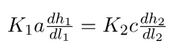 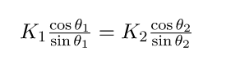 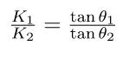

Equation (5.10) constitutes the tangent law for the refraction of groundwater flowlines at a geologic boundary in heterogeneous media. Knowing K1, K2, and θ1, one can solve Eq. (5.10) for θ2.

K1/k2 – hyperparam where we don’t know them indvually but we know their ratio/relationship

Flowlines, as if they had a mind of their own, prefer to use high-permeability formations as conduits, and they try to traverse low-permeability formations by the shortest route

In aquifer-aquitard systems with permeability contrasts of 2 orders of magnitude or more, flowlines tend to become almost horizontal in the aquifers and almost vertical in the aquitards

1) flowlines and equipotential lines must intersect at right angles throughout the system; (2) equipotential lines must meet impermeable boundaries at right angles; (3) equipotential lines must parallel constant-head boundaries; (4) the tangent law must be satisfied at geologic boundaries; and (5) if the flow net is drawn such that squares are created in one portion of one formation, squares must exist throughout that formation and throughout all formations with the same hydraulic conductivity. Rectangles will be created in formations of different conductivity.

If the complex flow net is desired, a transformed section is in order, but if flow directions at specific points are all that is required, there is a graphical construction that can be useful.