Davian Peterson

HWRS 482

Ty Ferre

February 10, 2021

Assignment 4

* Flow through the left boundary is relatively constant along the y axis but increases near the center due to low head at the location of the well. By the head gradient, flow will move faster towards the center. The inverse is true for the outlet boundary. Since the head difference has been decreased between the boundary and location of the well, flow will decrease near the center. This varies from the Type 1 boundary condition.

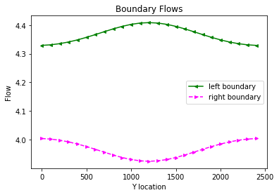

* By observing the flow just before the well, it looks like all the flow was “used up”, removing that chuck in the middle from what could have been flow at the well. I imagine this is a sort of inflection point that, instead of straightening out between the left and right boundaries, the closer the observations are to the well, the greater the amplitude until it flips right over it’s head.

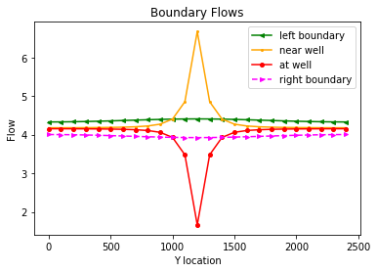

* At its given pumping rate, the well draws enough flow to collect three cells of width from the left boundary. The capture zone is defined below by the highlighted area

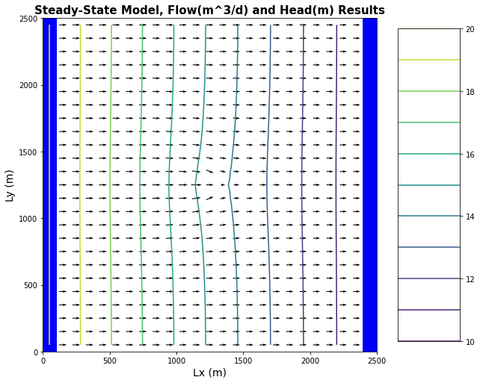



* Flow crosses the well horizontally, providing more volume on either side of the well
* As the well moves into the corner, its proximity to the inflow boundary presents a steeper fall in head, making flow greater than it would be with a well in the center. When observed at the outflow, however, the flow does not stray very far from what it would be if there were no well at all.
* It looks like the well should have been at the top left corner but it sits at the bottom left instead.

