Davian Peterson

HWRS 482

Ty Ferre

February 16, 2021

Assignment 5

**Head vs x**

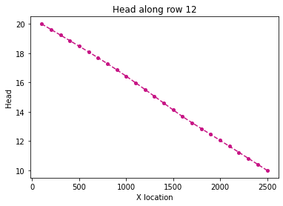

Figure 1: head in homogenous medium with no recharge or pumping

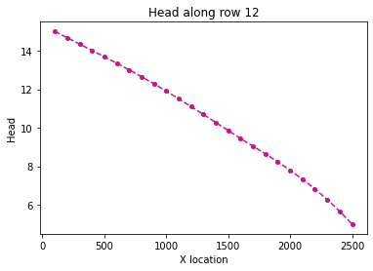

Figure 2: reduced head, no recharge or pumping

I’m not quite sure about the gradual drop at the end of Figure 2. I remember going over this on Thursday but I thought it had to do with the fact that one side was confined and the other was unconfined and I don’t think that’s the case in the model.

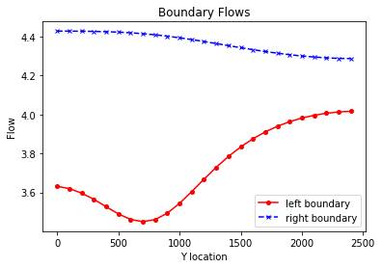

Figure 3: left and right flow of Head: 20-10

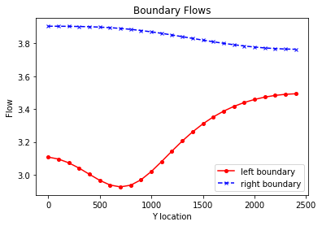

Figure 4: left and right flow of Head: 15-5

When reducing head on the left and right, all flow reduces slightly. I don’t quite understand this because I would’ve assumed that as long as the difference between head from beginning to end is the same, flow would stay constant by Darcy’s Law.

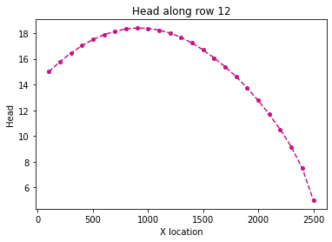

Figure 5: with recharge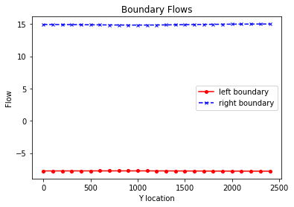

Figure 6: flow with recharge

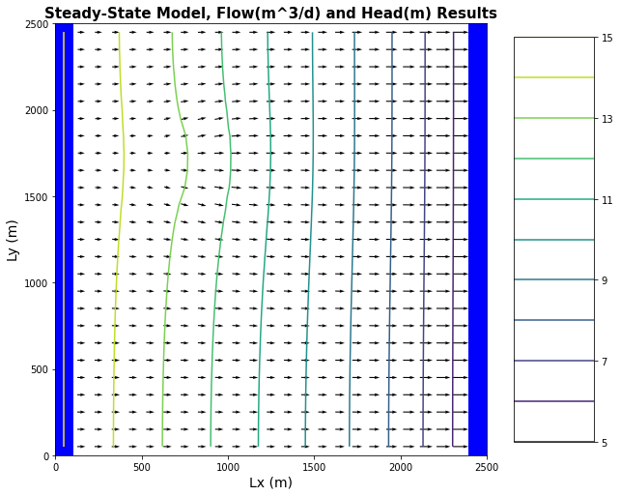

Figure 7: flow vectors with recharge, with contamination zone

As recharge enters the system, the water table will rise and across X and Y. It doesn’t look like they add as much to the edge as it does the center and this might have something to do with the bump at the end of Figure 2. With recharge, we also see negative flow from the left, likely because of the inverted slope of head on the left side. Flow is 3D and it is depicted in the 2D plan view as Figure 6 shows flow along y at two distinct x coordinates.

Annual Excess Irrigation: (1e-4)m/day * (4*100)^2m^2 = 16m^3/day

16/(2500^2) = 2.56e-6 meters

Total Annual Irrigation: Not quite sure how to determine total irrigation from excess

Area at Risk: by looking at the head distribution with recharge from the farm, it looks like contamination will be contained to down gradient of the farm as seen in Figure 7.

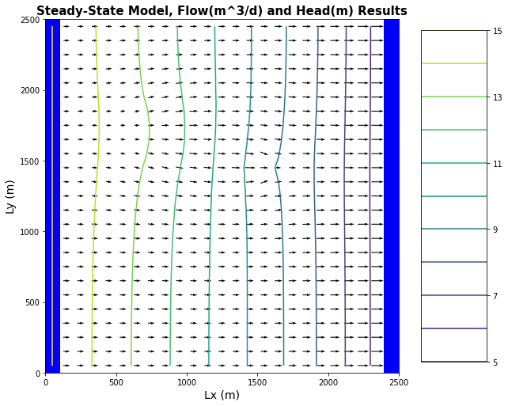

Figure 8: flow direction with recharge and pumping, contamination in orange and capture zone in blue

The well bends the equipotential contours down gradient of the farm slightly, widening the area of the contamination zone and even redirecting more contamination into the capture zone.