Davian Peterson

HWRS 482

Ty Ferre

February 23, 2021

Assignment 6: Trans-tired Zzzzz

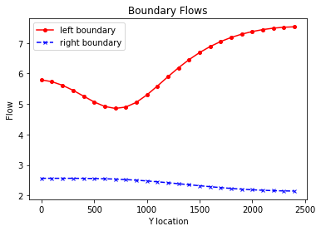

*Figure 1: boundary flow in initial conditions*

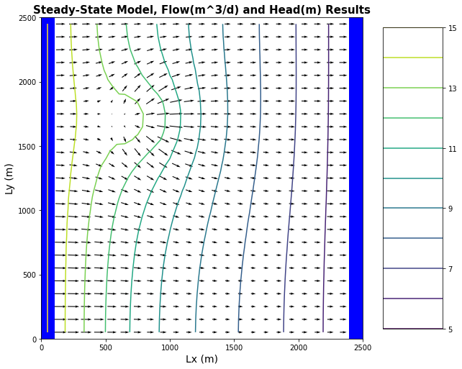

*Figure 2: equipotentials, flow vectors, and contamination zone in initial conditions*

*Figure 3: ET flux – I had trouble generating an ET map, not sure where to start*

*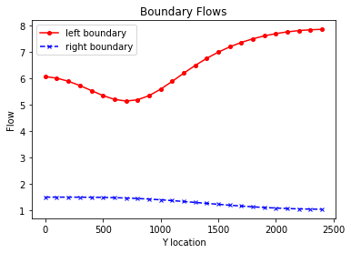*

*Figure 4: boundary flow with extinction depth of 6 meters*

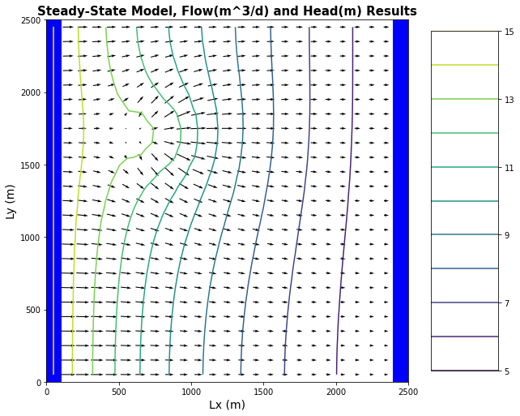

*Figure 5: equipotentials, flow vectors, and contamination zone with new extinction depth*

*Figure 6: ET flux with new extinction depth*

How does extinction depth impact the system?

When observing the difference made on the boundary flow by a greater extinction depth (and therefore greater ET), we can see more flow in and less flow out. This makes sense because the ET, which is only taking place between the two boundaries, is decreasing head between the boundaries and drawing more flow towards the center. This decrease in head can also be seen in the equipotential lines in Figure 5.

How is MODFLOW representing ET and why doesn’t this feel right?

A greater decrease in head can be seen further right which is where head is already low. I would assume that ET would be most dramatic in higher heads which would be more exposed to atmospheric vapor pressure.

*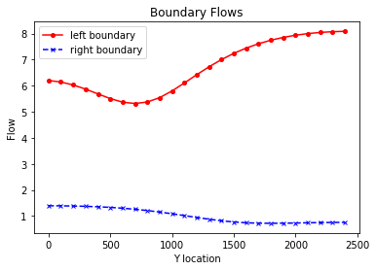*

*Figure 7: boundary flow with 20m3/day pumping*

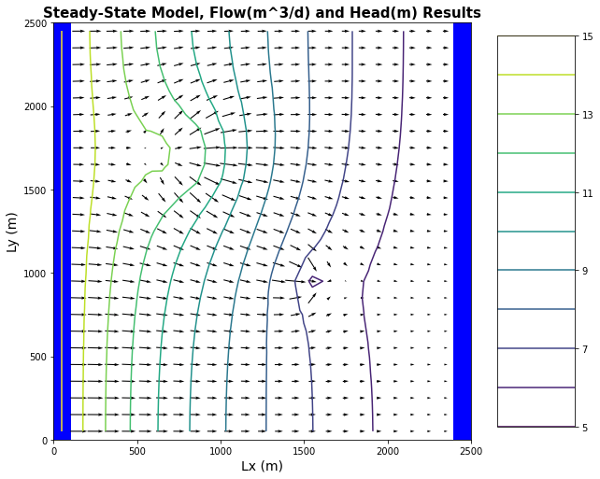

*Figure 8: equipotentials, flow vectors, and contamination zone with 20m3/day pumping*

*Figure 9: ET flux with 20m3/day pumping*

How does pumping change contamination zone?

The extent of the contamination zone has not changed very much. It extends south just about as much as it did before pumping.

How does pumping change ET map?

I’ll need an ET figure to understand this for sure but I would assume with lower head, ET should be lower, and out of ET’s reach, however, there is that weird relationship I noticed where ET increases with depth.

Mass Balance:

* How can I approach quantifying the flow across the boundaries and from recharge?
* How can I figure out how much is escaping from surface vs well?