Davian Peterson

HWRS 482

Ty Ferre

February 23, 2021

Assignment 7: Transient

a) The gradient is not uniform for the initial steady state conditions - discuss the influences of recharge and the unconfined condition on this nonlinearity.

The recharge zone is limited to near the center of the box model which slightly gets an increase in head from this recharge. In terms of the unconfined aquifer, transmissivity plays a role as the head decreases, so does b and therefore how much it can flow near the end of the gradient.

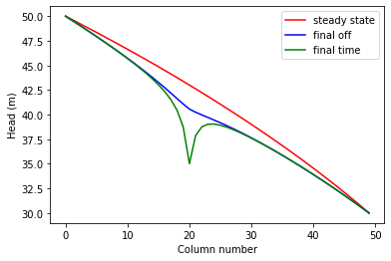

*Figure 1: head gradient across X at steady state, when pumping ends, and at the end of the 100 years*

b) Determine if the system has reached steady state - consider a point at the well and another at the center of the domain.

I would say the system is at steady state because the heads at the start and end of pumping look the same year-to-year towards the end. Although steady state refers to the relationship between flow-in and flow out so I’ll need to figure out how it connects to that.

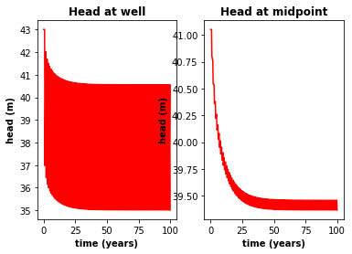

*Figure 2: decrease in head over the 100 year duration of the simulation, greater oscillations at well*

c) Find the zone of influence of the well defined in two ways: - Based on the drawdown from the initial steady state to the end of simulation time (end of final no-pumping stress period). - Based on the drawdown from the end of the last pump-on stress period to the end of simulation time.

Drawdown is identified in Figure 3 across the entire model. The contours reach each corner, revealing a decrease that leads to the location of the well.

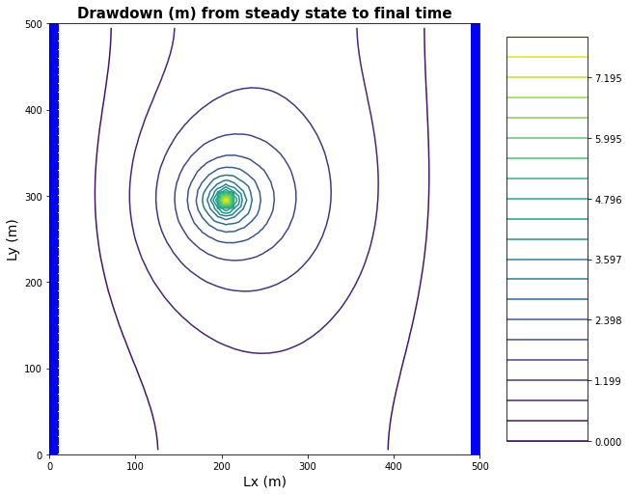

*Figure 3: drawdown reaching across the Box Model from steady state until the end of the simulation*

Figure 4 highlights the drawdown closer to the well that takes place following the last of the pumping. This zone of influence can also be seen in Figure 1 in the area between the lower two head curves.

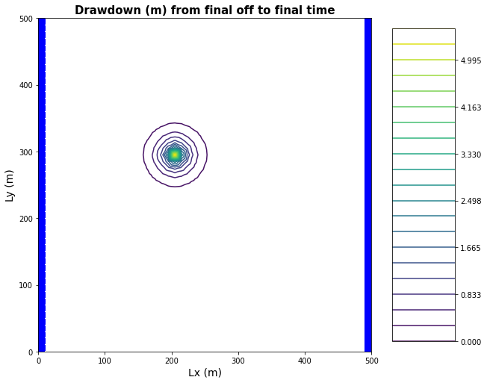

*Figure 4: drawdown within area near well from the end of pumping to end of simulation*

d) How long does it take a point at the center of the domain to reach steady state. At that point, explain how you could divide the domain into a steady and transient part and solve each separately.

As seen in Figure 2, the midpoint does not reach steady state until the 40th year. The transient part in the beginning will need to account for storage in the system as this can change before reaching steady state. From about year 40, the storage could be assumed to stay constant.

e) Find a constant pumping rate (same throughout the year) that matches the head time series at the middle of the domain.

Head(t=100) - Head(t=40) = -.0016 meters

dh/dL = .0016/60 = .000267

q = -K (dh/dL) = - 1 \* -.000267 = .000267 m/day

f) Find a constant pumping rate (same throughout the year) that matches the head time series at the well, leaving only a regular, repeating seasonal residual. Are the two pumping rates the same?

Head(t=100) - Head(t=40) = -.0015 meters

dh/dL = .0016/60 = .00025

q = -K (dh/dL) = - 1 \* -.00025 = .00025 m/day

These two pumping rates are very nearly the same.

g) Discuss the sources of water captured by this well. If you're up for a challenge, calculate them for the final pump-on period!

The well captures water from the higher constant head boundary and recharge.

h) Discuss how you would define the capture zone of the well. How is it different than our definitions of capture zone so far in the course?

For the capture zone, I would observe the flow vectors in Figure 7 and delineate all the vectors that move towards the well, starting from those closest to the well.

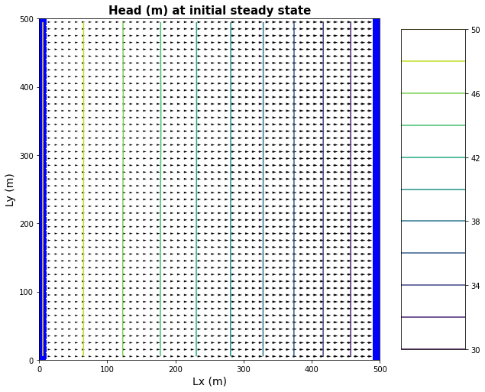

*Figure 5: flow vectors and equipotential lines at steady state*

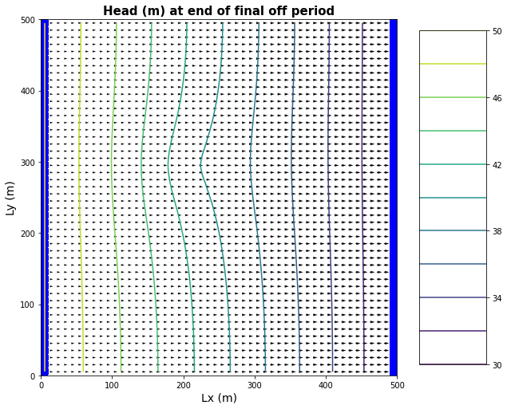

*Figure 6: flow vectors and equipotential lines when pumping ends*

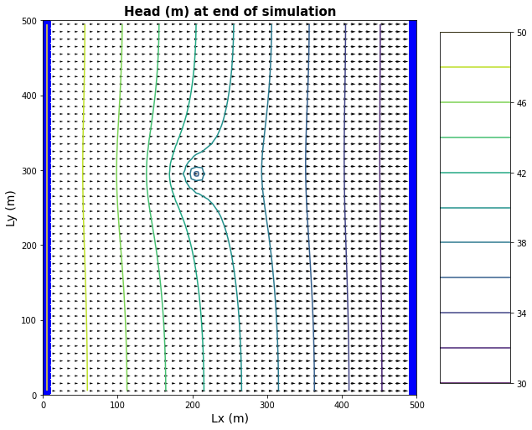

*Figure 7: flow vectors and equipotential lines at end of simulation*