Davian Peterson

HWRS 482

Ty Ferre

March 29, 2021

Assignment 8: Particle Tracking

1. How does the capture zone evolve in time? Where does the early time capture zone get its water?

The following figures were developed using the pumping rates in steady state that would produce the head at a given time during a transient system. Figure 1 does this for the head seen at 25 years and Figure 2 assumes that the head remains constant by 40 years of pumping, leaving the pumping rates – for 50, 75, 100 years, and essentially the end behavior of the ‘transient” system – the same. Between these two figures, however, the capture zones are similar for both the 1-layer and 3-layer scenarios. I would credit this to a flaw in the methods I used or the way I used the code because I would assume different pumping rates must produce different capture zones. To answer the second question, I’d say the capture zone draws from the left boundary and from recharge.

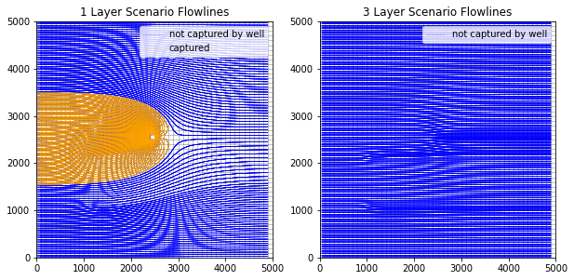

*Figure 1: capture zone of pumping rate associated with head after 25 years*

*Figure 1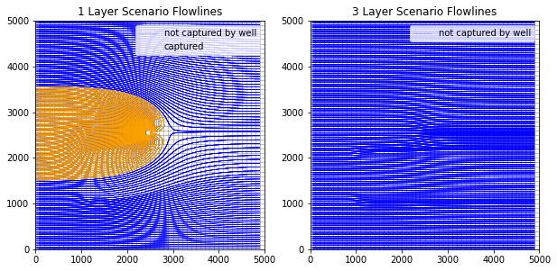Figure 2: capture zone of pumping rate associated with head after 40 years*

1. Where does the ‘infinite time’ capture zone get its water?

According to Figure 2, the source is the same and doesn’t reach beyond 1500 and 3500 in the left boundary.

1. How does the extent of the capture zone change when layers are considered? Can you still define a 2D capture zone?

I’ll need to figure out how the 3-layer scenario would look and why it impacts the capture zone.

If the 3-layer scenario were to show a capture zone, that would dictate a third dimension in which flow would be moving.

1. How does the extent of the ‘infinite time’ capture zone change when layers are added? Explain any different in the lateral extent of the capture zone along the left boundary.

I’ll need to figure out how the 3-layer scenario would look for end behavior and understand its impacts the capture zone.