Davian Peterson

HWRS 482

Ty Ferre

March 29, 2021

Assignment 9: Streams

1. Use the figures to describe the direction and magnitude of stream/aquifer exchange along the stream. In particular, explain why the leakage changes magnitude or direction where these values change.

Until about row 30, stream/aquifer exchange is mostly feeding flow into the stream. Flow is increasing up to this point, meaning that the stream is gaining. However, after the stream reaches a peak at about row 30, the stream begins losing flow until it drops down to zero at about row 45. The change in direction of flow between the stream and aquifer can be credited to the conductance of the stream bed which increases in the direction of the flow of the river or increasing row number. With greater conductance, more flow is able to drain into the aquifer until it is dry.

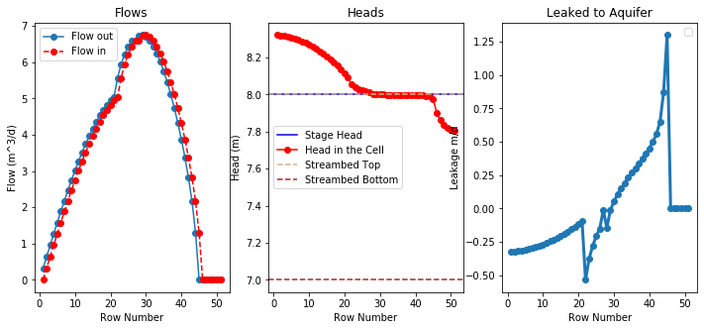

Figure 1: flow, head, and flow into aquifer

1. Use the head distribution to describe the movement of water across the boundaries and into/out of the stream.

With greater head from the lake on the left boundary, most of the flow will move right, towards the stream and once it approaches the stream more, it will detect the difference in head within the right boundary. The stream flows in the direction of decreasing Y which can be seen in the figure has the head decreases towards the bottom right corner. As the flow enters the stream, it will flow down this boundary.

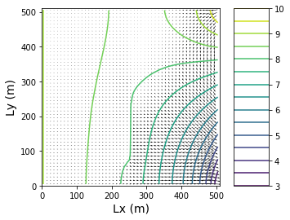

Figure 2: plan view of head distribution

1. Choose two things to explore (impact of streambed K, inflow into the river, or recharge rate). Produce a plot for each to compare to the base plots and use the plots to explain the impact of the hydrologic change.

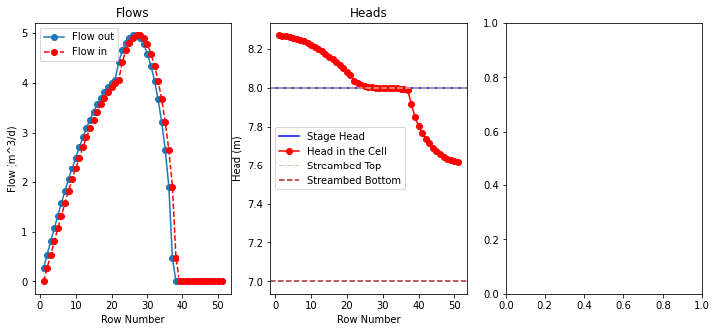

Figure 3: reduced recharge to 1\*10^-5 m/day

In reducing the recharge, flow saw a lower peak in flow which only reached 5 m^3/day. This is likely because the aquifer did not have as much head to supply to the stream.

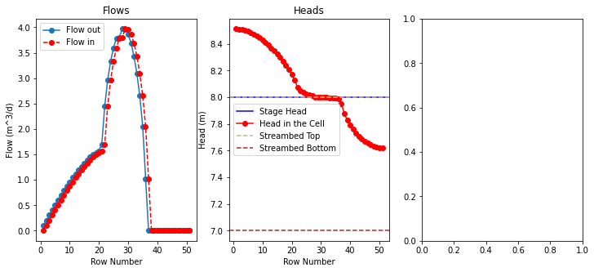

Figure 3: reduced conductance at top of stream to .002 m/day

With the original conductance applied to the first section of the stream, flow was able to reach up to 5 m^3/day. This figure was reduced which, in part, reduced the overall peak in flow from about 7 m^3/day to 4 m^3/day.