Davian Peterson

HWRS 482

Ty Ferre

February 2, 2021

Assignment 3

* Explain why the flow distributions are the same for the left and right boundaries.
  + Flow distributions are the same on the left and right because the system is steady state, meaning that flow in and flow out are equal at all times.
  + Flow dips as it approaches the center by the inclusion’s obstruction. Even though it’s not passing through the inclusion, the flow competes for space with the water that is moving quickly around the inclusion.
* Add a plot of the left-to-right flow along a line that passes through the center of the inclusion. What can you learn from comparing this distribution to that seen on the boundaries?
  + The plots of the boundary flow are relatively constant, only slightly slowed by the inclusion in the middle. However, flow going straight through the inclusion will slow much faster once it enters the inclusion of lower hydraulic conductivity.
  + The increase in flow before dropping sharply as it enters the inclusion comes from the contribution of lateral flow. This takes places because the flow headed for the inclusion is then diverted away to move quickly around through the greater hydraulic conductivity.

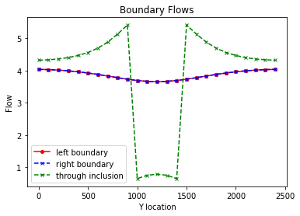

* Calculate the total flow into (and out of) the domain. Use this to calculate the Keq of the heterogeneous system with the K values as given in the starter code. Repeat this calculation for the following K values for the inclusion (keeping the background K as it is given): 0.01, 0.1, 1, 10, 100. Compare the Keq to the harmonic and arithmetic mean K values based on the area occupied by each medium (rather than the length for a 1D system). Can you draw any general conclusions about the impact of high or low K heterogeneities on the equivalent K for the flow system examined?
  + Both harmonic and arithmetic Keqs better represent the background despite inclusion Ks as low as .01 or as high as 100 m/day, likely because of the greater area.
* Does the equipotential distribution depend on the absolute or relative K values for the background and the inclusion? How would you use the model to test your answer?
  + To understand this better, the hydraulic conductivities of the background and inclusion could be multiplied by a common magnitude factor. Multiple equipotential distribution graphs could be developed by adjusting the magnitude while preserving the ratio between the background and inclusion values.