Increasing the K value within the inclusion to higher than the background turned the inclusion into a virtual no-flow area to the main conduit. Head seems to slightly dip when going through inclusion area.
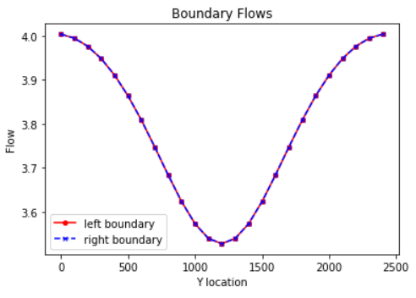
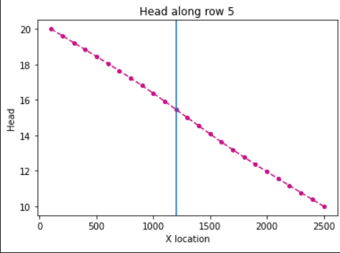
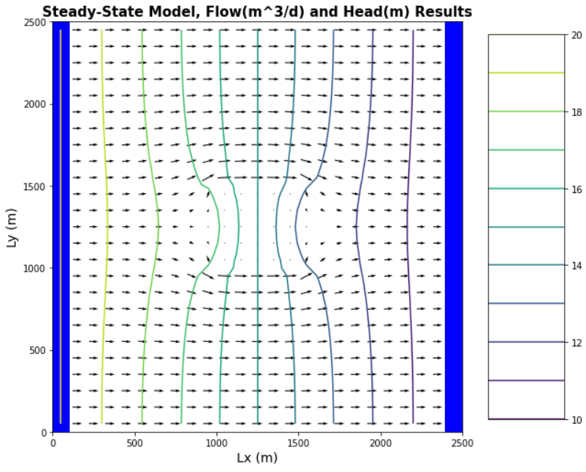
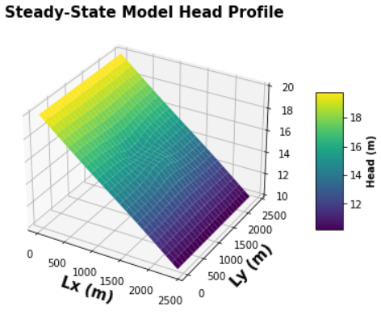
Initial run:
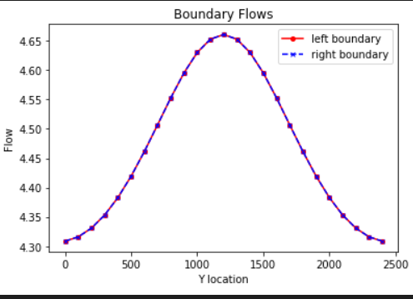
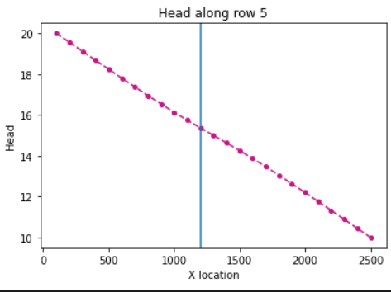
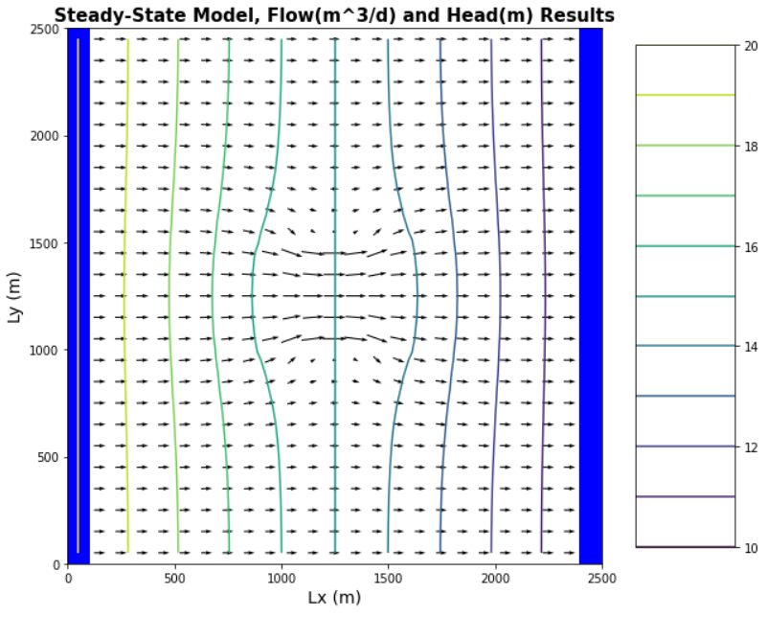
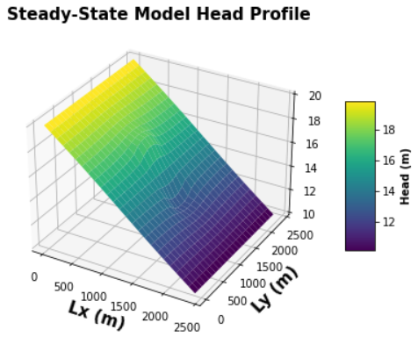
High K in inclusion:
Why are the values not constant along the boundary?
They’re not consistent along the boundary?
  - Relate to definition of Type I boundary(constant head boundary)
    - Temporary head loss related to lower K values?
- Add plot of left-to-right that passes through the center of inclusion
  - What can you learn from comparing the distribution to that seen on boundaries?
- Calculate total flow from initial condition
Q from the model is 6.25 m³/d. The effective K in the model is 0.625 m/d
Q_{0.01}=0.1 m³/d
Q_{0.1}=1.0 m³/d
Q₁=10 m³/d
Q₁₀=100 m³/d
Q₁₀₀=1000 m³/d
K_{aritmetic}=0.9775 m/d → 9.8 m³/d
K_{harmonic}=0.9756 m/d → 9.8 m³/d

- Conclusions?
In the case where water can flow around a low K area, neither the arithmetic nor a harmonic mean produce an effective K that is as low as the effective K. (Flow boundary defined in FloPy as 6.25 m³/d?)
- Does equipotential distribution depend on
  - absolute or relative K?
  - Background or inclusion K?
  - How would one test this?

