Jason Schlottman

HWRS 582

**Ensemble Code Challenge**

Before any specific functions are called upon to produce plots, the initial ensemble code does not produce any figures prior to package installation and direction. Below is a picture of the necessary packages to be installed for this assignment:

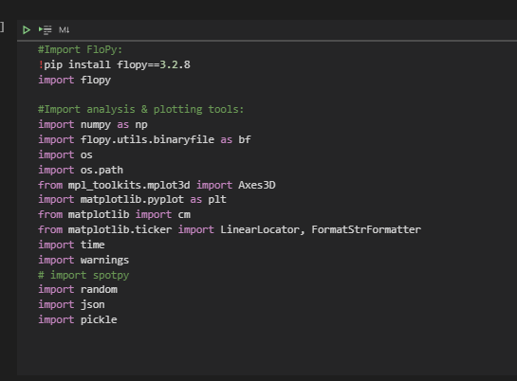

The following steps must be taken to perform the necessary functions for the ensemble code to be analyzed after it's run:

1. Get the run_ensemble code running.
2. Empty the current model output directory.
3. Delete all of the m#### files from the output directory.
4. Run run_ensemble.
5. Move the files from current output to output.
6. Run run_ensemble and extract the results that you want.
7. Copy the m### files to a 'hold' directory in case you want that model set later.
8. Set up run_ensemble to add models to your ensemble.
9. Repeat steps 2-8 to augment your ensemble.

I have not yet performed these neccessry steps, however the code has ran with a few errors. This is my draft outline prior to actually analyzing the code that is run once the errors are fixed!