Jason Schlottman

HWRS 582

**The Challenge -Transient**

1. The gradient is not uniform for the initial steady state conditions - discuss the influences of recharge and the unconfined condition on this nonlinearity

Initial Figures prior to corrections:

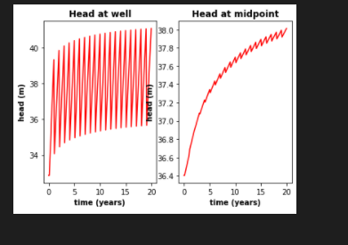

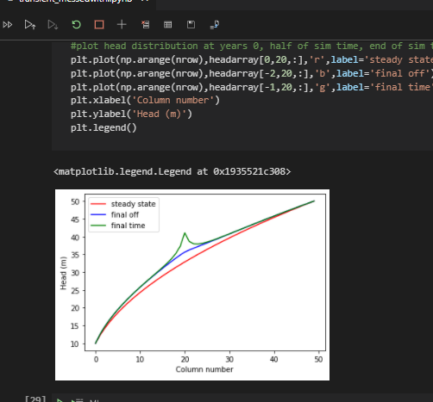

b) Determine if the system has reached steady state - consider a point at the well and another at the center of the domain.

c) Find the zone of influence of the well defined in two ways: - Based on the drawdown from the initial steady state to the end of simulation time (end of final no-pumping stress period). - Based on the drawdown from the end of the last pump-on stress period to the end of simulation time.

d) How long does it take a point at the center of the domain to reach steady state. At that point, explain how you could divide the domain into a steady and transient part and solve each separately.

e) Find a constant pumping rate (same throughout the year) that matches the head time series at the middle of the domain.

f) Find a constant pumping rate (same throughout the year) that matches the head time series at the well, leaving only a regular, repeating seasonal residual. Are the two pumping rates the same?

g) Discuss the sources of water captured by this well. If you're up for a challenge, calculate them for the final pump-on period!

h) Discuss how you would define the capture zone of the well. How is it different than our definitions of capture zone so far in the course?