Jason Schlottman

HWRS 582

**Streams_"Challenge"**

**Initial figures produced:**

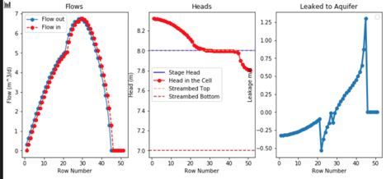

We can observe from the flow distribution that flow is highest near the middle of the stream where the level is deepest and the most water passes through the domain. Flow out matches flow in for the most part . The head is highest on the left boundary before a gradual decrease until a stagnant point is reached for a short period until the head begins to drop again at the right boundary of the stream.

This head and flow distribution reflects the aquifer leakage, which shows the greatest loss at the right boundary, where by that point most of the flow has exited the stream into the groundwater system.

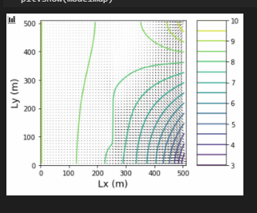

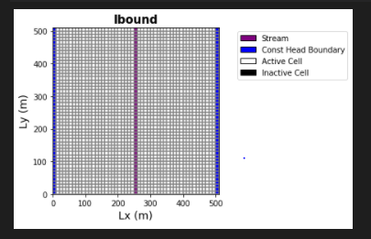

**Below are the plots produced with the same code, except the recharge rate was changed from 5E5 m/d to 1E5 m/d.**

We observe similar flow and head distribution plots, although the decrease in head seems to be more of a gradual and smooth exponential decrease, perhaps caused by the large reduction of flow volume due to the reduction in recharge from 5e5 m/d to 1e5 m/d. The flow experiences a drop from a max flow rate of about 7 m^3/day to only about 5 m^3/day. This means there's less water to exit the system and less change will occur overall compared to the higher flow system.

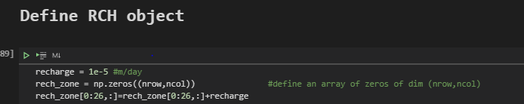

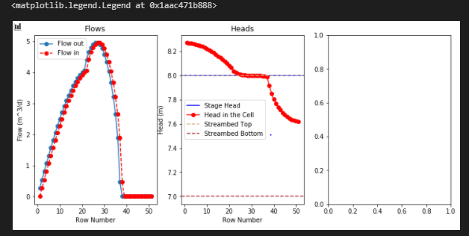

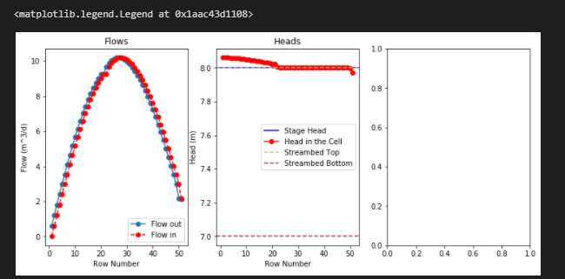

**Finally as shown above the recharge rates were returned to initial conditions, but the bottom hydraulic conductivity "k_strbott" was changed from 1 to 10 f/d.**

In this case the recharge rate is unchanged from the initial 5e5 m/d but the hydraulic conductivity is greatly increased from 1 f/d to 10 f/d. This results in an extreme shift in the change in head for the system, with an almost linear decrease ranging much less in head value than previous plots. Perhaps the massive increase in conductivity of the medium allowed for flow to exit the system and Modflow did not have to induce as much of a head gradient to reduce the total flow as water is lost to the system.

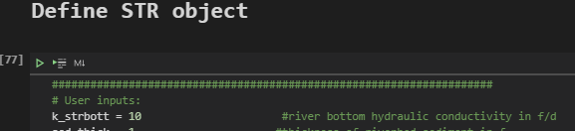

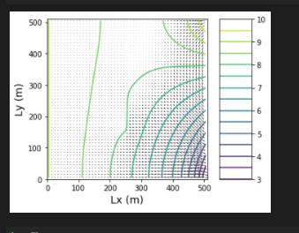

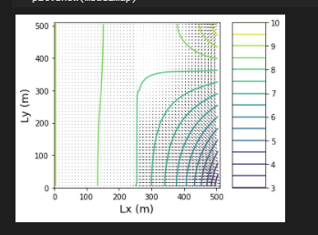

Above the plots show the difference in system response for the two cases, where the head range has changed substantially reducing in less variation from the flowline's original path.