Jason Schlottman

HWRS 582

"Transpired" Challenge_Draft

a)

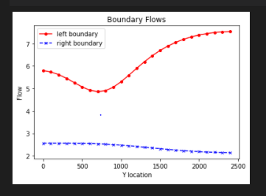

The plot below shows the contour head plot with the initial set extinction depth 3. The box 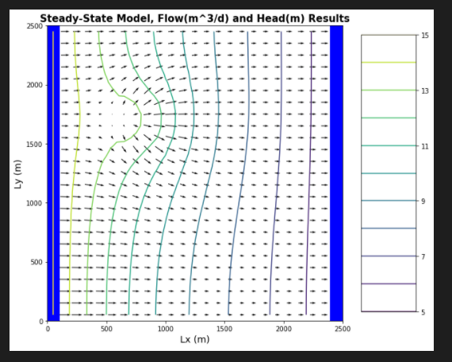

The orange zone outlines the potentially affected recharge area if contaminated while the purple lines form the well's capture zone.

b)

Plot below shows Extinction Depth=10

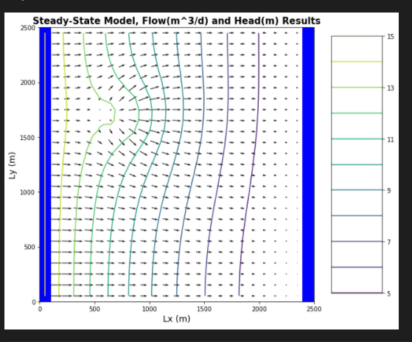

Shown in the contour head plot shown below, now the Extinction Depth has been reduced =1

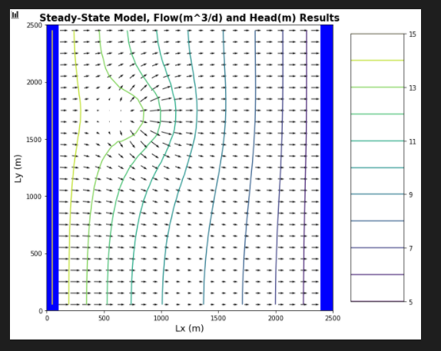

As we can see by comparing the plots, reducing the extinction depth from 10m to 1m has altered the flow in the system, largely due to the amount of available water to be input in the form of recharge. In other words, when the extinction depth is larger, the depth at which evaporation can occur is greater and thus greater amounts of water can be lost. The extinction depth is generally defined as the extent of plant's roots in the subsurface. The second plot with a much lower extinction depth results in a larger recharge area, with the flow vectors diverging from the recharge zone to display this shift in trend.

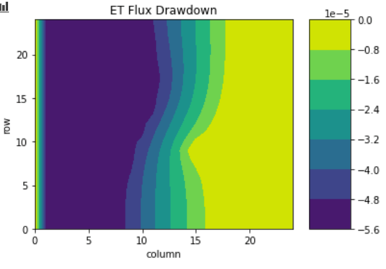

c)

MODFLOW can be utilized to assign ET values to a system in different ways. A simple concept approach does not operate with direct calculations of ET accounted for but rather, ET is represented as a standard loss in the system. The program accounts for the water balance inputs and outputs and attempts to balance the system. Oftentimes the loss from ET will simply be removed in the form of recharge. So an input is reduced to account for the loss of water in the form of evapotranspiration. An alternative route may be when MODFLOW is used to assign an ET value for the region based on extinction values

This approach resonates with my real-world understanding of ET, as I really appreciate the mathematical approach of modeling based on a simple water balance.

d) Now that the well's been turned on, Qin = -20 m3/day. The well, like ET is an overall water loss or system output. With less available water in the system to be transported or affected, the loss due to pumping will absolutely hold an effect on the ET distribution, likely resulting in a lower spatially distributed ET flux plot.

A mass balance may be similar to following example balance equation:

P + GWin = ET + QIN+ GWin ; where P= precipitation, Q= pumping, GW = lateral subsurface flow

WIP!!!