Jason Schlottman

HWRS 582

2/10/2021

The Challenge HW4

* Explain why the values are not constant along the boundary (relate to the definition of a Type I boundary). Explain the shapes of the flow distributions and why they are not the same for the left (inflow) and right (outflow) boundaries.

The values are not constant along the boundary. The system displays a type 1 boundary where boundary heads are kept constant. There is a pumping well in the center of the domain which results in a greater flow at the center of the left boundary than near the edges. The right boundary displays the opposite, where flow is the least in the center as it has been removed by the well. We also need to account for spatial distribution and distance from each point along the boundary to the well. In other words, the edges of the boundaries are closer to no-flow boundaries and are further from the pumping well than the centers and will therefore be less influential on flow.

**Well at [0,10,15] pumping rate of -8:**

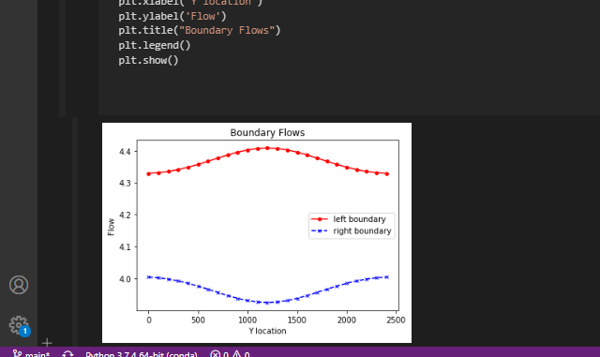

* Add a series of the left-to-right flow along a line that passes through the center of the well [:,12]. How do you interpret the flow along this transect? Hint, also look at the flow along a transect just upgradient from the well [:,11].

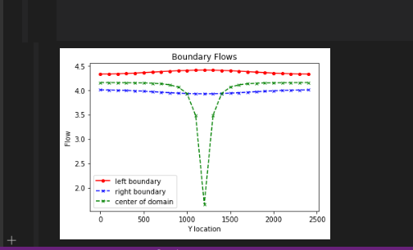

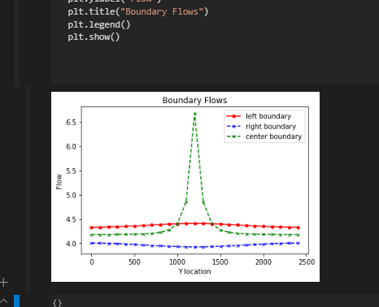

Installing a center flux line gives a better perspective in the rapid changes that occur in flow within the left and right boundaries to account for changes in total flux. This provides a broader perspective on how flow operates holistically through the whole system. Directly at the center flow is extremely low whereas upgradient the flow will be significantly higher. This resembles a pumping well location, and another location upgradient where the effects of drawdown are less influential. These changes in flow may be attributed to boundary conditions and type.

* Then, look at the plot of equipotentials and flow vectors. Describe how water flows through the domain. To aid in your description, draw a line through all of the flow vectors that terminate in the well. This approximates the capture zone of the well. Use this to refine your description of the flow system, being as specific as possible about where water that ends up being extracted by the well originates on the inflow boundary.

Flow in the system is largely driven by the head gradient introduced by the pumping well. We can observe that water flows from left to right as shown by the flowline arrows. As the water moves towards the pumping well due to the head gradient it is drawn from the surrounding areas in the capture zone. This capture zone is defined by the influx of vector arrows that end in the well. This leads me to believe the capture zone is the immediate area surrounding the well ranging from around L_x [1250-1500]

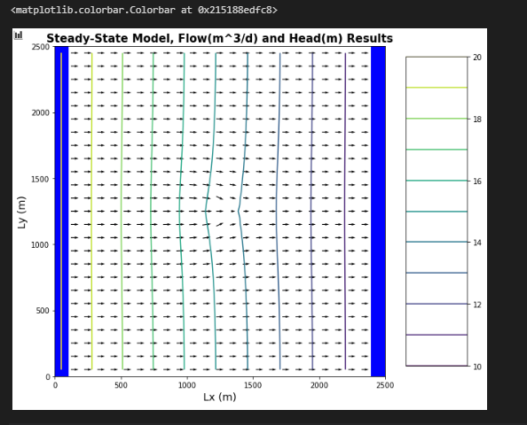

* Then, look at the plan view drawdown plot. Why aren't the drawdown contours circles? Either explain why this is correct, or fix the plot.

We observe a shift from concentric circles due to effects imposed by the boundary conditions. Type 2 no-flow boundaries introduce compression as the equipotential lines are directly perpendicular to flow. Type 1 constant head boundaries cause stretching of the contours as flow is skewed, varying from center to edges of the boundary. This results in the distorted, uneven contours we see on the plan view plot.

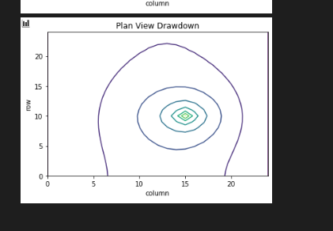

**Well at [0,12,12] pumping rate of -10:**

For this system we observe the well is placed much closer to the edge of the left boundary, which results in a heavily skewed plot where flow spikes dramatically on the left edge, then gradually reduces along the boundary through the center, then continues a gradual transpot through the right boundary. The right boundary shows a gradual increase in flow as water moves across the domain.

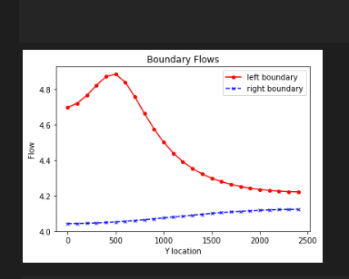

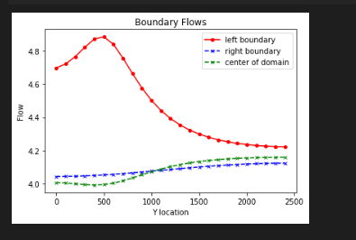

Here the peak falls on the left boundary, and we see that the center boundary is actually pretty similar to the right boundary, with a very gradual increase in flow as it moves across the domain.

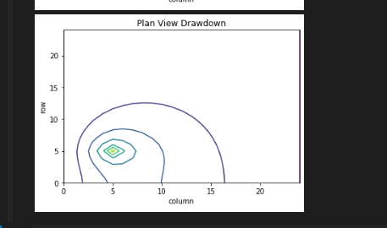

Here the contour plot is skewed left as expected, due to the vast amount of flow drawn towards the well located near the left boundary, where the compression causes the circles to fall closer together towards the left edge of the system. Flow can be observed in steady state with a influx of vectors towards the well on the left, then a gradual transport across the system.

