Jason Schlottman

HWRS 582

The Challenge "Recharge Me"

Head values at boundaries 20 to 10

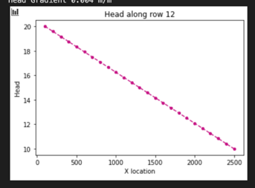

Head values at boundaries 15 to 5

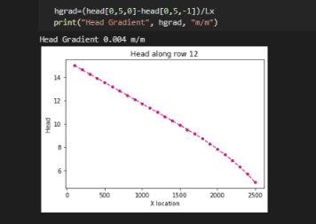

The initial boundary conditions set the head ranging from 10 m to 20 m with no pumping and no recharge yet occurring. As we travel along the transect head seems to decrease in a linear fashion. However, when the boundary conditions are changed we see a shift in the curve where at a certain point along the transect where head drops below about 10 m, the graph follows a type of exponential decay. The overall conductivity and gradient are the same, however flow does change. For the scenario where head is now below 10m, the piezometric surface falls below this line, saturated thickness begins to drop and flow through the medium is limited.

Uniform Recharge over entire surface

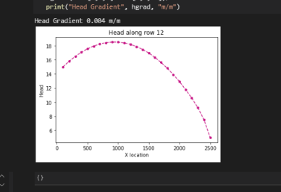

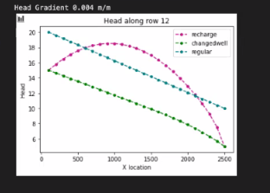

Here we observe uniform recharge applied over the boundary, and this results In a different flow pattern. The left boundary is now largely influenced by the influx of new water from the recharge event, so the head reflects this increase in flow until the water flows onward and the head gradually declines again as it exits the system.

Flow is assumed to behave in a 2D fashion where vertical movement is constricted and the vector flow paths reflect this horizontal assumption, even though water may behave in a 3D matrix in the real world. With our assumptions for our model to operate the flow is modeled as 2D.

Calculate total irrigation qi=qR+qC → extremely efficient use of water under cotton, loss is 1 out of 66, mostly uses irrigation

annual excess irrigation =m^2 \*m/d= m^3/d \*365 days = m^3

A= 10,000 m^2 \*16 cells = 160,000 m^2

(160,000)(1e-4)(365) = 584 m^3

Total irrigation: 1.6 m^3/day?

Potential contamination area:

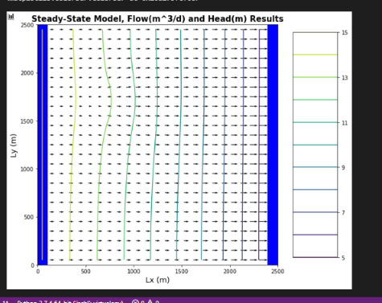

Qin= -8 m/d

The plot below shows a potential capture zone as well as the contamination area induced by irrigating farms. Pumping can draw flow towards a well and possibly increase the contamination area spread, if it's close enough or within the zone of influence. However if a pumping well is a good distance away, it may theoretically not affect flow in the contaminated region and not contribute to further spread of the contaminant.

