Jason Schlottman

HWRS 582

2/08/2021

The Challenge HW4 Draft

* Explain why the values are not constant along the boundary (relate to the definition of a Type I boundary). Explain the shapes of the flow distributions and why they are not the same for the left (inflow) and right (outflow) boundaries.

The conductivity values are not constant along the boundary as a component of darcys law must drop as changes occur over space. In other words if head is kept constant, the conductivity must decrease as Q decreases since Q=-KA(dh/dL) or K=q*(dL/dh). The flow distribution shape is of equal magnitude for left and right boundaries, however the outlflow is a mirrored reflection of the inflow.

**Well at [0,10,15] pumping rate of -8:**

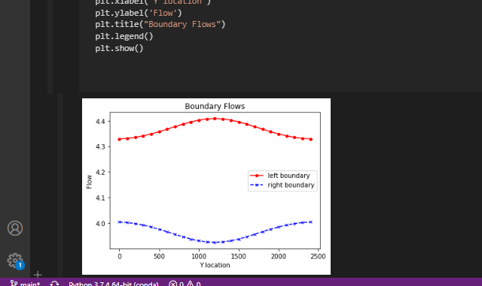

* Add a series of the left-to-right flow along a line that passes through the center of the well [:,12]. How do you interpret the flow along this transect? Hint, also look at the flow along a transect just upgradient from the well [:,11].

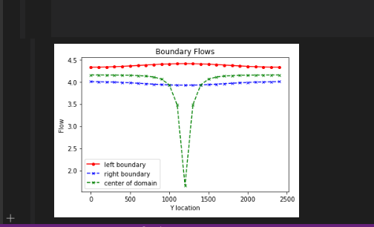

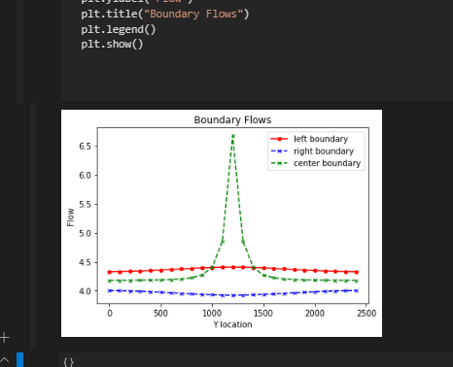

Installing a center flux line gives a better perspective in the rapid changes that occur in flow within the left and right boundaries to account for changes in total flux. Directly at the center flow is extremely low whereas upgradient the flow will be significantly higher. This resembles a pumping well location, and another location upgradient where the effects of drawdown are less influential.

* Then, look at the plot of equipotentials and flow vectors. Describe how water flows through the domain. To aid in your description, draw a line through all of the flow vectors that terminate in the well. This approximates the capture zone of the well. Use this to refine your description of the flow system, being as specific as possible about where water that ends up being extracted by the well originates on the inflow boundary.

Flow in the system is largely driven by the head gradient introduced by the pumping well. We can observe that water flows from left to right as shown by the flowline arrows. As the water moves towards the pumping well due to the head gradient it is drawn from the surrounding areas in the capture zone. This leads me to believe the capture zone is the immediate area surrounding the well ranging from around L_x [1000-1500], L_y [1000-1500].

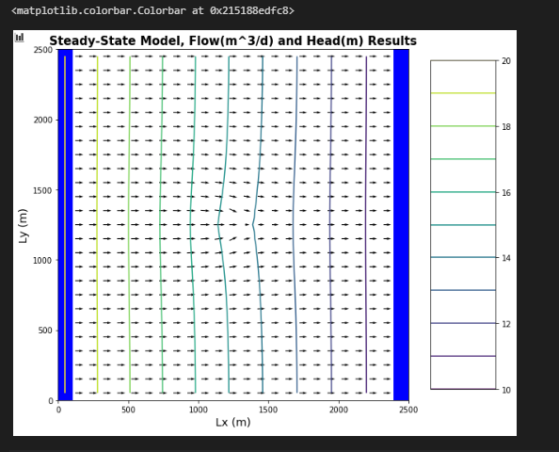

* Then, look at the plan view drawdown plot. Why aren't the drawdown contours circles? Either explain why this is correct, or fix the plot.

We will not observe perfectly concentric circles for the drawdown contours a the rate at which drawdown occurs is not perfectly consistent in the real physical world. The contours represent water table elevst

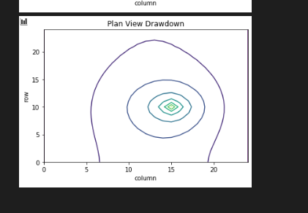

**Well at [0,12,12] pumping rate of -10:**

