Jason Schlottman

HWRS 582

Correct Figures "Recharge Me"

Head values at boundaries 20 to 10

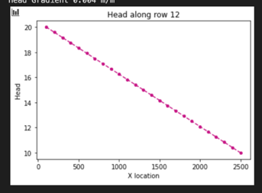

Head values at boundaries 15 to 5

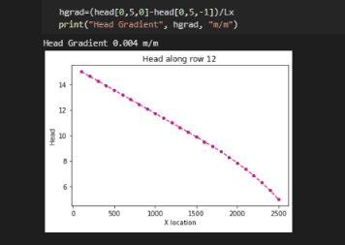

Uniform Recharge over entire surface

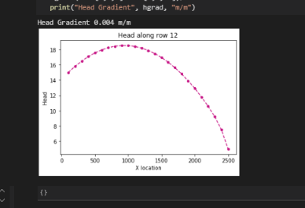

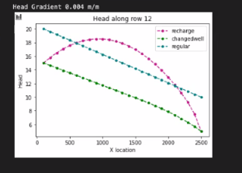

Qin= -8 m/d

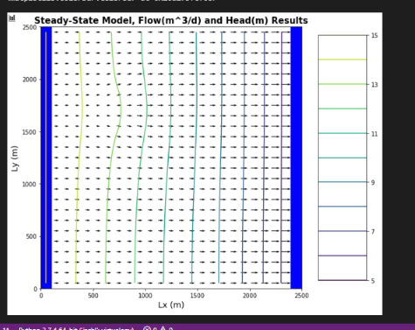

Qi=0

