Jason Schlottman

HWRS 582

**Streams_Correct Figures**

**Initial figures produced:**

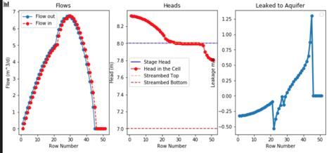

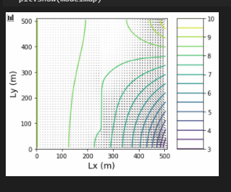

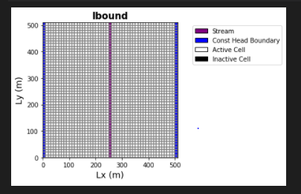

**Below are the plots produced with the same code, except the recharge rate was changed from 5E5 m/d to 1E5 m/d.**

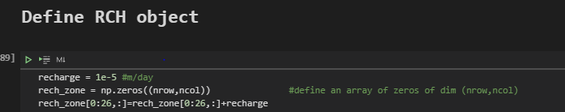

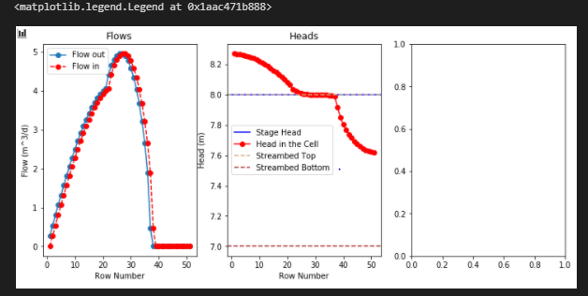

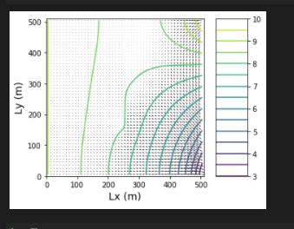

**Finally the recharge rates were returned to initial conditions, but the bottom hydraulic conductivity "k_strbott" was changed from 1 to 10 f/d**

