Jason Schlottman

HWRS 582

Correct Figures "Recharge Me"

Head values at boundaries 20 to 10

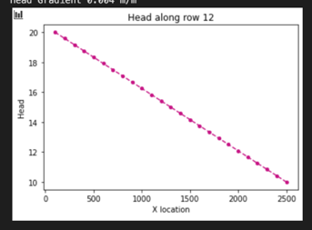

Head values at boundaries 15 to 5

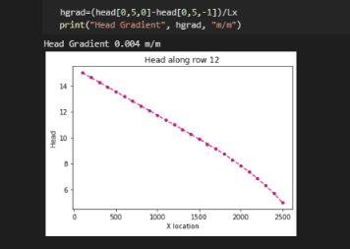

The initial boundary conditions set the head ranging from 10 m to 20 m with no pumping and no recharge yet occurring. As we travel along the transect head seems to decrease in a linear fashion. However, when the boundary conditions are changed we see a shift in the curve where at a certain point along the transect where head drops below about 10 m, the graph follows a type of exponential decay. The overall conductivity and gradient are the same, however flow does change. For the scenario where head is now below 10m, the piezometric surface falls below this line, saturated thickness begins to drop and flow through the medium is limited.

Uniform Recharge over entire surface

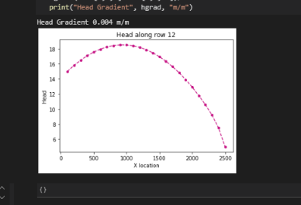

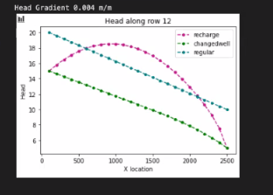

Here we observe uniform recharge applied over the boundary, and this results In a different flow pattern. The left boundary is now largely influenced by the influx of new water from the recharge event, so the head reflects this increase in flow until the water flows onward and the head gradually declines again as it exits the system.

Qin= -8 m/d

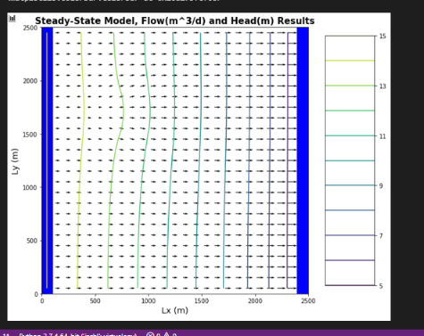

Qi=0

