Jason Schlottman

HWRS 582

"Transpired" Correct Figures

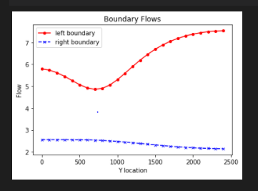

The plot below shows the contour head plot with the initial set extinction depth 3. The box 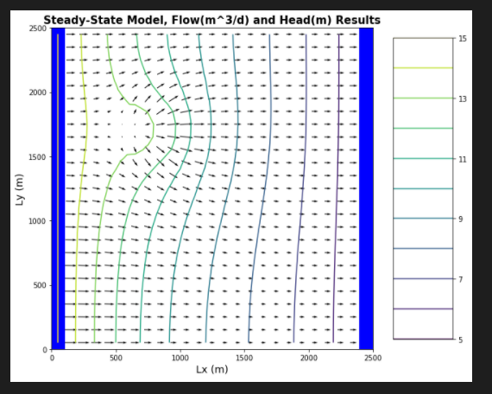

The orange zone outlines the affected recharge area if contaminated while the purple lines form the well's capture zone.

Plot below shows Extinction Depth=10

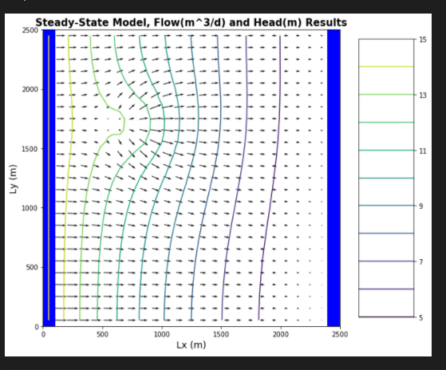

Shown in the contour head plot shown below, now the Extinction Depth has been reduced =1

