Jason Schlottman

HWRS 582

**HW7 Transients**

Correct Figures & Challenge Questions:

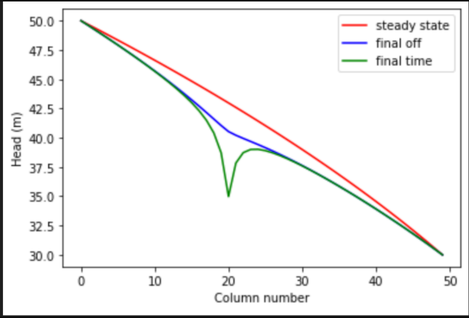

1. The gradient is not uniform for the initial steady state conditions - discuss the influences of recharge and the unconfined condition on this nonlinearity

We can observe a non-linear gradient where recharge changes the head value and volume of water input into the system. In unconfined conditions, the saturated thickness of the aquifer may be changed and the gradual curved reduction in head accounts for this shift.

1. Determine if the system has reached steady state - consider a point at the well and another at the center of the domain.

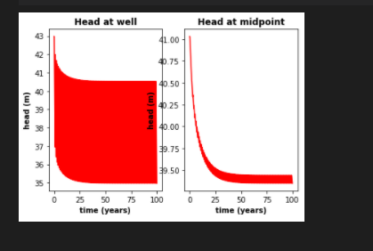

Based on the "Head at Well" and "Head at Midpoint" plots I believe the system has reached steady state around 60 +/- a few. There seems to be a point where oscillations stabilize and conditions remain constant, as steady state define constant head and change in storage over time unlike a transient environment.

1. Find the zone of influence of the well defined in two ways:

- Based on the drawdown from the initial steady state to the end of simulation time (end of final no-pumping stress period).

- Based on the drawdown from the end of the last pump-on stress period to the end of simulation time.

For the cases shown in the figures below we can observe an estimated zone of influence based on the drawdown contours. The second figure displays the recovery stage, where no pumping is occurring and the recovery zone is near the edge of the circle border.

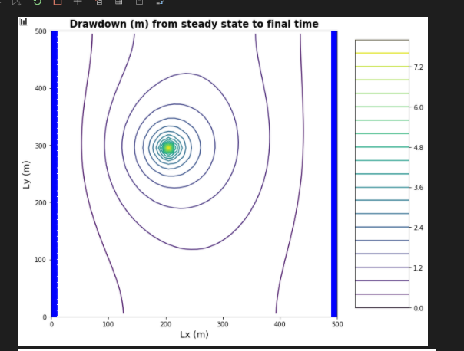

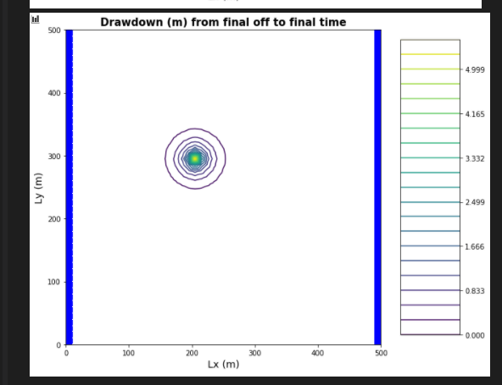

1. How long does it take a point at the center of the domain to reach steady state. At that point, explain how you could divide the domain into a steady and transient part and solve each separately.

Based on the "Head at Midpoint" plot we determined steady state to be around 60 years +/- a few. At this point we can find the circular zone of influence where everything outside of this contour which is past the point is at steady state. Every point within the contour is transient.

1. Find a constant pumping rate (same throughout the year) that matches the head time series at the middle of the domain.

Potentially treat pumping rate as "drawdown" to match up a plot that resembles the curve for the "Head at Midpoint" plot. There is a reduction of slightly less than 2 meters of head over the period.

1. Find a constant pumping rate (same throughout the year) that matches the head time series at the well, leaving only a regular, repeating seasonal residual. Are the two pumping rates the same?

The two pumping rates will not be the same at all, as the yearly rate must account for all the periods of on and off pumping. In other words, I'd expect a lower calculated rate for the whole year than the seasonal rate.

1. Discuss the sources of water captured by this well. If you're up for a challenge, calculate them for the final pump-on period!

The main source of water to the system is the flow that enters through the left boundary and exits through the right boundary, driven by the existing flow gradient with a lower head at the right boundary than the left.

h) Discuss how you would define the capture zone of the well. How is it different than our definitions of capture zone so far in the course?

Since the well exists in transient conditions, pumping can go on and off and change the true capture zone of the well. In other words, the actual capture zone might not always equal the true potential for capture in the zone of influence.

