Matthew Ford

GW Model

Assignment 1

1. The model is in steady state in both cases heterogeneous and homogeneous because when looking at the downward flux vs. column height we can see it is constant in both cases spatially throughout the column. In a homogeneous case flux must be the same and the K is the same everywhere therefore the gradient must be linear. If you “break” the column into an infinite number of cells the flow in and out of each cell would be equal. The excel graph of flux versus height shows this as a constant value.
2. We can see that steady state flux agrees with the direct calculation because the value for each cell iteration in the q column is equal to the q in the direct solution.

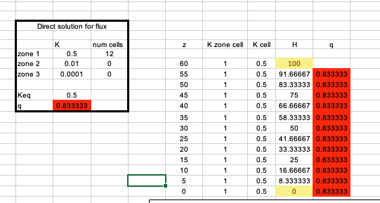

1. Water flow in the column is being limited by the layer with small K which contains smaller pore sizes which limits water flow. Energy is related to the square of the gradient and because of this relationship this means that the energy loss is squared. This mathematical relationship means that the limiting K layer has a huge amount of energy lost because energy loss is a squared term. Due to this relationship between energy loss and hydraulic conductivity the Keq will always be closer to the layer in which the most energy is lost which is the layer with the lowest K value.

