Matthew Ford

Assignment 11

There were 190 non-behavioral models

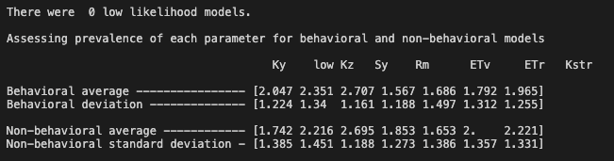

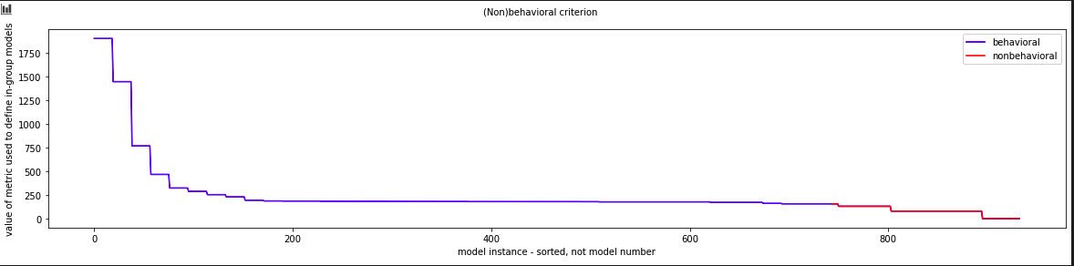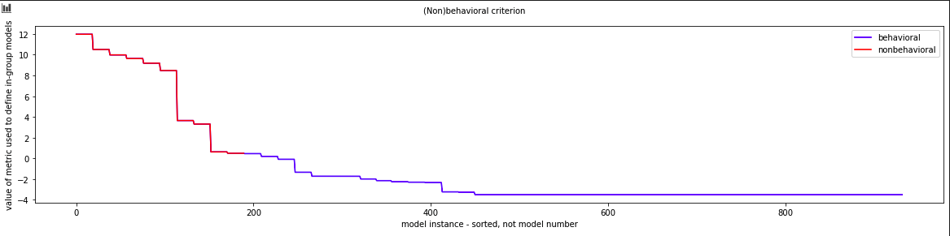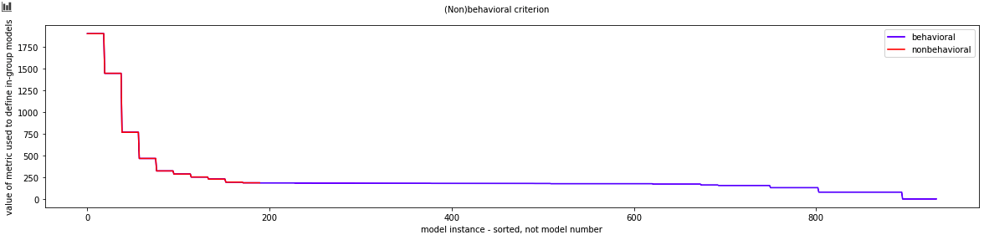

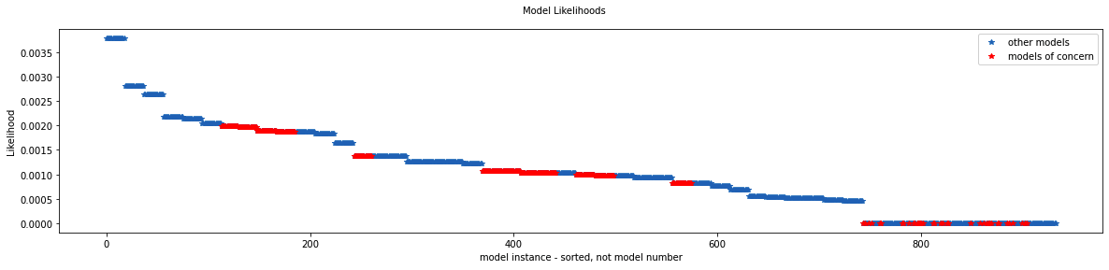

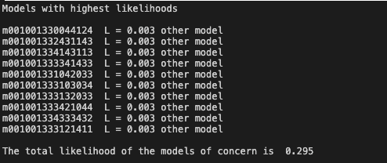

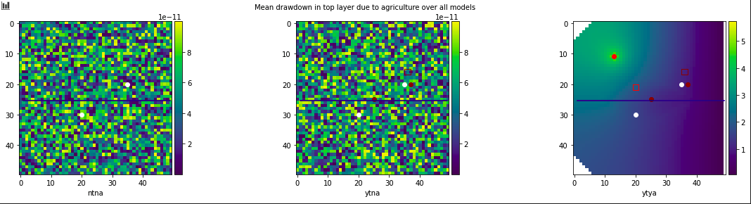

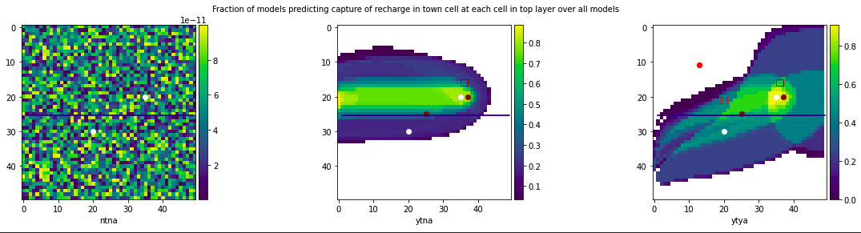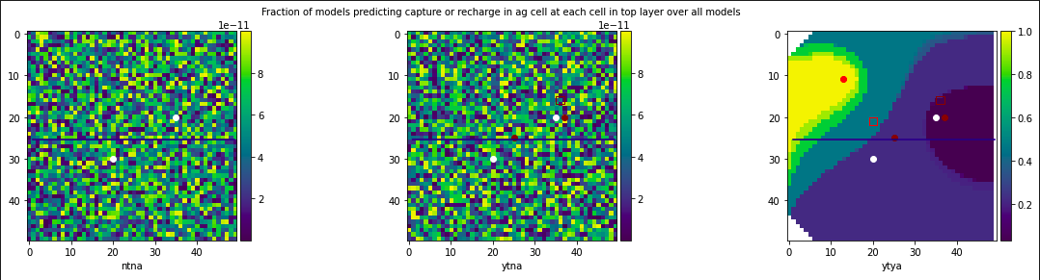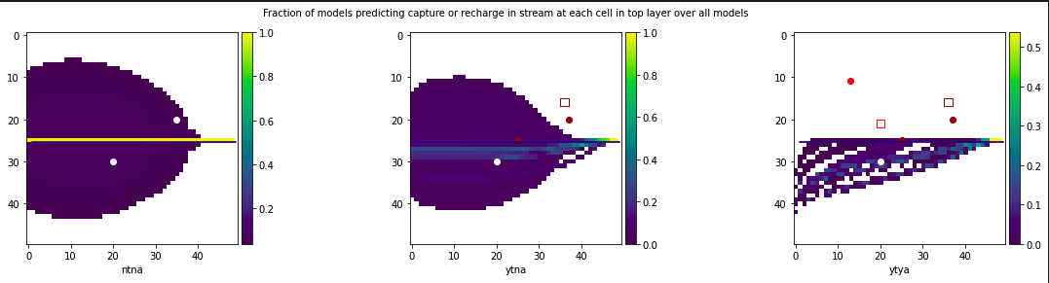

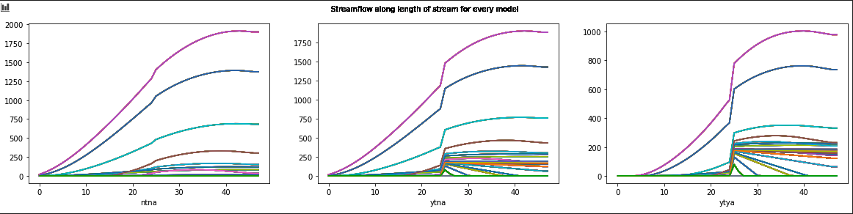

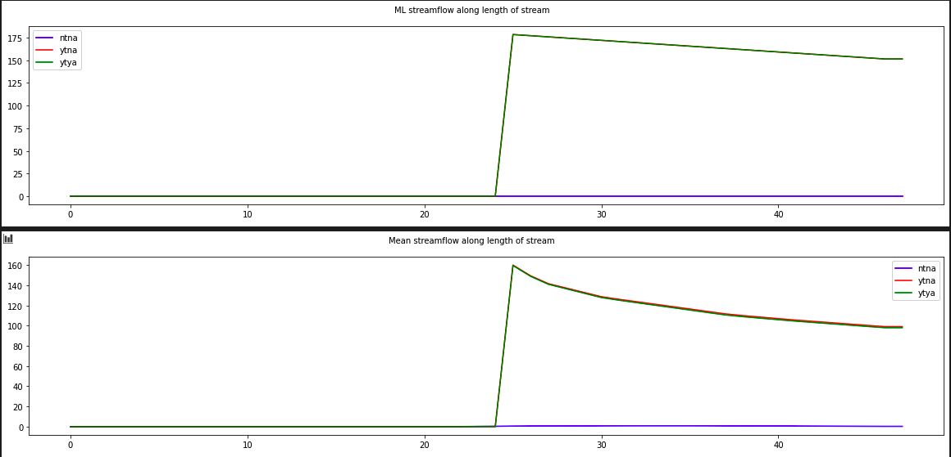

**After adding MOC-inspired models**

I generated 146 non-behavorial models.

0 low likelihood models.

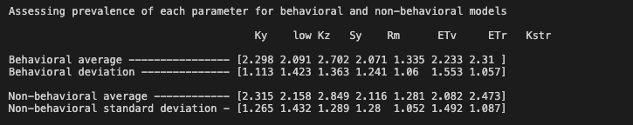

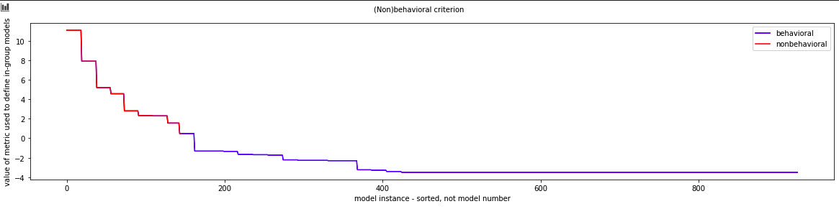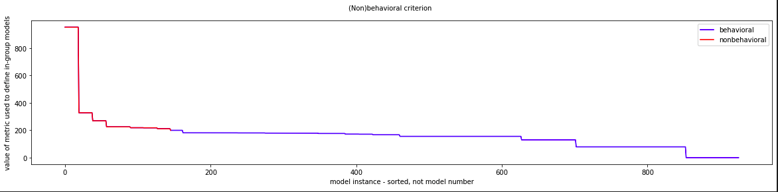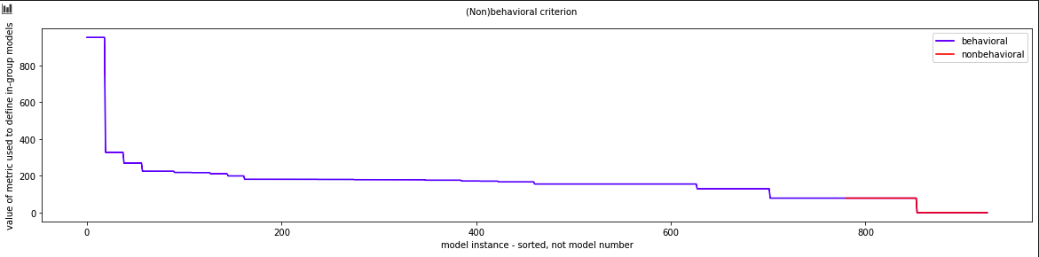

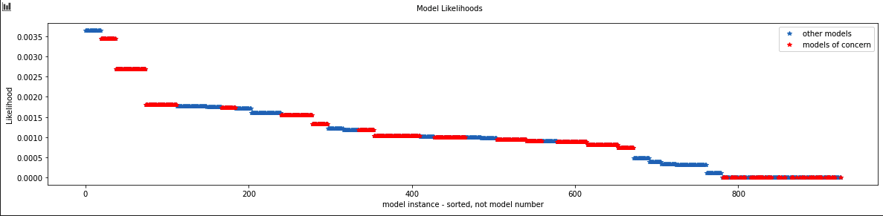

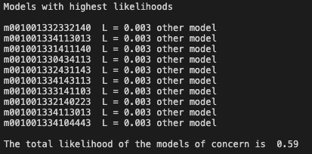

None of the highest likelihood models were MOC’s

