Matthew Ford

Assignment #11

Describe the scenario being modeled based on the fixed parameter values and the base model parameter values. Who is the stakeholder? What is their definition of an MOC? What are the selected 'design' options of the ag facility and the town (return flow fraction, location, field location, etc)? Essentially, paint a picture of what is being represented by the model.

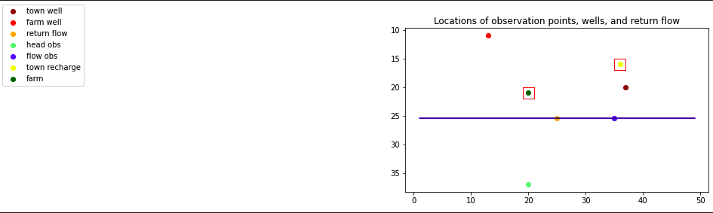

In my fixed parameter values I went with the default values. This means:

0= Steady State model

0= one particle per cell

1=pistachios

0=NW cell of the farm located at [20,19]

0=irrigation well located at [0,11,13]

1=70% of the towns water is recharged vs. returned to streamflow

3=column 25 for towns return flow to stream

3=Nw cell of recharge basin located [15,35]

2= kx=ky=kz = 10

2= ratio kz in low k layer to baseline k =1e-4

2=Sy=0.3

2=Recharge in mtns= 5e-5

2=Et in valley =1e-5

2=Et multiplier riparian vs valley = 3

2=ratio k streambed to k background=1

In this scenario there are 3 stakeholders. The agricultural stakeholder who is focused on the ag well. Then there is the town who is mainly focused on the town well but also has some interest in the return flow in the stream. Lastly, there is the environmental group who is focused on the return flow in the stream.

The scenario I am interested in is the environmental group as a stakeholder. The environmental groups defines an MOC as:

Time sequence has to be yes town and yes ag because both of those people affect the stream

Basis sequence streamflow at a specified location is important

Comparison sequence would be the minimum groundwater depth over the first layer

Limit sequence which defines the behavioral response in our case =50

Column sequence for basis 2 which is streamflow we are looking at column 38

Row sequence for basis 2 which stream we are looking at is row 25

**Original Runs**

Based on your initial random ensemble, what is the most likely additional drawdown at the town well due to pumping the ag well? How confident are you in that response - explain/defend your answer.

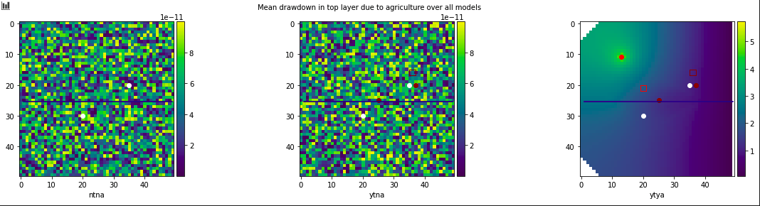Looking at the initial random ensemble we can see the town well is the rightmost red dot in the rightmost figure. We can see that the additional drawdown from ag pumping is minimal at the town well maybe only 1-1.5 units.

What is the likelihood that the reality (represented by the meager observed data) is best represented by an MOC?

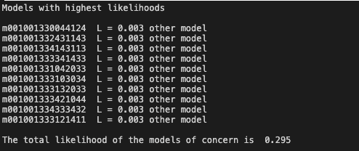

Models of concern represent 29.5% likelihood from the original run.

What is the most likely loss in streamflow at the outflow end of the domain? Justify your answer.

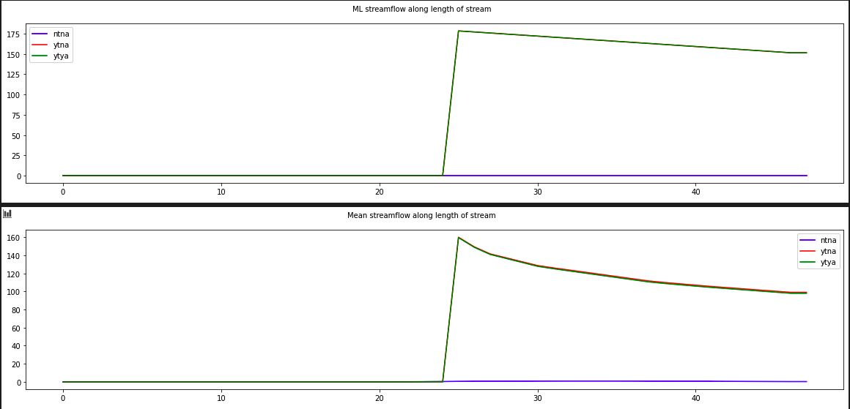

The most likely loss in streamflow is equal between the ag well and the town well. No differences.

Is it likely that either the town or ag well could be contaminated by the ag field? Justify your answer.

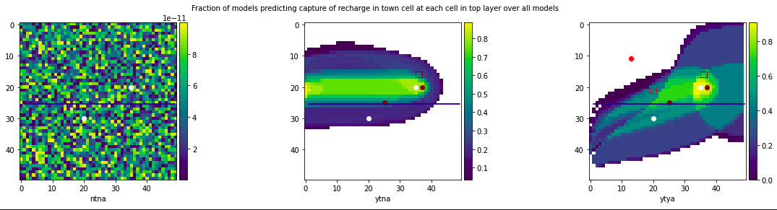

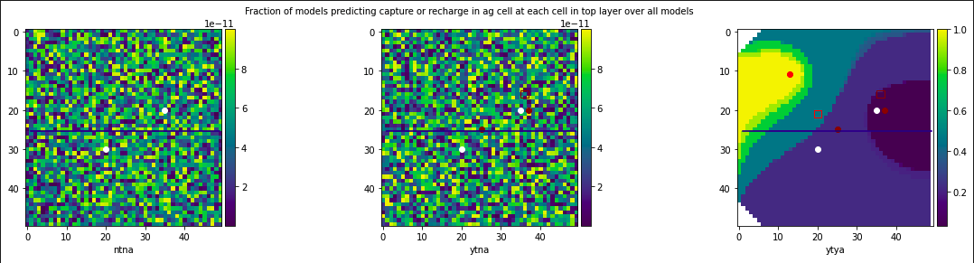

Looking at the top 3 figures, the most right hand figure shows that in the ytya scenario there is a 40% likelihood that the town well has capture from the ag field.

Looking at the bottom 3 figures, the most right figure shows that in ytya scenario there is also around a 45% likelihood that the ag well has capture from the ag field. It looks to be when zooming in on the images that the town well is a slightly lighter shade of teal.

Make a set of plots based on ensemble 2 and discuss how each of your answers to the first four questions changed due to adding the MOC-inspired parameter sets.

**Same questions After Running 2 MOC’s**

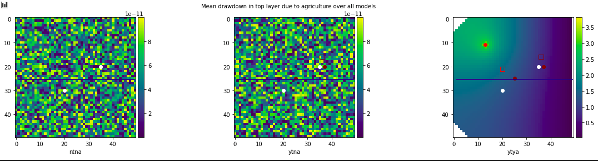Based on your 2 MOC ensemble, what is the most likely additional drawdown at the town well due to pumping the ag well? How confident are you in that response - explain/defend your answer.

Drawdown at the town well after adding the 2 MOC’s looks to be unchanged from the original ensemble runs at 1-1.5 units.

What is the likelihood that the reality (represented by the meager observed data) is best represented by an MOC?

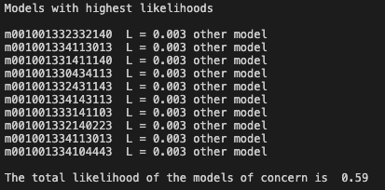

Models of concern represent 59% likelihood with the 2 MOC’s this is a 29.5% increase from the original model run.

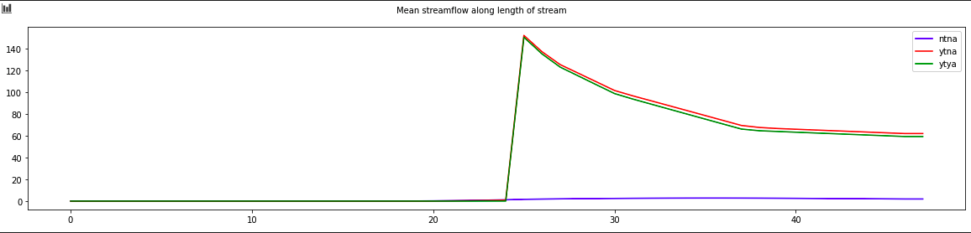What is the most likely loss in streamflow at the outflow end of the domain? Justify your answer.

We can see that the most likely loss in streamflow is the yes town and yes ag scenario (ytya). This mean that it is most likely that the agricultural well does have a greater effect on streamflow than the town well. The combination of both looks like it lowers streamflow by 5 units.

Is it likely that either the town or ag well could be contaminated by the ag field? Justify your answer.

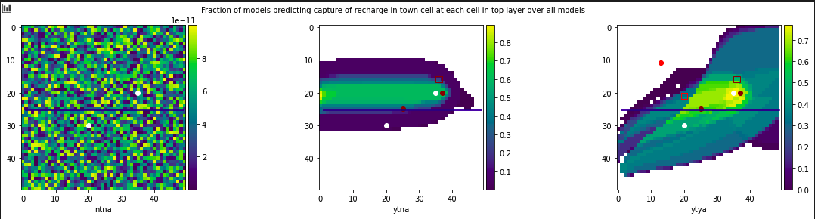

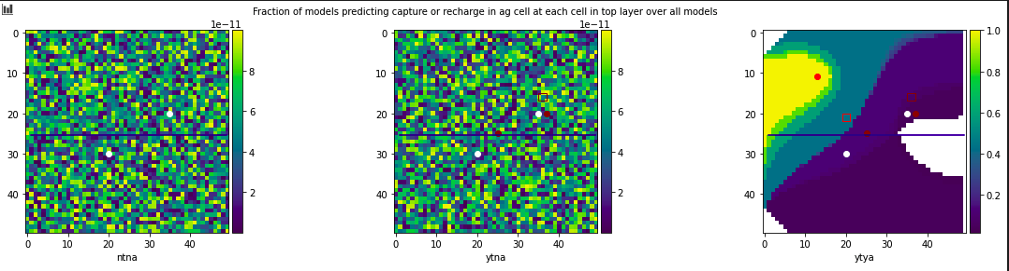

Likelihoods look most unchanged from the original scenario. It look to be 40-45% likely that the town or ag wells are contaminated by the ag field.

**Something additional that I thought was interesting**

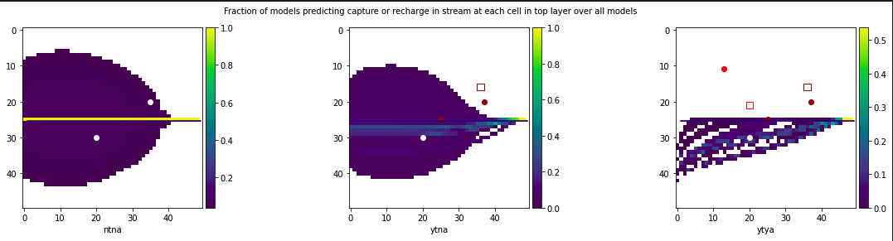

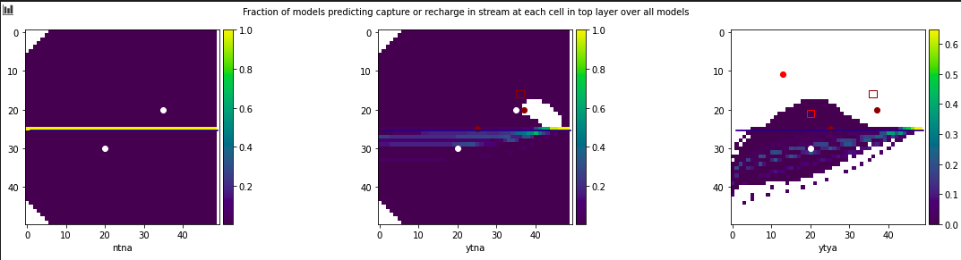

Looking at capture in the stream we can see some differences between the original run and the 2 MOC run. In the original run we can see in the ytya scenario there was 0% likelihood that the stream would capture any particles from the ag field. In the 2 MOC run we can now see there is a small likelihood between 0-10% that the stream could capture particles from the ag field. This could be problematic for the environmental stakeholder.