Matthew Ford

GW Model

Assignment 2 “The Challenge”

1. **Show based on flux vs. distance that the model is steady state.**

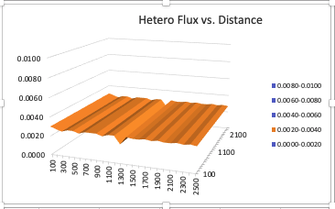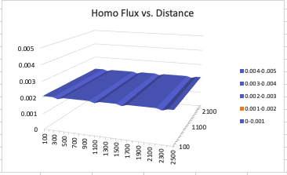As we can see from the figures below that the flux vs. x,y distance are both flat planes. This means that the system is steady state because the flux is constant throughout. (Note: the planes are not quite perfectly flat due to excel rounding). We can see that all the Q or flux values are the same and that we are going out to the 4th decimal place with change.

$$Q=-k×\frac{dH}{dL}$$

1. 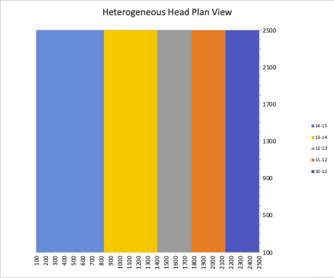**Show the steady state head contour in plan view for heterogeneous. Why is flow 1D? Why is Keq closer to the lower of the two K values?**Flow is 1D because we can see that the colors on this graph represent difference in head values. Pick any value on the x-axis which would represent a distance horizontally in the tube. Pretend you are standing at the bottom of the tube looking up throughout the whole 2500 m of the tube. The head would be the same at every point above you vertically meaning no water flow in this direction because change in head drives flow. On the other hand when standing at a vertical point on the column and looking horizontally we can see there will be a head change throughout the whole 2500 m of the column. We know that change in head drives flow and therefore water would only move in the horizontal direction. Keq is closer to the lower of the two values because Keq is controlled by the layer where more energy is used by the fluid to pass through that layer. The layer will the smaller K would be harder to pass through and therefore more energy is needed to pass through it. Mathematically the relationship between change in head and K is quadratic meaning that the amount of energy needed to pass through the lower K layer is significantly higher than the original K layer.
2. **What can you learn based on your explanation of what controls the effective K for a 1D flow system now that you are applying it to a 2D system? What do you think the Keq of this entire system would be compared to the high and low K values? Explain why it is much more difficult to develop a direct solution for this 2D system than it was for a 1D system (including the zones placed in series).**We have learned in a system with 2 or more K values that the Keq of the system is dominated by the lower K value. In this system the lower K value is a select set of boxes in the middle of the domain. Flow will take the path of least resistance. Therefore in this example water can flow both horizontally and vertically around the area with the lower K value, meaning the flow doesn’t have to do extra work. Therefore I think that the lower K value will have a much smaller effect on the Keq versus the 1D example. Understanding all the different paths water has to flow in a 2D example is much more complex that a 1D example. For this reason it would be much harder to develop a direct solution for Keq for a 2D system rather than a 1D system.

