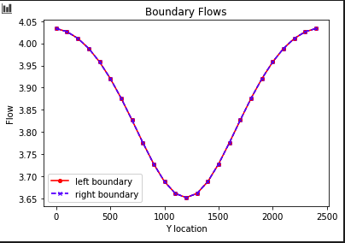Matthew Ford

GW Modeling

Assignment #3

**For the initial values of background and inclusion K, plot the flow into the left and out of the right boundary. (The code, as provided, makes this plot for you.)**

**Explain why the values are not constant along the boundary (relate to the definition of a Type I boundary).**  
Type 1 boundary conditions are specified head values. In specified head boundaries the head remains constant at both boundaries of the domain. You can see this as the LHS and RHS. The reason these values are not constant because as you venture towards the middle of the column with the inclusion zone the k changes. In a specified head boundary the model simulates fluid as moving in or out of the system at a rate sufficient to maintain the user input head value. In order to maintain that constant head the flow or q must change because k is also changing. This system could be modeled as only half of the system. Since this system is symmetric what happens in half of the domain happens in the other half of the domain. We could model this by putting a type 2 no flow boundary through the middle of the system. The importance of only having to model half of the system is that if less area is modeled we can increase model efficiency.

**Explain why the flow distributions are the same for the left and right boundaries.**  
Flow (Q) is equal at both boundaries because it has to satisfy Darcy’s law.

$Q=-K(\frac{dh}{dl})$

In this example:  
-K,dh,dl are all the same at both the left & right boundary because of the symmetric nature of this domain.   
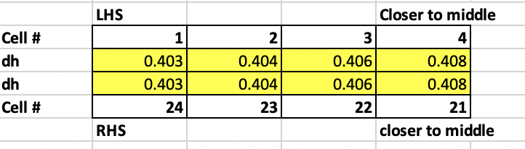

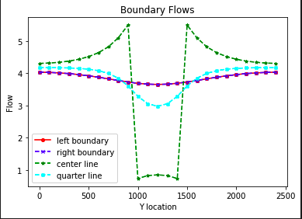**Add a plot of the left-to-right flow along a line that passes through the center of the inclusion. What can you learn from comparing this distribution to that seen on the boundaries?**  
If you are in the column and you leave the inclusion zone back into the higher K the flow jumps extremely rapidly in a short distance. This has to happen because the K is so low in this area that the flow (q) has to be higher in order to compensate for the low K and keep head constant. Q rises right before the inclusion zone because of the no flow boundaries at the sides of the domain. This mean that the flow is compressed and has to flow through a small area between the no flow boundary and the low K inclusion zone. There is a hump at the bottom of the Q for the center line because flow is diverted away from the middle. The flow really does not want to move along the centerline and the flow right around that center line increases as flow moves around the edge of the now flow zone.

**Calculate the total flow into (and out of) the domain.**This was calculated by summing all the flows along a flowline.

**Use this to calculate the Keq of the heterogeneous system with the K values as given in the starter code. Repeat this calculation for the following K values for the inclusion (keeping the background K as it is given): 0.01, 0.1, 1, 10, 100. $$K_{eq}=(\frac{Q}{A})(\frac{dL}{dH})$$**

Q=(see above)  
A=25x10=250  
dL=24  
dH=10

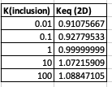

**Compare the Keq to the harmonic and arithmetic mean K values based on the area occupied by each medium (rather than the length for a 1D system). Can you draw any general conclusions about the impact of high or low K heterogeneities on the equivalent K for the flow system examined?**When K inclusion is <10 the Keq is better correlated with area weighted arithmetic mean versus when K inclusion >0.1 it is better correlated with the area weighted harmonic mean. It seems like when you have extremely high or low values the actual Keq values can vary significantly from their calculated values. The for low K inclusion the Keq isn’t greatly affected by this small area. This makes sense because of preferential flow the flow lines will bypass this area in which it is hard to travel. For low K inclusion values the real K of the system is badly represented by the harmonic mean. This is true because flow in real life can easily move around the low flow K inclusion zone. The problem with the harmonic mean is that is does not account for this ability for the water to “flow around”.

**Does the equipotential distribution depend on the absolute or relative K values for the background and the inclusion? How would you use the model to test your answer?**Equipotential distribution depends on the relative K values rather than the absolute values. The equipotential distribution shows the gradient of how the head changes. The gradient of how the head changes has to do with the K of different areas of the medium and how those K values compare to other K values in the medium. I would use my model to test my answer by running the model with a K background of 10000 and a K inclusion of K inclusion =0.0001. There we can see the extreme change of the equipotential lines around the limiting K inclusion layer. The next figure shows a homogeneous medium with K background equal to K inclusion. On this graph we can see evenly spaced equipotential lines. This shows that it doesn’t matter about the absolute K value but how K is relative to its neighbors.

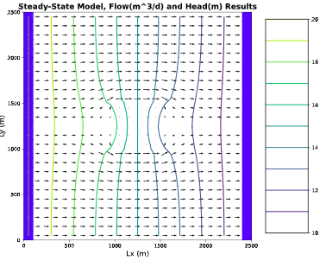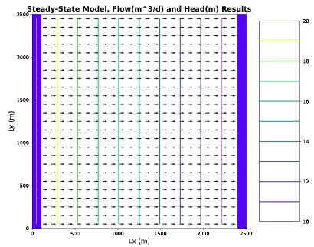

**Overall Take Away:**  
There is really no correct value of K. The K value that we calculate is really only calculating the K in the direction that we are calculating it in but flow is happening in all directions. This mean that the actual K value of the system is really unknown and when we think we have solved the K value we have really only solved the K value for one specific situation in the system as a whole. The overall takeaway is that a models best use is to help us understand the system and what is happening in the system rather than actually solve values for the system.