Matthew Ford

GW Modeling

Assignment #4

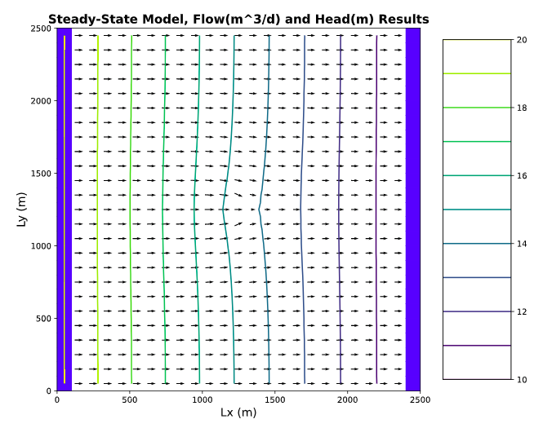**For the initial well location, plot the flow into the left (constant head = 20) and out of the right (constant head = 10) boundaries. (The code, as provided, makes this plot for you.) Explain why the values are not constant along the boundary (relate to the definition of a Type I boundary). Explain the shapes of the flow distributions and why they are not the same for the left (inflow) and right (outflow) boundaries.**

Type 1 boundary conditions are specified head values. In specified head boundaries the head remains constant at both boundaries of the domain. You can see this as the LHS and RHS. The reason these values are not constant because as you venture towards the middle of the column with the pumping well the head changes. In a specified head boundary the model simulates fluid as moving in or out of the system at a rate sufficient to maintain the user input head value. In order to maintain that constant head the flow or q must change because head is also changing.

**Add a series of the left-to-right flow along a line that passes through the center of the well [:,12]. How do you interpret the flow along this transect? Hint, also look at**

**the flow along a transect just upgradient from the well [:,11].**

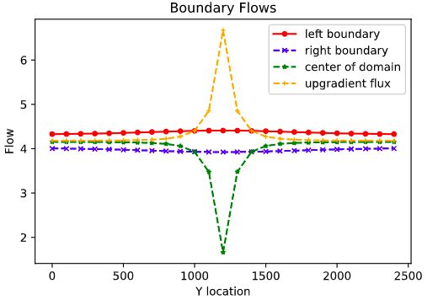I interpret the flow along the center transect that passes directly into the well as follows. As the flow goes into a well it is forced into a domain with a much smaller area. Basically it must go up the bore hole which is a much smaller domain than the groundwater aquifer. Therefore because there is a backup of water molecules trying to get from a big domain into a small domain flow must slow. The flow line just upgradient of the well we can see the opposite the flow line accelerates around the well. The reason this happens is because of the backup of water flowing into the well. Since flow is so low into the well the flow really does NOT want to flow along this flowline. Therefore the water wants to take the path of least resistance and therefore accelerates to flow around the well.

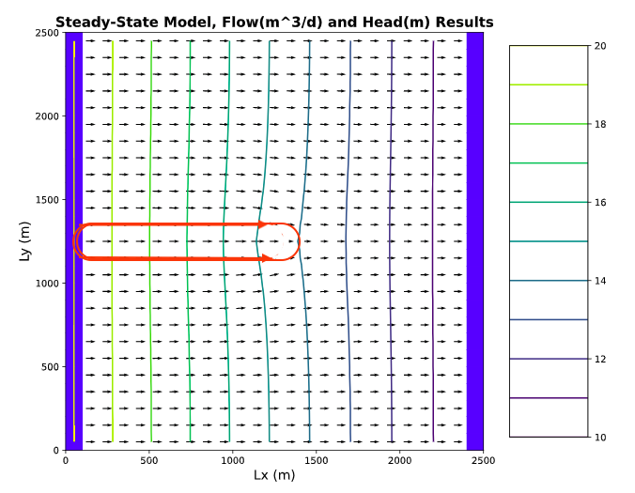**Then, look at the plot of equipotentials and flow vectors. Describe how water flows through the domain. To aid in your description, draw a line through all of the flow vectors that terminate in the well. This approximates the capture zone of the well. Use this to refine your description of the flow system, being as specific as possible about where water that ends up being extracted by the well originates on the inflow boundary.**

Everything inside the red oval would be approximately part of the capture zone of the well which is all the flow lines that terminate at the well. Since this is a steady state model NONE of the flow we are generating from pumping if coming from storage all the of the flow is coming from the boundary.

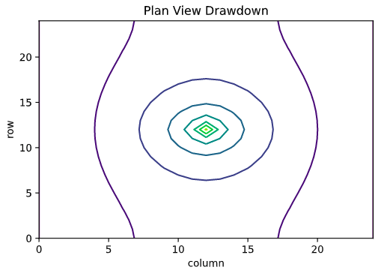**Then, look at the plan view drawdown plot. Why aren't the drawdown contours circles? Either explain why this is correct, or fix the plot.**This is the correct plot for a plan view for drawdown. The drawdown contours are not circles because of the initial conditions and no flow boundaries. The initial conditions are constant head and therefore water must flow from higher head to lower head and therefore perpendicular to the flow contours on this image. If contours were circular that would mean that flow is moving perpendicular to those flow lines and “north to south or vice versa in this domain. This is not possible because of the head gradient and the fact that the boundaries of the column are no flow boundaries. If they were circular that would mean that flow would be able to break the no flow boundary and that is NOT POSSIBLE!

**Move the well to [0,5,5]. Use all plots necessary to describe fully how water is flowing through the domain with the well in this location. Be sure to include the drawdown plot in your discussion - compare this plot to the equipotentials and flow vectors. Something is not right about how the well location is shown. Fix it and explain what was wrong!!**

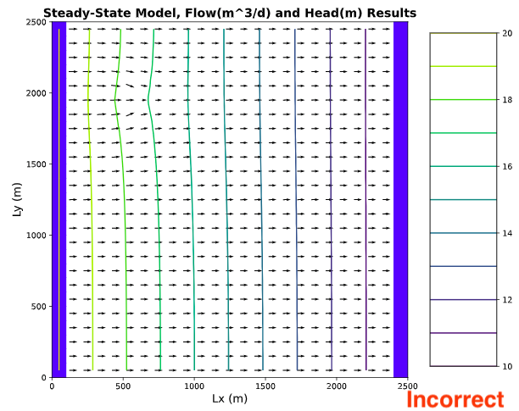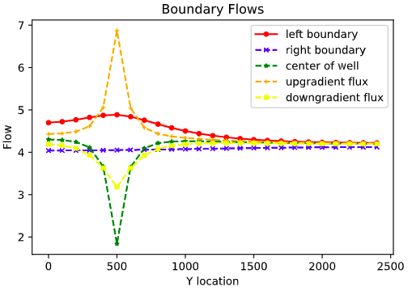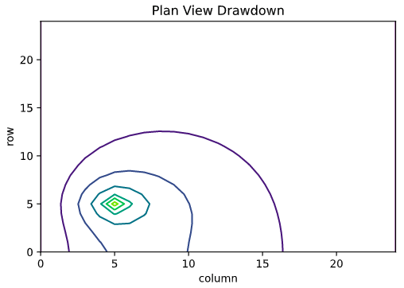When moving the well to [0,5,5] we can see that water flows somewhat similarly to what we saw when the well was in the middle of the column. Except this time flow along the left no flow boundary is somewhat affected. We can see that flowlines into the well still decrease significantly leading up to the well and flowlines just around the well accelerate around it. We can see when comparing the drawdown plot to the equipotential and flow vectors chart that something does not line up. We put out well at [0,5,5] this means row 5, column 5 but our flow vector graphing it showing a location of [0, 20,5]. The reason for this plotting error is because the code for MODFLOW counts rows and column differently than Python does. One counts bottom to top versus top to bottom. To get the correct contour plot for the well location of [0,5,5] you have to use [0,20,5]. This states that you are 20 rows down and 5 columns over versus before we thought we were only 5 rows down and 5 columns over.

