Matthew Ford

Assignment 5 (Recharge Me)

GW Model

**For the initial boundary head values and pumping and recharge rates, compare the head versus x distance - along a transect from the middle of one constant head boundary to the other - to the results for the BoxModel. Now reduce the boundary heads to 15 and 5. Compare this result and explain any observed differences. The overall gradient is the same, as is the K of the medium ... is the flow the same for both boundary conditions? Why or why not?  
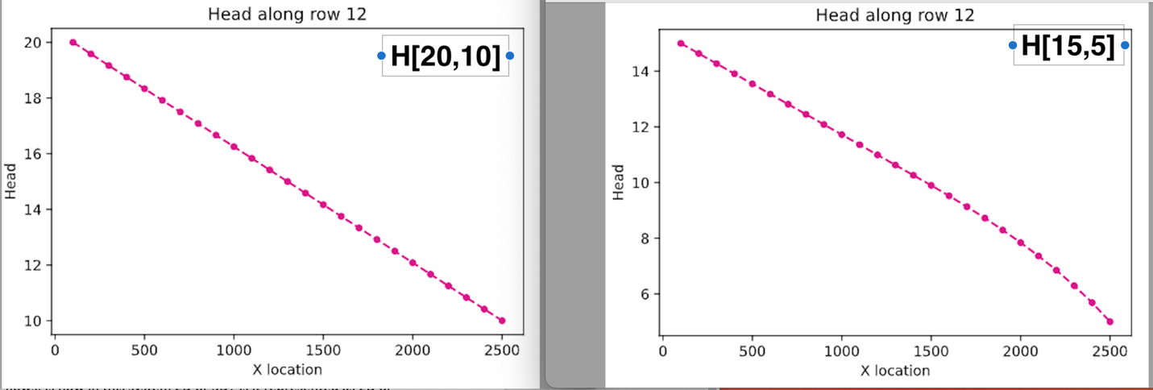**

We can see the difference when changing the head to 15,5 the behavior seems to become nonlinear in the second half of the cross section. This is true because the domain is 10m thick and the head is only 5m at the RHS we have a section of the domain that is unsaturated. It is much harder for water to flow through unsaturated medium than saturated medium you can think of the different like lowering the hydraulic conductivity. For the figure on the right the gradient towards the right half of the domain has to be steeper to account for the same flow. Since K has effectively been reduced by dewatering the domain the head gradient has to steepen in order to let the same flow through the domain.

**Now add recharge at a constant rate of 1e-4 m/day over the entire top boundary. Explain the head transect and boundary flows. Is flow in this system 2D or 3D? Is it represented as 2D or 3D? Explain what you mean by your answers.  
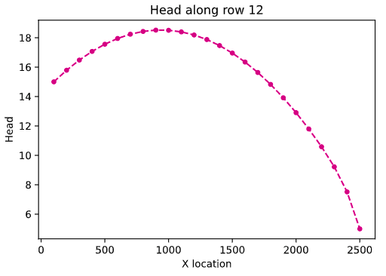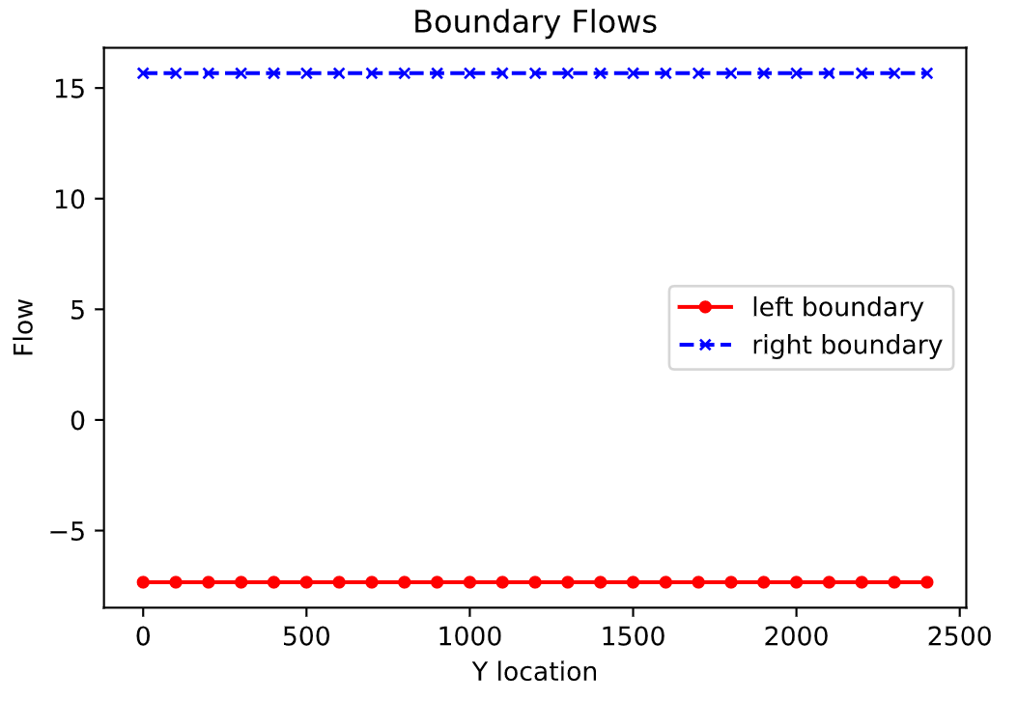**In the head transect we can see some very interesting things when adding uniform recharge over the top boundary. The shape of the head versus x-location looks like it does because the transmissivity of the domain decreases as we move away from the center of the domain. We can see that we created a groundwater divide and actually reversed the gradient of the domain. We made a groundwater mound in the middle of the domain which reversed the direction water flows through part of the domain. We can see that around 1000 m into the domain is the crested or maximum head in the domain. Remember water flows from higher to lower heads. We can see that now if put a molecule just to the right of that groundwater divide it flows to the right boundary but if you put a water molecule to the left of the groundwater divide it flows back to the left boundary. This can also been seen in the boundary flows graph below. The flow through the LHS is a negative value. This does not mean that there is negative flow the negative sign represents the direction of flow. You can also see that we didn’t dewater the domain till about 2250 m. The gradient is so steep in the right hand section of the groundwater divide because now our flow out of the domain is greater than our inflow into the domain. The flow in the system is still represented as 2D because the recharge in our system is a uniform distribution.

**Now model a system with zero recharge except for a farm located in [6:10, 6:10] - in python terms. Recharge beneath the farm is 1e-4 m/day due to excess irrigation. First, calculate the annual excess irrigation, in meters, that has been applied to the farm. Second, assuming that the crop is cotton, it is located in southern Arizona, and cotton is grown all year (for simplicity), calculate the total irrigation rate on the farm that would be associated with this amount of excess irrigation. Finally, identify the area within the domain that might be subject to contamination if the recharge water was somehow tainted.**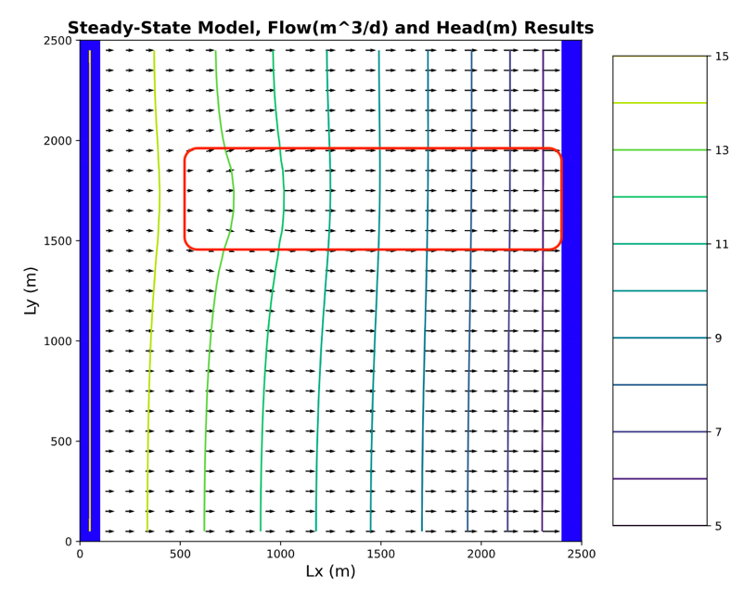Calculate excess irrigation:Domain = 4 cells x 4 cells = 16 cells x 100 x long x 100 m wide = 160,000 m^2  
160,000 m^2 * 1e-4 m/day * 365 days = 5840 m^3/yr  
5840 m^3/year / 160,000m^2=0.0365m/year

Calculate total irrigation:  
Cotton water requirement in southern AZ= 5 ft/ year = 1.5 m/yr / 365 days = 0.0041 m/day  
Total irrigation rate on farm: 1e-4 m/day + 0.004 m/day = 0.0041 m/day  
0.0041 m/day is what the irrigation rate would have to be for the cotton on the farm to get that excess irrigation rate.

SOURCE: (<https://www.pimafoodalliance.org/696/#:~:text=Over%20the%20course%20of%20a,water%20for%20cotton%20per%20year>.)

**Lastly, start the well pumping at a rate of 8 m3/day. Using one color, identify the capture zone of the well. Using a second color, show the area that might be contaminated by the irrigated farm fields. Comment on the impact of the well on the pattern of potential contamination.**  
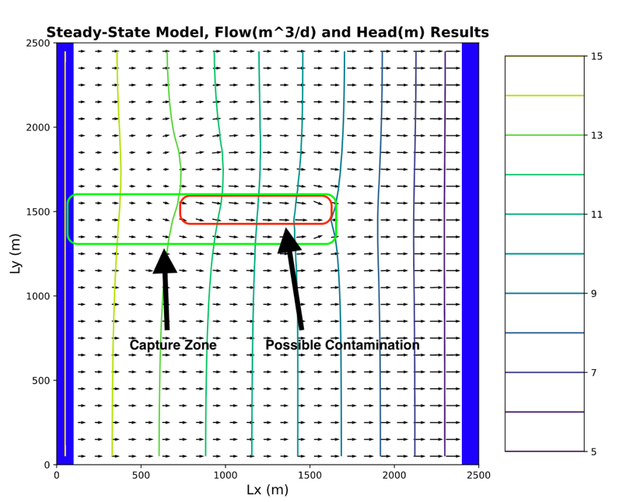

Part of the contamination zone is also included in the well capture zone. This means at a recharge rate of 1e-4 m/day and a pumping rate of 8 m/day the contamination would travel from the recharge area and be captured in the well. If you were to change the recharge rate or change the pumping rate then this statement may change. Also this is a steady state model where none of the background conditions are changing. If you changed other conditions such as hydraulic conductivity or transmissivity or the recharge was transient and changed over time the contamination may not be part of the well capture zone. Overall there are so many factors that influence the well capture zone even in this simple model. It is daunting to think about how hard it is to predict contaminant capture in a real life groundwater system.