Matthew Ford

GW Modeling

Assignment #6

**For the initial boundary head values and recharge and ET rates, establish the flow versus x-distance along the left (15 m) and right (5 m) boundaries. Plot the equipotentials and flow vectors in plan view and outline (hand draw) the area that would be affected by recharge (i.e. if it were contaminated). Also show a contour plot of the steady state ET flux in plan view.**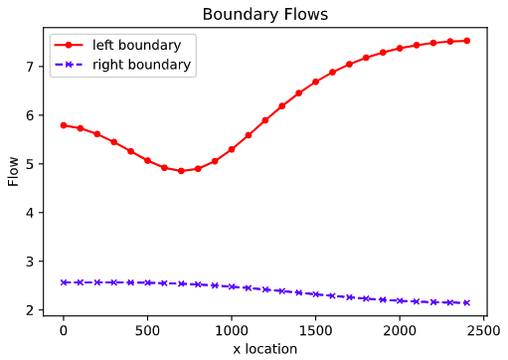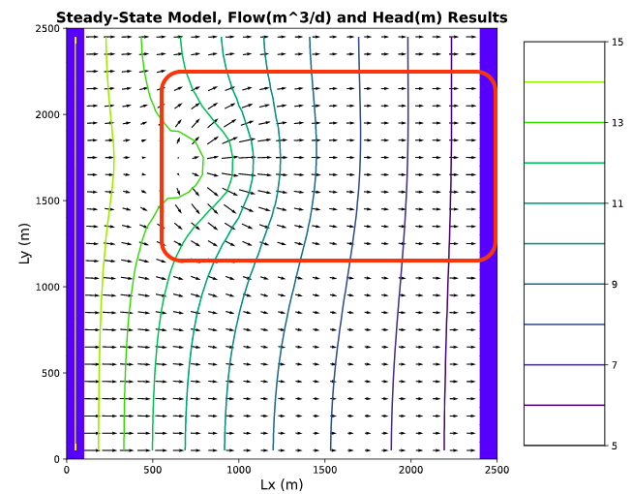

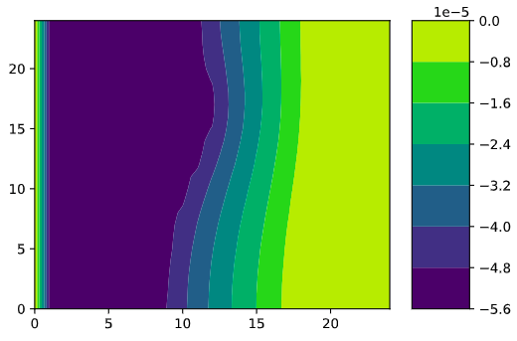

**Change the extinction depth. What impacts does this have?**The extinction depth is a set depth in the model which ET stops at, meaning no ET occurs below this point. This is equivalent to a point in a groundwater system that would be too deep in the system for ET to below. In order to represent ET our model uses a linear interpolation for the section in-between the land surface and the extinction depth. When we change the extinction depth we can see that the deeper we set our extinction depth more ET occurs. This logically makes sense because there is a thicker domain for ET to occur over. We prove this using our ET Flux graphs. An extinction depth of 1 shows much smaller ET Flux values than an extinction depth of 10.

E=1 E=10  
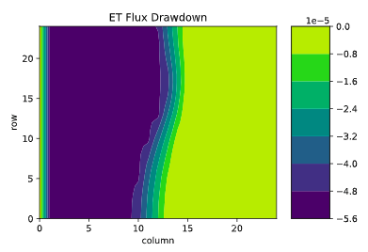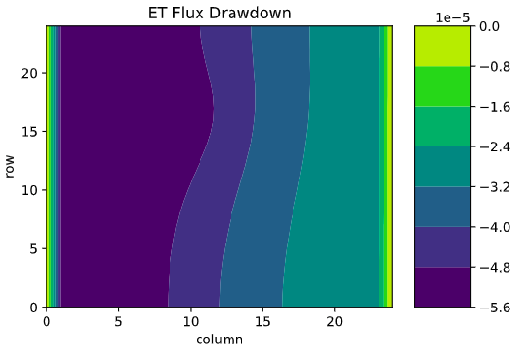

**Explain, conceptually, how MODFLOW is representing ET. How does this compare to your intuitive understanding of ET in the real world?**MODFLOW models evaporation by subtracting the value out of the recharge that goes into the cells. This in turn really just makes the recharge, which just appears in the cell, value smaller. MODFLOW models transpiration a little differently, it models it by using tap roots that descent into the water table and subtract water. The way MODFLOW models ET is not very realistic but the way ET works in the real world is complex and would be very challenging and computationally heavy and therefore it is simplified to the methods listed above. My understanding of evaporation in the real world is that temperature, wind, vapor pressure, and initial saturation are the main factors that affect evaporation. Evaporation is when a liquid such as water changes state into a gas. This usually occurs during the runoff process and when water is contained in soil pores in the vadose zone close to the surface. Once pore water has descended below a certain depth it is not susceptible to evaporation. Transpiration on the other hand is modeled a little better. Transpiration in the real world is when plants release water vapor as a byproduct of photosynthesis. In shallow groundwater system some tap roots may actually reach the water table but in the arid desert southwest this most likely isn’t happening. Therefore MODFLOWS interpretation of tap roots entering the water table maybe realistic for shallow groundwater systems but not as accurate in a groundwater system lets say locally here in Tucson. Here in the desert southwest a tap root would intercept the water in the vadose zone before it was able to reach the groundwater table.

**d. Now start the well pumping, extracting 20 m3/day. How does the well change the zone that is affected by the recharge area? How does it affect the ET map? Write a mass balance for the well - how much water is coming from a boundary? How much is originating as recharge? How do you account for the impact of ET on this mass balance? At steady state, what are the effects of 'capture' by the well?  
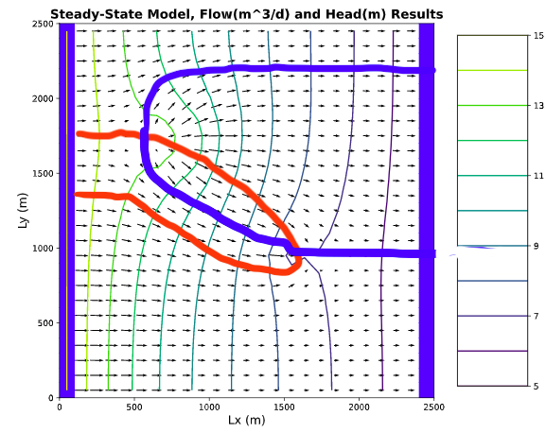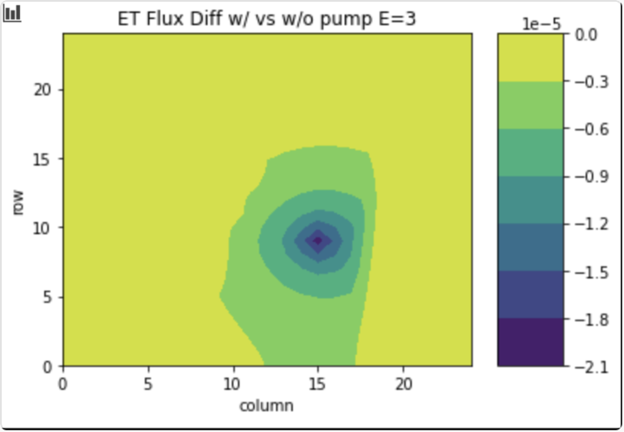**

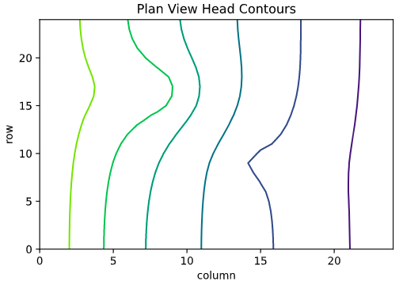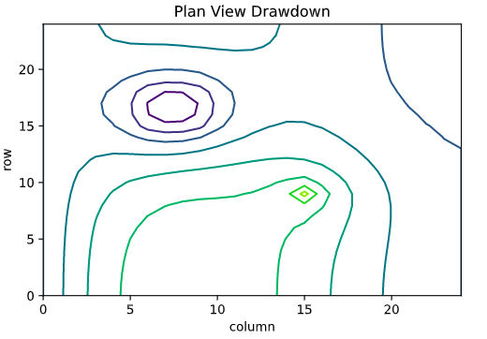

The well significantly tightens up the head gradient which increases the velocity of flow towards the well. As seen on the flow vectors graph we can see that a portion of that recharge flow that was directed towards the right boundary is now channeled towards the well. A lot of the recharge still goes to the right boundary but a portion of it travels towards the well. On the graph above we can see how the well affects the ET map, we can see how the pumping well reduces ET. We can think about the effects of well “capture” by thinking the well is “stealing” water that the plants will use for photosynthesis that will turn into ET. A real life example of this is thinking of the vegetation decrease around the Santa Cruz river since groundwater pumps have been invented and widely used. This could also be related to the gw pumps affecting the connected flow between the river and the gw table but they are all interconnected.

Well Mass Balance

$$Q_{well}=Q_{left boundary}+Q_{recharge}-Q_{ET}$$

Q(ET) = 9 m^3/d (summed using difference in ET well vs without well in python)  
Lets see if we can duplicate that value roughly:

$$Q_{ET}=\left(Flow\right)*\left(Area\right)$$

10 m^3/d = (1e^-5)*(1000*1000)  
We can see this estimate is close. My area was the main estimate which is probably the discrepancy in the calculation.

$$Q_{Recharge}=\left(Flow\right)*(Area)$$

20 m^3/d = (1e^-4)*(400*400)*(0.25)  
We can see an estimate of the recharge to the well is about 20 m^3/d seeing as the total recharge is around 80 m^3/d and about ¼ of that area is in the capture zone of the well.

$$Q_{well}=Q_{left boundary}+Q_{recharge}-Q_{ET}$$

20 = Q(Left Boundary) + 20 - 9  
Q Left Boundary= 9 m^3/d

I accounted for this ET on the mass balance by completing a model run with and without a pumping well. I took the difference in ET values between the model with no pumping versus pumping to see how much affect ET was having on this system. This came out to 9 m^3/d. I thought to check my work by looking at the whole domain which was part of the capture zone of the well. I estimated this area and then multiplied it by ET rate and got 10 m^3/d which is very close to the model calculated value.