Matthew Ford  
GW Modeling  
Assignment 7: Transient  
  
**a) The gradient is not uniform for the initial steady state conditions - discuss the influences of recharge and the unconfined condition on this nonlinearity**

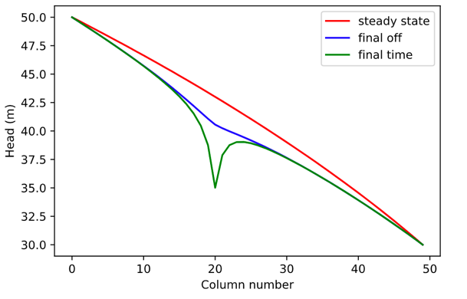

As seen from the figure above we can see the steady state (red) line is not uniform and it is also non-linear. The reason for this is the recharge zone in this domain. Again recharge is 5e-4 m/day in a square from cells 10-20 both horizontally and vertically in the center of the domain. We can see a bow up in the steady state condition in the center of the domain showing the recharge water is raising heads in that location. The unconfined condition also plays a role in this that MODFLOW models unsaturated conditions by essentially lowering the hydraulic conductivity in those cells making it harder for water to flow. The head has to change in order to account for the same amount of flow through the domain but still having it be “harder” for it to flow. Remember we have to keep the amount of flow the same through the domain but we have to change head to adjust velocity and energy expended.

MODFLOW doesn’t really modeling unconfined by lowering the hydraulic conductivity. MODFLOW models unconfined conditions by changing the saturated thickness in each cell. When the saturated thickness is lowered the transmissivity is lowered which means it takes more energy for water to move through creating the non-linearity.

**b) Determine if the system has reached steady state - consider a point at the well and another at the center of the domain.**

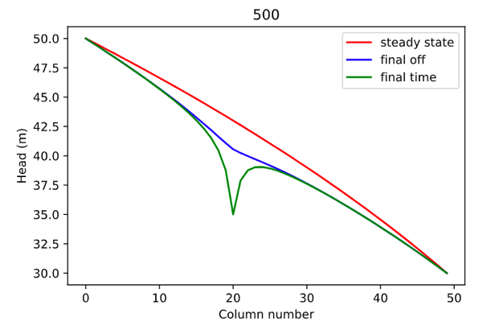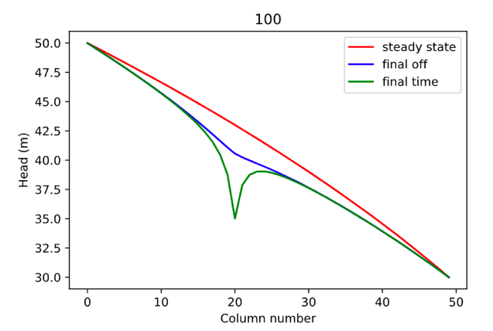

We can see from the 2 figures that at 100 years the system has reached a steady state. I ran the simulation for 100 & 500 years. We can see that the head graphs are identical. This means that the heads do not change after 100 years and the system is constant over time.

**c) Find the zone of influence of the well defined in two ways: - Based on the drawdown from the initial steady state to the end of simulation time (end of final no-pumping stress period). - Based on the drawdown from the end of the last pump-on stress period to the end of simulation time.**

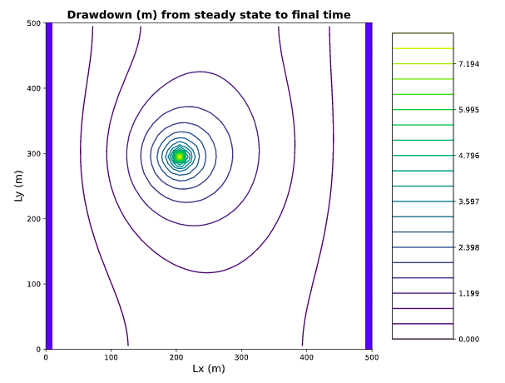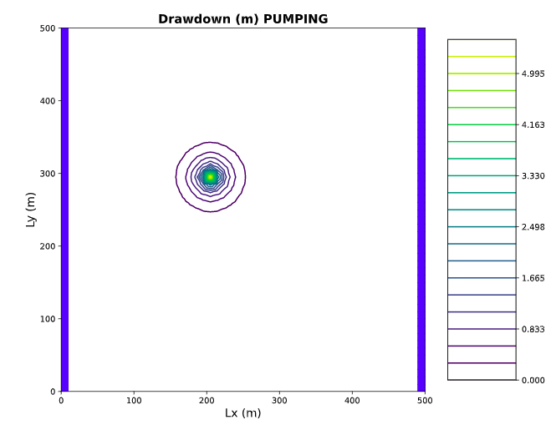

We can see that the drawdown on the left image is for the whole period. We can see that drawdown across the whole 100 years affects the whole domain. The graph on the right shows more of the cyclical steady state and everything outside this circle is steady state. This circle is very small in size because the pump is taking and adding water to storage every pumping cycle. First the water is pulled from storage and then the water that is taken from storage is replaced by water from the left boundary. We can see the difference between the two images shows that the capture zone extends with time. The figure on the left is the whole 100 years and the figure on the right is just end of the pumping period. In the image on the right we can see everything outside the circle could be considered steady state which could simplify modeling our domain. This is important because a water particle doesn’t know it is in a transient solution until it reaches inside the circle. A water particle inside the capture zone travels from the boundary towards the well at a constant rate and then moves with a lurching forward and backward motion once it enters the drawdown circle depending on if the pump is turned on or off.

**d) How long does it take a point at the center of the domain to reach steady state. At that point, explain how you could divide the domain into a steady and transient part and solve each separately.**

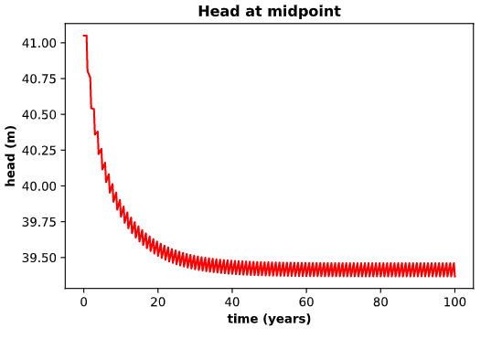

It looks as if it takes around 43 years to reach steady state. I could divide the beginning of the simulation 0-43 years into a transient solution for modeling, and then divide the remaining 43-100 years as a steady state solution. Since steady state is much easier to model this would significantly reduce computation power.

When looking at the head at midpoint and at well graphs lower down in this document we can see that the head at the well looks like it reached steady state around 40 years and when looking at the midpoint it looks like it reaches steady state around 60 years. This is slightly visually deceiving and would be better to run actual analytics because the model reaches steady state quicker the further you travel away from the well since the well is the thing that is changing in the domain cyclically.

**e) Find a constant pumping rate (same throughout the year) that matches the head time series at the middle of the domain.**

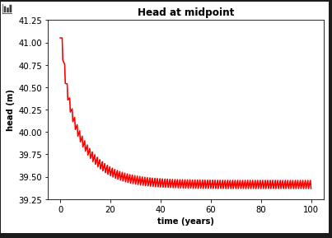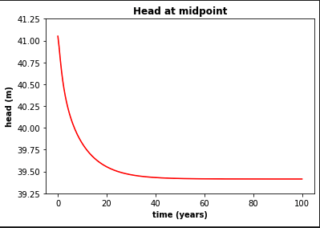

A pumping rate of 250 m^3/day seems to be the best matching constant rate.

**f) Find a constant pumping rate (same throughout the year) that matches the head time series at the well, leaving only a regular, repeating seasonal residual. Are the two pumping rates the same?**

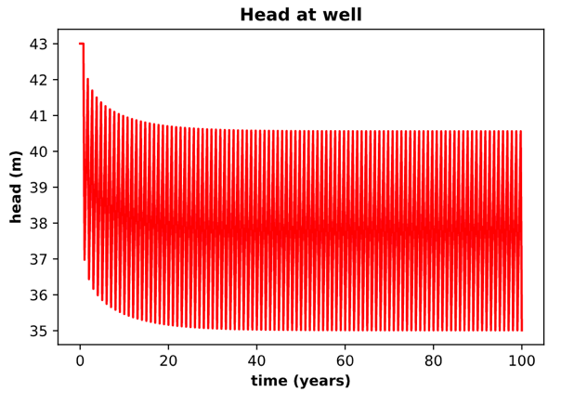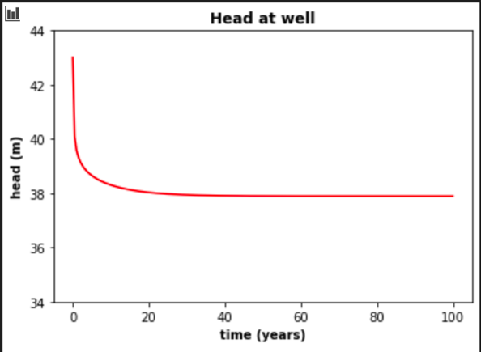

The average for the 90 days pumping 270 days no pumping seems to be a head of around 38 meters. When running the pump at a constant rate of 250 m^3/day we can see it reaches the steady state solution of 38 meters. The constant pumping rates would be the same at 250 m^3/day for the midpoint and at the well. They are both the same pumping rates because the wells close proximity to the midpoint of the domain.

If the other sample point was further away from the well the pumping rates would be different. Since the further away from the well goes to steady state quicker a smaller constant pumping rate should satisfy the head the further you go from the well.

**g) Discuss the sources of water captured by this well. If you're up for a challenge, calculate them for the final pump-on period!**

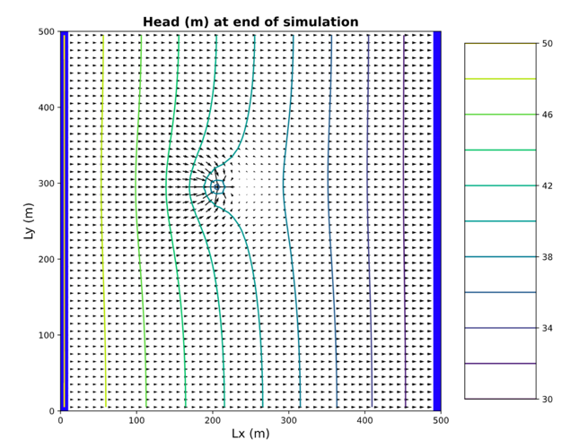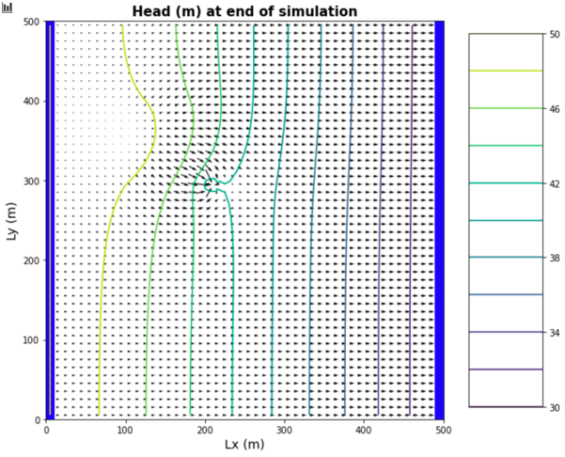

One of the sources of the well is water across the left boundary. This can be seen at the end of the simulation on the figure above. One of the other sources of water for the well includes the recharge area. The recharge area is from cells 10-20 in the center of the domain. This can be seen very well when I increased the value of recharge to 5e-4 to 5e-2. We can see in the above right image that the well is capturing recharge. This is happening with the lower recharge rate of 5e-4 it is just much harder to see, but is much more visible with the higher rate.

The source of water as discussed above is from storage and that water is then replenished by water from the left boundary. Think of the liquor store vs. bottle distributor example.

**h) Discuss how you would define the capture zone of the well. How is it different than our definitions of capture zone so far in the course?**

The capture zone of the well would change throughout time during the simulation since this is a transient solution versus what we have previously done which is a steady state. Our definition of capture zones in the past in this class have been you have been able to draw it on a graph and it would stay constant throughout time because it was a steady state solution. This time depending on if it’s a period of pumping or recovery the capture zone of the well would change this would be very challenging to draw on one single graph. We would need a time series of flow throughout the domain overtime and at each time step we could then draw the zone of capture and then watch it change throughout the time series. What also we could do would be to divide the domain into a steady state period and a transient solution. We would only have 1 capture zone for the steady state solution and the capture zone would change for the transient part. This would make our model solution more simple because we would have a shorter portion of transient solution to solve for which would make it easier.