Matthew Ford

Stream Assignment  
  
**a) Use these figures to describe the nature (direction/magnitude) of stream/aquifer exchange along the stream. In particular, explain why the leakage changes magnitude or direction where these values change.**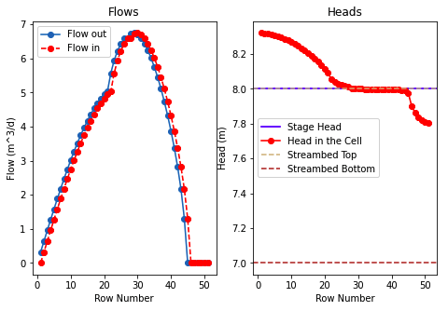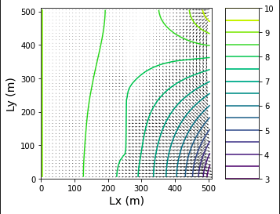

Flows figure: We can see that as we move from the top of our domain which is row 0 to the bottom row 50. We see the flow at the top of the river is near 0 and then velocity starts increasing as we move down the river into the middle of the domain. The middle of the domain is where the maximum flow occurs and then flow starts to slow down as we continue down the river from the middle of the domain to the bottom.  
Heads Figure: The stage head is set constant at 8 in the model and the streambed top and bottom is held constant. We also want to remember that recharge happens over the top 26 cells in the domain hence why heads are above the stage height. As water travels down the stream infiltration rate increases. This is important because at the top of the stream the stream is gaining water from the groundwater system. In the middle of the domain head is equal with stage meaning the stream is neither gaining or losing just flowing downstream. Downstream of there the head is lower than stage height which means that the river is losing water to ground around it and subsequently flowing to the RHS of the domain.  
Head Contours: As talked about in the last 2 figures this figure also makes sense. Head contours are spaced very far out at the top of the domain where the river starts which suggests low flow velocity which can be confirmed from the domain. Also this is the area with the highest head which makes sense since the recharge happens here. As water travels downstream more and more water is infiltrating meaning towards the bottom of the domain we have a surplus of groundwater in the system which must exit the domain and it goes towards the constant head boundary on the RHS and because there is that surplus of water velocity increases and you get the larger gradient at the bottom.

**b) Use the head distribution to describe the movement of water across the boundaries and into/out of the stream.**Water moves into the domain from the LHS VERY SLOWLY. In the top half of the domain the head in the cells is higher than the river stage head. This means water is flowing into the river. In the middle of the domain head in river and groundwater is equal so flow is traveling down the river. At the bottom of the domain head in river is higher so water is leaving the stream and out the RHS boundary. Water also moves into the domain from the top RHS because recharge is occurring in this area. The water then travels in a sort of circular motion towards the center of the domain where the stream is because it is “attracted” to the lower head boundaries. The reason for these lower head boundaries in the stream is k_strbott variable which is infiltration happening in the stream. Once the particles get far enough down the stream a lot have infiltrated and there is a surplus of water which must exit the domain and they can’t at the bottom of the domain because the stream abruptly ends at a now flow boundary. Therefore the particles must exit to the area of lowest head which is the bottom right corner represented by a lake and because of this surplus the gradient increases and velocities increase.

**c) Choose two things to explore (e.g. impact of streambed K or inflow into the river or recharge rate). Produce a plot for each to compare to the base plots and use the plots to explain the impact of the hydrologic change.**  
1. Added a farm that is irrigating crops, recharging the aquifer at a rate of 5e-2 rows 40-45 and columns 40-45. Will this farm recharge the groundwater enough to reverse the gradient and pollute the stream?  
Matt: Yes farm recharge will reverse the gradient meaning water will flow from the groundwater into the stream in the bottom most section. You can see this on the plan view head graph with the flow vectors pointing away from the farm. You can also see this on the heads graph where the head rises above the stream gage meaning it is a gaining stream in this section.

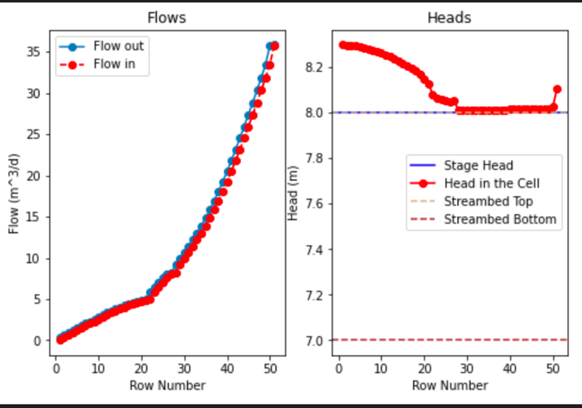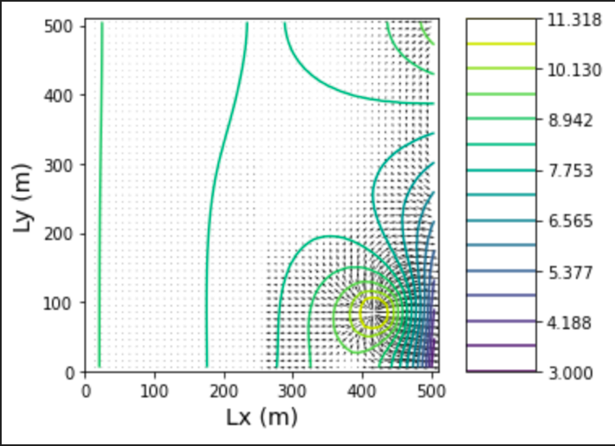

2. I added a pumping well at 45,30 with a pumping rate of 7 very close to the most downstream section of the river. This was to simulate a farm having a farm near a river where groundwater levels are usually shallow so pumping costs can be minimized. Will this well pull water from the stream?

Matt: Yes the well will pull water from the stream. We can see this after cell 30 the head drops dramatically. This means the well is pulling water from the stream and the stream is turning into a losing stream in this section. We can also see this on the flows vectors graph that there is flow leaving the stream and going into the well.

