Sierra Bettis

HWRS 482

February 10, 2021

The Challenge_Updated

1. Explain why the values are not constant along the boundary (relate to the definition of a Type I boundary). Explain the shapes of the flow distributions and why they are not the same for the left (inflow) and right (outflow) boundaries.

The values are not constant along the boundary because of Darcy’s law, which is Q=-K(dh/dl) and then rearranging the equation to find the dl and then solving for dh. When this equation is applied to the graph, you notice that the Q would have to change from a changing K value, so that is why the values are not constant along the boundary. The shapes of the flow distributions are not the same because the lines represent the flow around the well, which would be in the middle. The lines show a symmetrical pattern surrounding the well.

The left boundary shows the water that the well is drawing in, whereas the right boundary shows the response from the well as it is pulling the water, so this is why they are not the same. The area between the left and right boundary is the exact pumping rate because this is a steady state model.

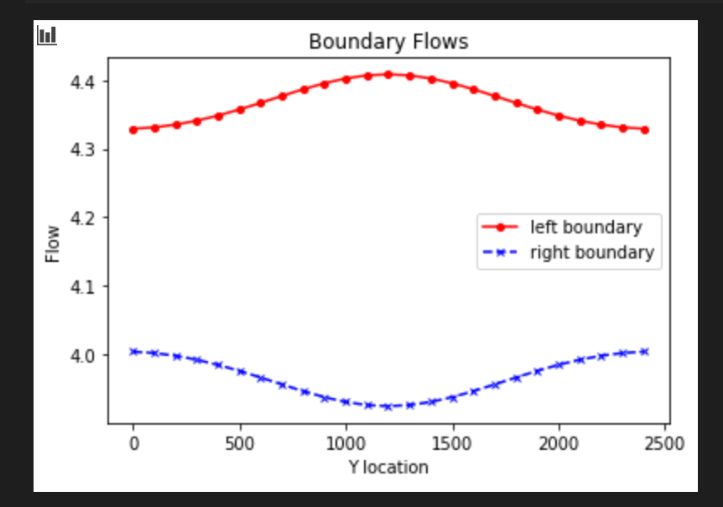

1. Add a series of the left-to-right flow along a line that passes through the center of the well [:,12]. How do you interpret the flow along this transect? Hint, also look at the flow along a transect just upgradient from the well [:,11].

The line that passes through the center represents the level of water in the well after pumping whereas the flow lines upgradient of the well shows the effect of the well on the areas close to it. These graphs are similar to the graphs from inclusion, where it spikes up or down in the middle of the graph. The graphs are opposites so there must be some symmetry component.

The flow along this transect indicates the lack of flow from the pumping of the well but it is not zero because there is still some flow from the left and right. If the flow were negative it would mean that there was a reverse gradient. The line upgradient of the well shows that the flow has not reversed gradient and shows that there would be more flow because everything is moving toward the well.

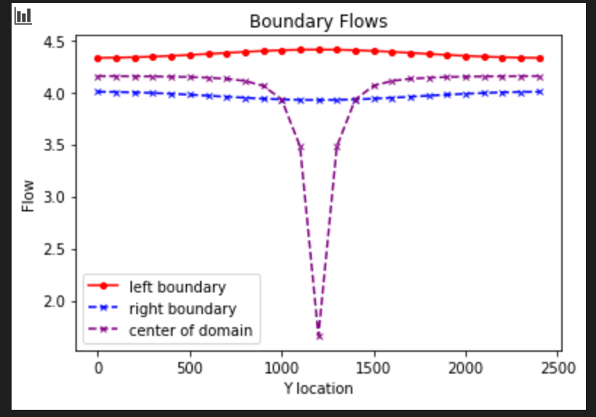

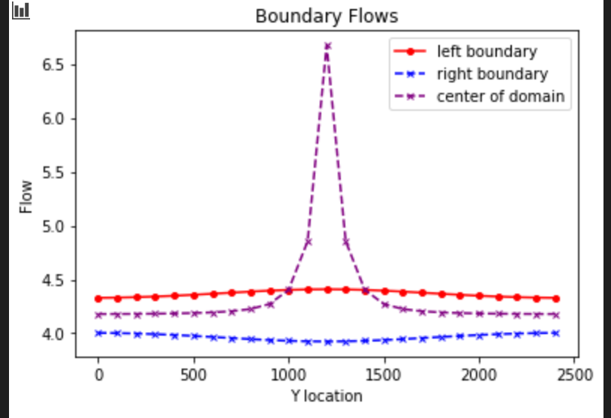

1. Then, look at the plot of equipotential and flow vectors. Describe how water flows through the domain. To aid in your description, draw a line through all of the flow vectors that terminate in the well. This approximates the capture zone of the well. Use this to refine your description of the flow system, being as specific as possible about where water that ends up being extracted by the well originates on the inflow boundary.

As we move toward the well the head values start to converge toward the well. The head values increase as you get close to the well and then decrease and then increase as you pass the well. The water for the well originates from the surrounding areas, from the left, because that is where the flow lines are coming from. This shows that the capture zone for the well is from 1000-1500m on the y axis and then the same values on the x axis.

The diagram shows flow lines drawn out and right at the well, where the star is, you can see 2 arrows opposing each other which is where there is a stagnation point because of the drawdown from pumping and you can see the pulling of the well. Since it is no flow, the water has to be moving from the left and going to the right (and not coming from the top or bottom) and if it wasn’t a no flow boundary than the water could be coming from all directions since the water would take the least path of resistance/easiest path.

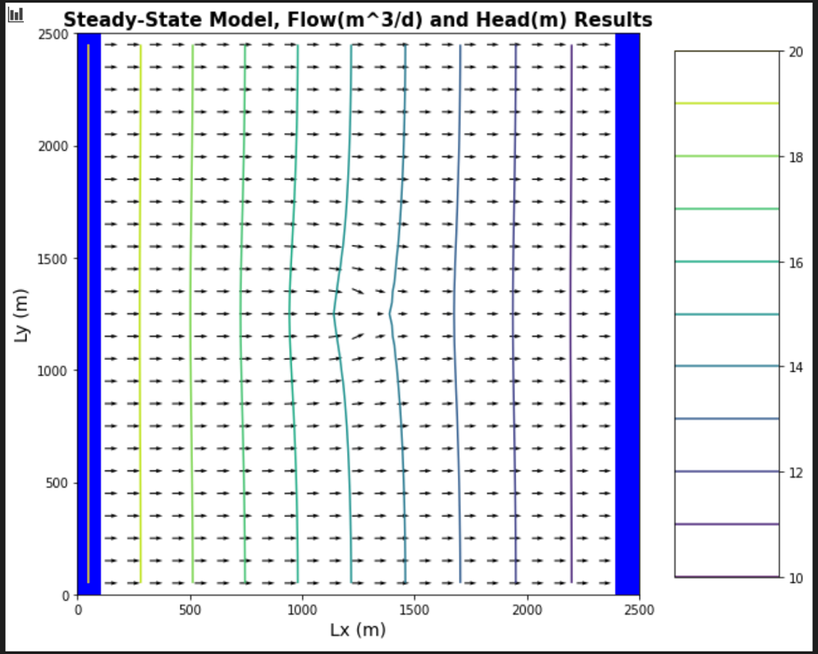



1. Then, look at the plan view drawdown plot. Why aren't the drawdown contours circles? Either explain why this is correct or fix the plot.

The drawdown contours aren’t circle because the drawdown isn’t perfectly circular and more curved. The contours represent the drawdown from the well and show the decline in the water table elevation. This plot is correct because it matches the contour head plot graph, where the drawdown is shown in the middle of the plot and curved around it to shows where the water table declines.

Drawdown is elliptical and not circular is because of the no flow boundaries on the top and bottom of the well, so the equipotential lines have to cross perpendicular. So, it becomes a type II well as it crosses perpendicular, so that’s why the drawdown becomes more elliptical. The no flow boundary would not be recognized until the area becomes large enough, so the drawdown also changes shape and is determined by the distance from that no flow boundary. This is important because if the no flow boundary was father away from the well, then the drawdown would be circular. The gradient is higher from top to bottom than from the sides so that is why the shape of the drawdown is more vertically elliptical and horizontally elliptical, since the flow is coming from the left and moving to the right.

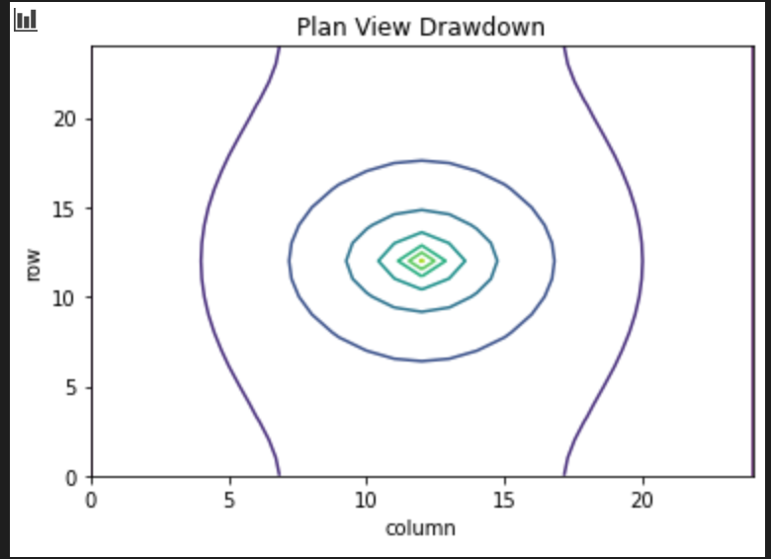

1. Move the well to [0,5,5]. Use all plots necessary to describe fully how water is flowing through the domain with the well in this location. Be sure to include the drawdown plot in your discussion - compare this plot to the equipotential and flow vectors. Something is not right about how the well location is shown. Fix it and explain what was wrong!!

For this model, the well is in the top left corner. The way the water is moving is the same as the other model but just moved up and to the left. As we move toward the well the head values start to converge toward the well. The head values increase as you get close to the well and then decrease and then increase as you pass the well. The original drawdown plot shows the well in the bottom left corner, which is wrong. I cannot figure out how to change the mistake in graph. I tried changing the flux which would move the drawdown head values up slightly but not enough to make a big change.

In order to change the location of the well on the drawdown plot, you have to change the code to read from top to bottom not bottom to top. The model shows a type II boundary at the top and then a type I boundary on the sides, which makes the drawdown of the well distorted. The drawdown distance changes shape as it approaches either boundary condition. From the graphs, we can also tell that since we moved the well closer to the left boundary, the flow decreases.

