The Challenge

1. Compare the impact of pumping on the single layer model vs the multi-layer model. What physical explanation do you have for the differences?

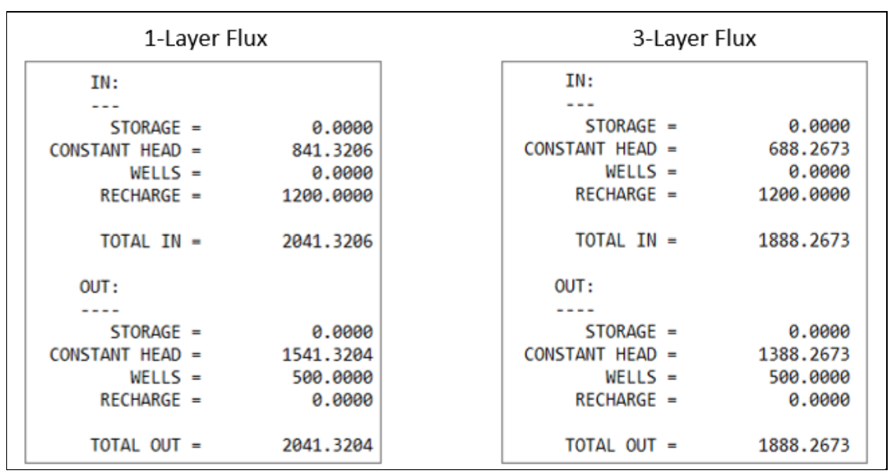

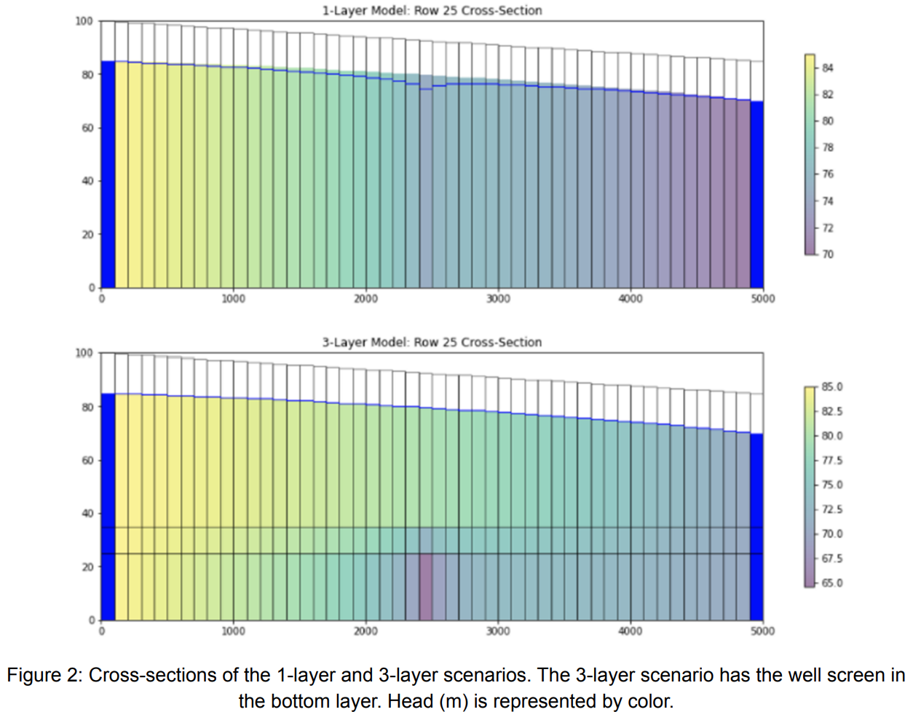

We can see a difference in the drawdown clearly in our graphics. The single layer model has a defined drawdown curve; however, we don’t see that in our 3-layer model. Our single layer model is pumping as normal, but the key difference in our 3-layer model is our middle confining layer, with significantly lower K. This prevents the well, located at the bottom, from influencing the top of our water table depth. This confining layer causes the water instead to be drawn from our left boundary along the bottom layer. This is reflected in the more extreme head gradient observed in our bottom layer in the 3-layer scenario.

1. Repeat the three-layer simulations putting the well in each layer (i.e. once in the bottom once in the middle and once in the top) provide plots and discussions comparing and contrasting your simulations. Provide at least one plot where you have all of your runs in the same figure.

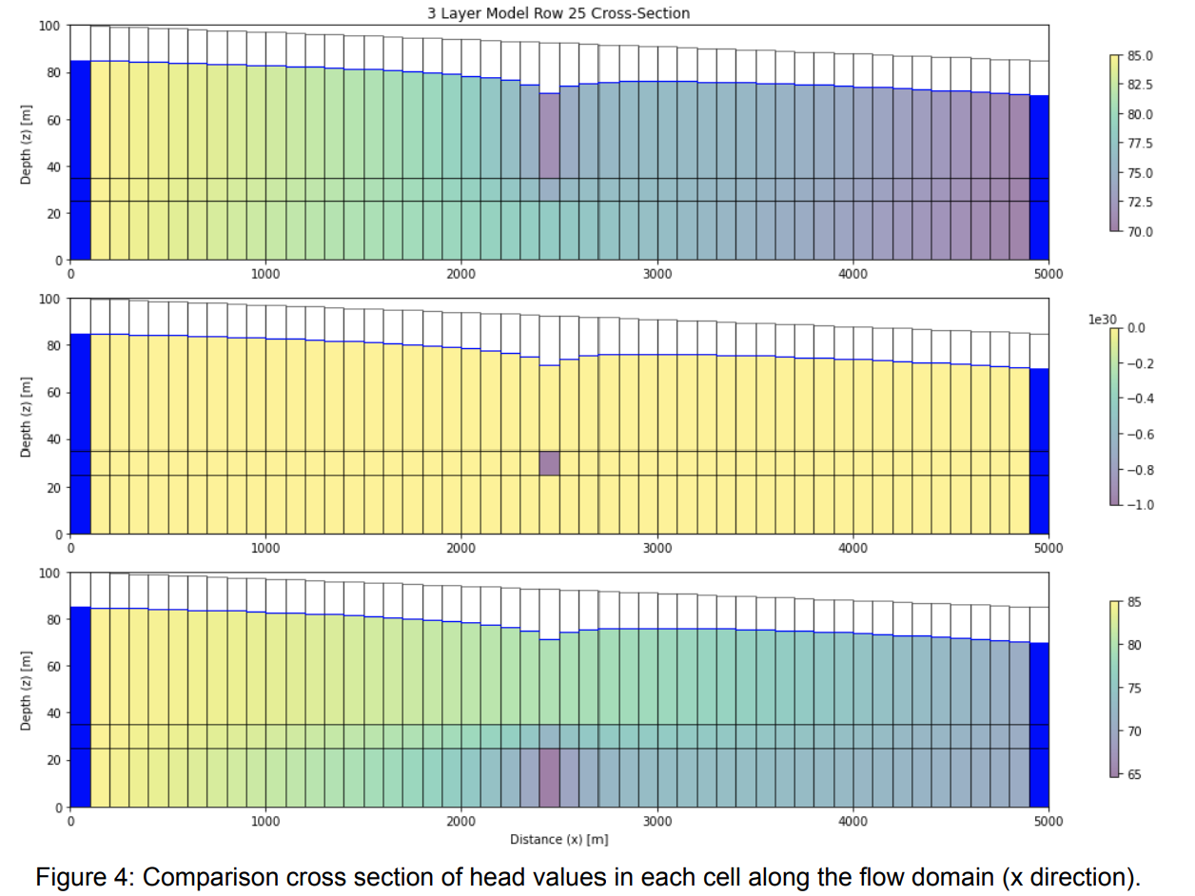

In the top layer pumping case, we can see a marked increase in head gradient across our entire domain. Comparing it to our base case model (bottom plot shown above), we can see a much broader influence on the model as a whole. This is again likely due to the confining layer in the middle. Pumping above the confining layer has pumping taking place effectively without the influence of this confining layer, which allows the drawdown to manifest at the surface of our water table. We can also see that the top layer pumping case has a lower head gradient immediately around the well, implying the well is stressing the aquifer less than if we were pumping below our confining layer.

The second case simply appears to be a matter of the model not converging, or drying up with our current pumping rate. This makes sense, as our K in this central layer is much lower, and simply may not facilitate pumping of 500 m^3 per day.

1. Change the properties of your three-layer model so that it matches the 1 layer model (but still has 3 layers) put the pump in the bottom layer and compare and contrast with your one layer solution. How does your answer to this challenge compare with your answer to the first?

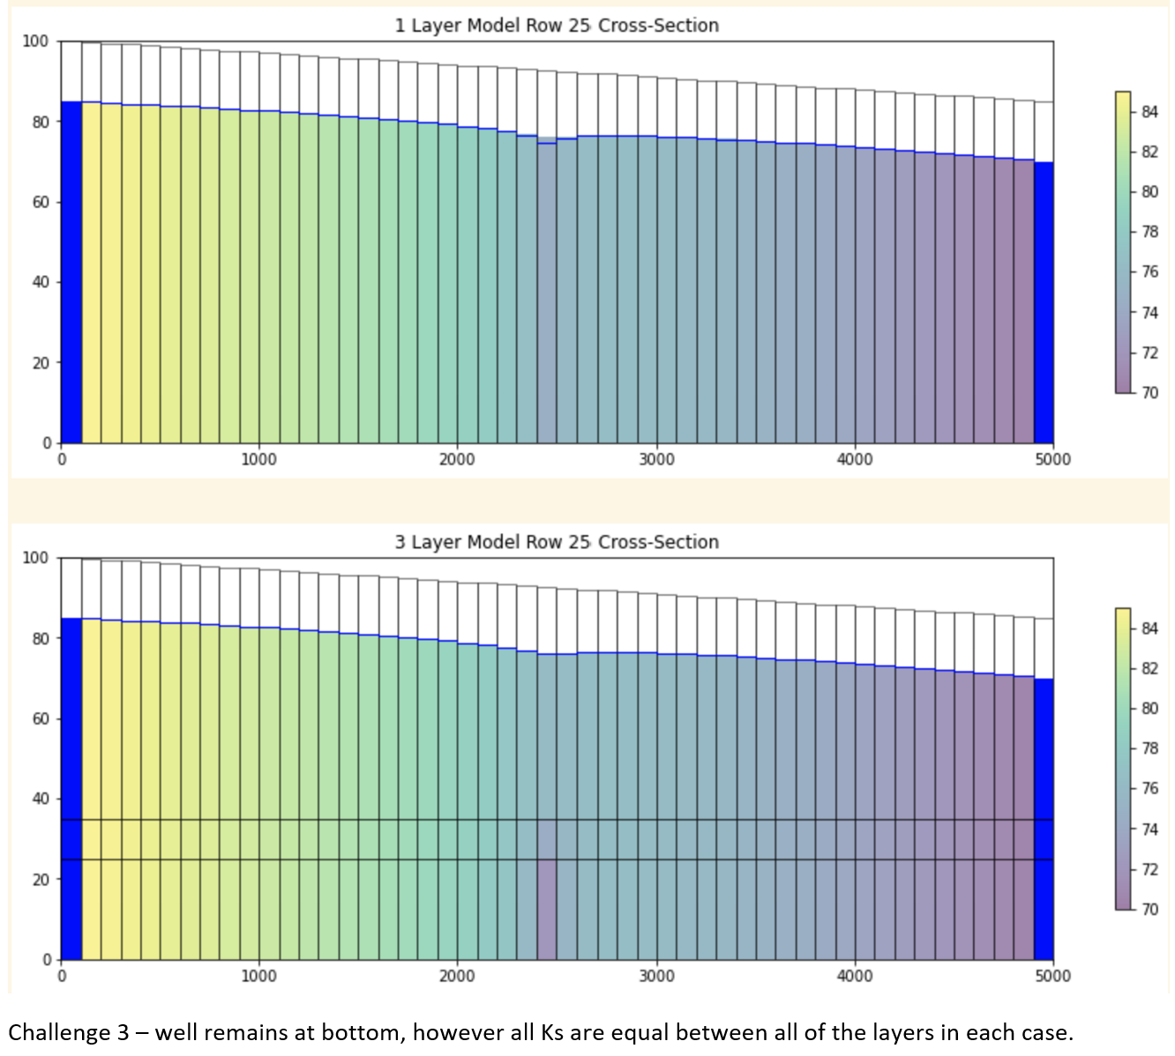

We see almost identical results in this case when comparing our same K cases for 1 and 3-layer models. This makes perfect sense, since I would expect that with the same K values, the 3 layers effectively disappear as far as MODFLOW’s output is concerned. They would behave the same way as a single layer of the same thickness and K.

1. Modify the topography of your domain so that it is no longer sloping left to right (you can make it a valley or have it sloping the other way, whatever you want). Re-run your 1 and 3 layer solutions and explain any differences you do or don't see.

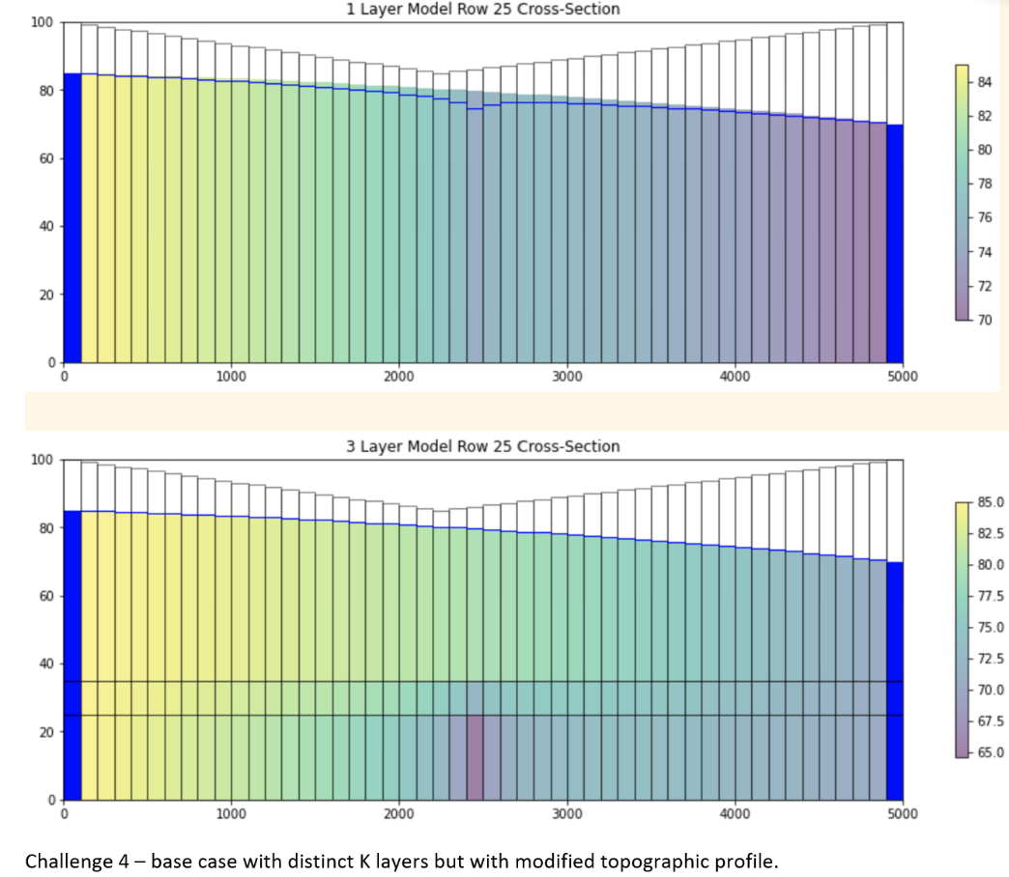

I don’t see any differences between the two models with my chosen valley case, or the sloping from 100-85 base case. This is likely due to the topography all being above the water table. To influence the results, I feel like the water table would have to intersect or cross over our terrain z values.

Glossary Questions

1. Layers: Why do we want multiple layers in our groundwater models? Compare and contrast the different approaches to vertical discretization (briefly describe different approaches and discuss their strengths and weaknesses).

Multiple layers allow us to resolve flow properly in the z direction, allowing us to have a true 3d flow model. This will much better capture reality, as K and soil properties usually vary in the z direction, not just x and y.

Different approaches –

Rectilinear grid – even cells in the x, y, and z direction

Pros – simple to execute, increasing resolution is a simple matter of altering dx, dy, zy and nlay

Cons – limited ability to model complex flow, lose the complexity at the grid cell level – no distinction within each cell.

Deformed & semi deformed grids – uneven cells in the z direction

Pros – model reality better, especially non-linear features, accurate representation of topography

Cons – much more complex to create, have to consider flow into and out of cells, more computationally intensive

1. Discretization: What are the pros and cons of adding more layers to a model? Are there considerations for vertical discretization that are different from horizontal discretization?

Adding more layers to your model allows you to capture movement of water in the z direction, and allows you to better represent reality. Soils change in the z direction too, not just x and y. adding more layers allows you add things like confining layers, flow constrictions, and even rivers and stream systems. It also dramatically increases model computation intensity and rendering time. It can also increase sensitivity within a model, or cause instabilities that weren’t present in a single layer scenario.

Vertical discretization is different than x and y, as you only have to set x and y once. Z thickness can vary by layer, and has to be carefully controlled when writing your code. There is much more complexity, and surface topography has to be considered as well with our z direction.

1. Stream Aquifer Exchange: How is water exchanged between a stream and an underlying aquifer? Include the following concepts: (dis)connected streams; streambed hydraulic conductivity; boundary condition type; and coupled models.

Water is exchanged between a stream and the aquifer through the streambed. There can be either a gaining or a losing stream – the stream is either fed by groundwater coming in from a higher hydraulic head, or the stream has the higher head and dumps the water into the aquifer from the streambed. Disconnected streams are likely in the losing scenario, where the stream water is being supplied from elsewhere, and is effectively recharging the aquifer to some extent. The streambed itself is important to distinguish, as its characteristics are likely different from the nearby soils, even directly below the streambed. Things like slope, roughness, thickness, and hydraulic conductivity can be different in the streambed. This would be valuable to delineate within a groundwater model. The stream could be represented by a constant head boundary, assuming that head levels in the river don’t change significantly. This has its limitations, as you have essentially created an infinite water source in your stream, which if not carefully implemented can warp the reality of a groundwater model significantly. A coupled model is a model that combines aspects of the streamflow packages, within the packages in MODFLOW that govern sub-surface properties.