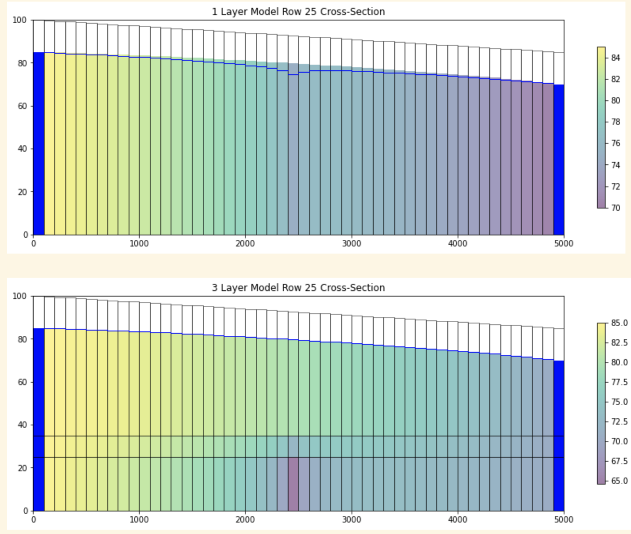

Initial case – difference between one and 3 layer models – above and below

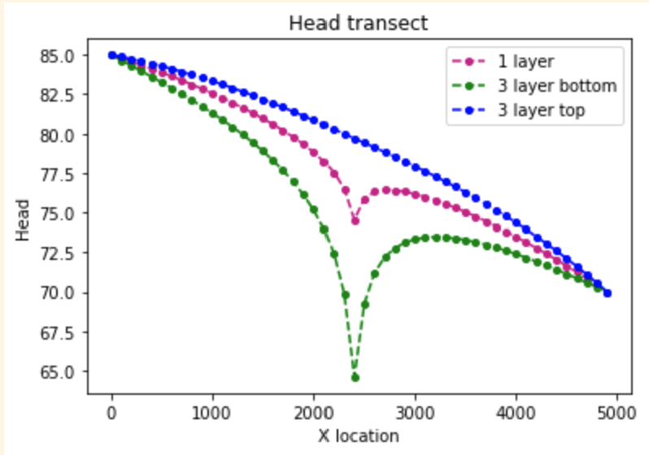

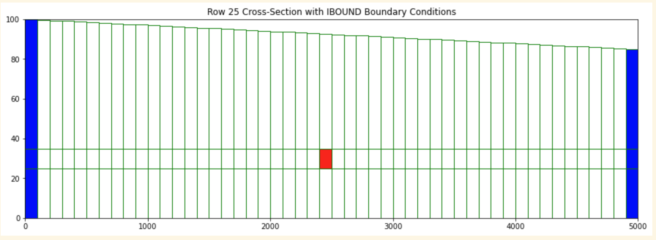

Above and below – well moved to middle layer, all other parameters original case

*It appears to be an issue with conductivity of this layer causing drying out.*

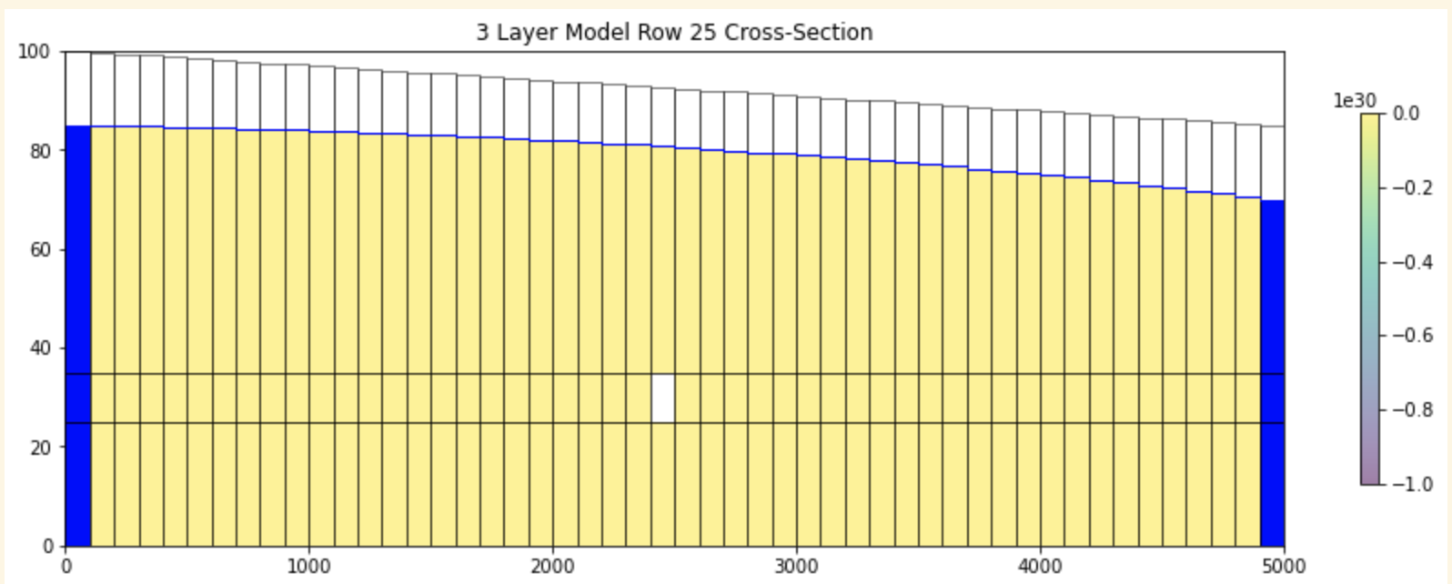

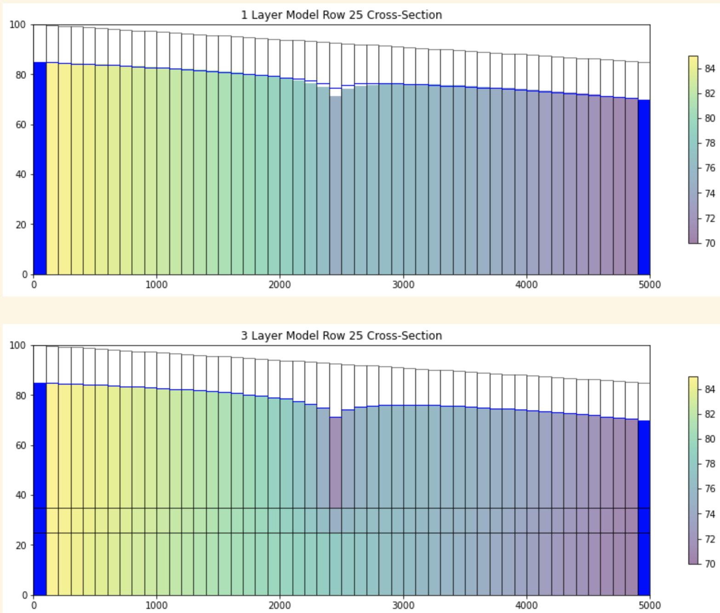

Initial conditions, with well moved to the top layer (2) for our pumping. Heads listed.

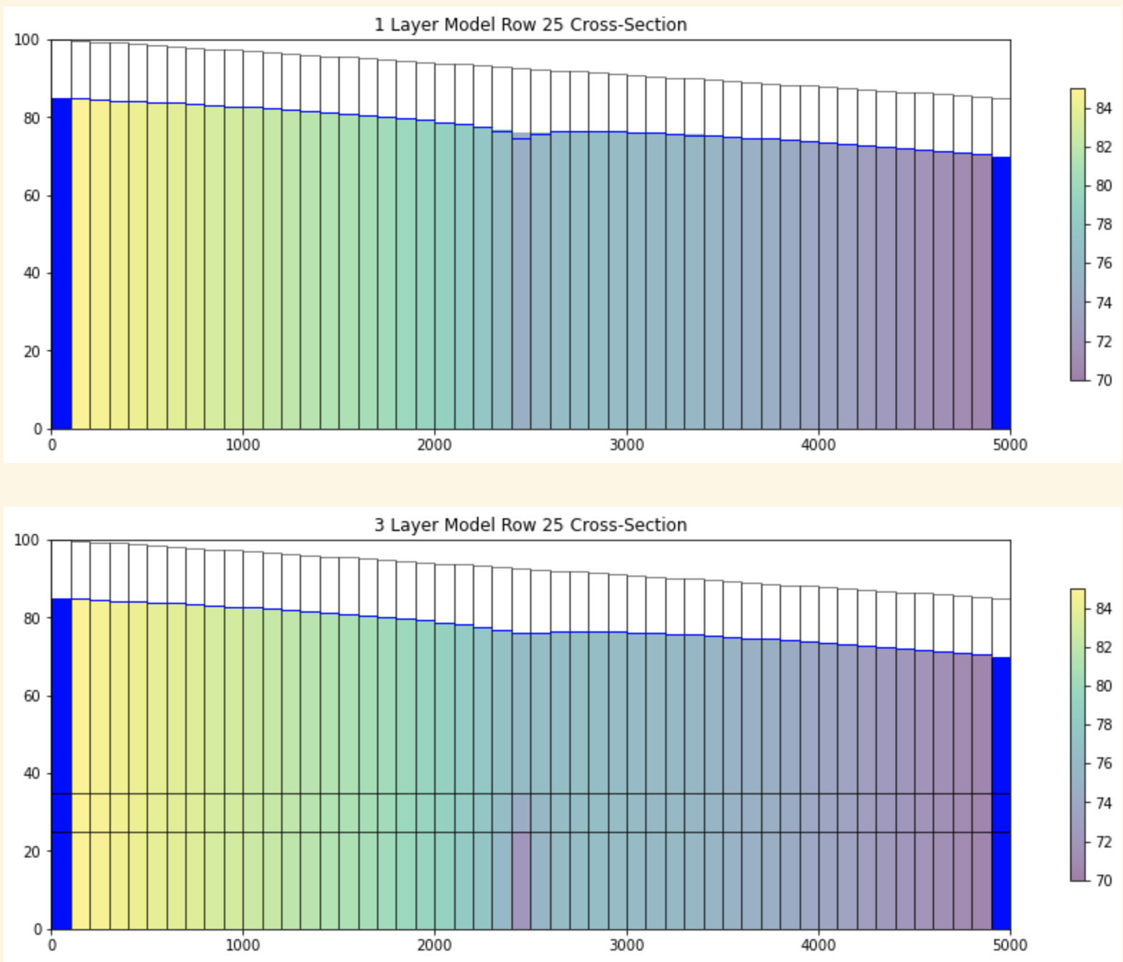

Challenge 3 – well remains at bottom, however all Ks are equal between all of the layers in each case.

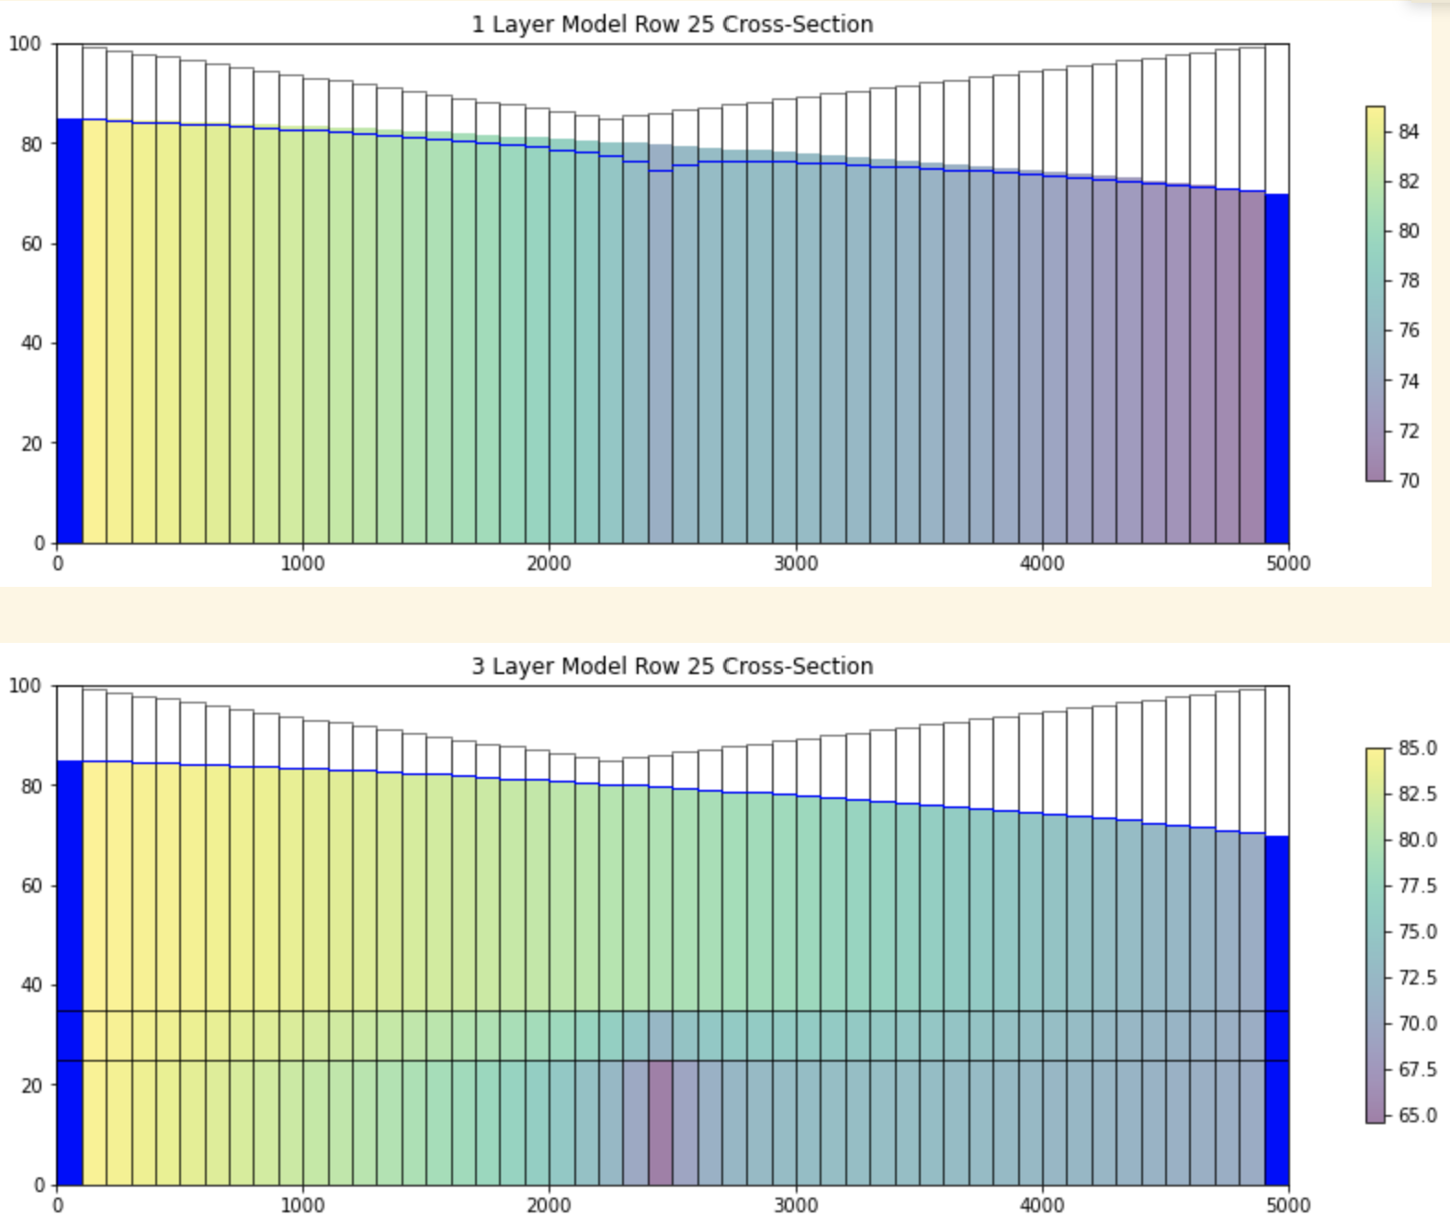

Challenge 4 – base case with distinct K layers but with modified topographic profile.