The Challenge

1. Read the paper that summarizes the stream flow packages in Modflow and look at the [flopy documentation](https://flopy.readthedocs.io/en/3.3.5/source/flopy.modflow.mfstr.html" \o "https://flopy.readthedocs.io/en/3.3.5/source/flopy.modflow.mfstr.html) for the str package to understand how we have implemented this in our code. Write a short explanation for how the str package works and what assumptions it is making.

The STR package in MODFLOW simulates surface water flow, and its effect on groundwater. You input the parameters of the stream, such as streambed properties. Shown below are the parameters we included in the flopy code for our basic model. A major assumption of this function is that significant head losses only occur through the streambed. It is also assumed that the cell immediately below the streambed is fully saturated.

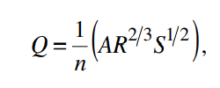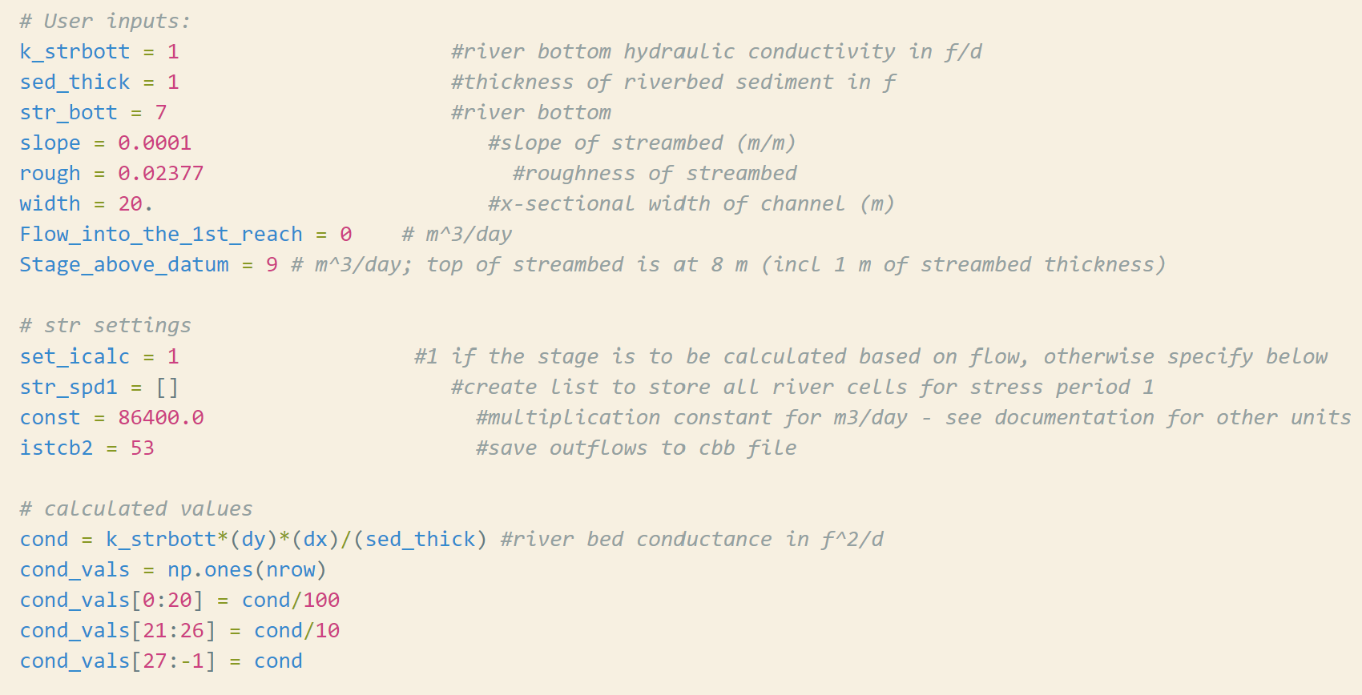

1. The code is provided to produce the first set of 'correct' figures. Use these figures to describe the nature (direction/magnitude) of stream/aquifer exchange along the stream. In particular, explain why the leakage changes magnitude or direction where these values change.
2. Use the head distribution to describe the movement of water across the boundaries and into/out of the stream.

*I combined my answers for 2 and 3 for simplicities sake.*

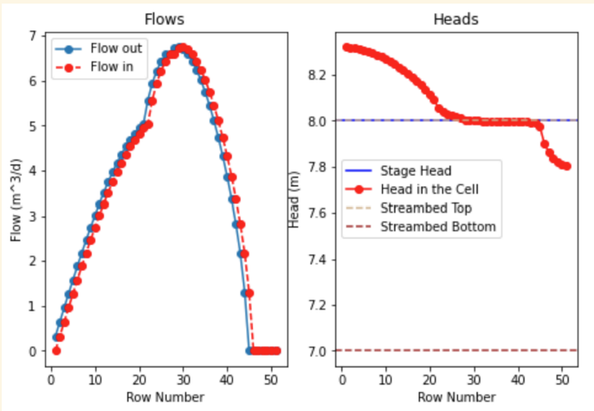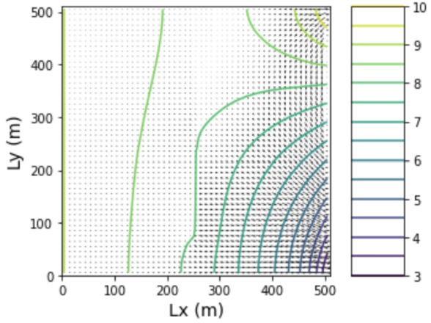

Base case head and flow profiles along the streambed

Right figure – base case head map and flow-lines

The first figure shows us a starting flow of 0, but a building flow as water gets a chance to accumulate in our stream. We can see this in the two different views of the head profile above. Since our head in the cell is higher than the streambed, we can assume that this stream is gaining at this point along our domain. This means that the groundwater is what is supplying the stream. This also makes sense, given our initial stage input of 0 in the code. This is also sensible, in that our conductivity is the lowest here, so we would expect the flow to begin to accumulate faster than it drains. The section of peak flow is when things start to reverse in the stream. This is likely due to the marked increase is streambed conductivity. Flow doesn’t instantly respond, but lags a bit. At this point the streambed matches our head profile, so we begin to have a system losing water, and returning water from further north into the aquifer. Towards the end of the plot, we simply see the streambed drying out, as the head profile can no longer sustain any water in the stream itself. It has all drained into the streambed itself.

1. Choose two things to explore (e.g. impact of streambed K or inflow into the river or recharge rate). Produce a plot for each to compare to the base plots and use the plots to explain the impact of the hydrologic change.

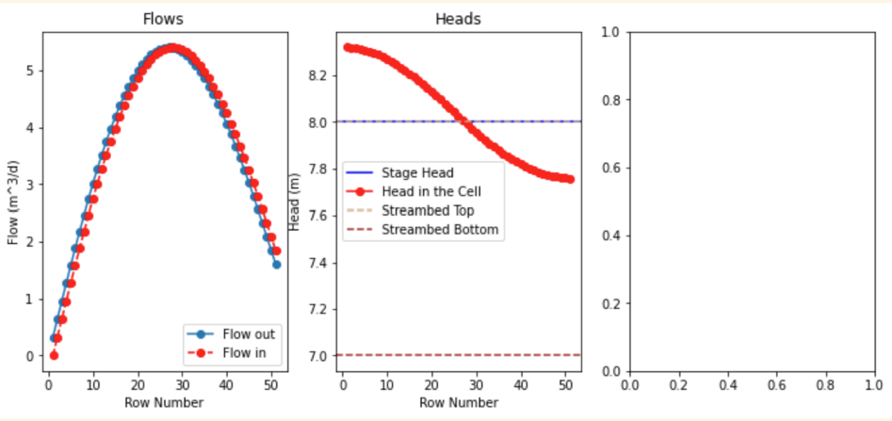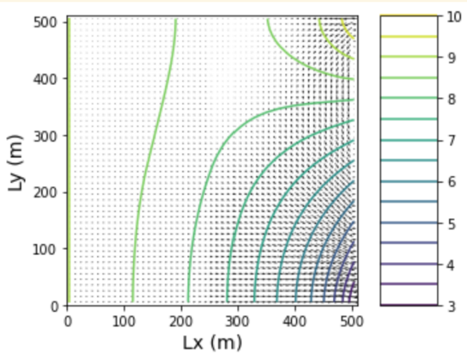

*Case with all cond set to cond/100* *head map of cond/100 for all stretches*

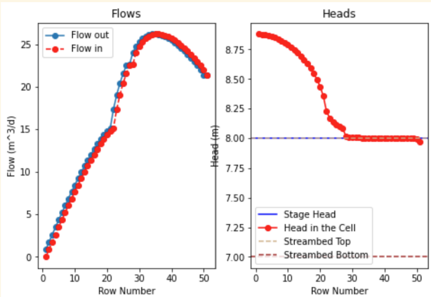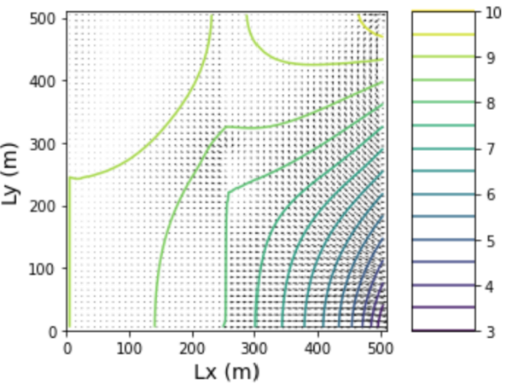

(case with base recharge x10) flow, head along river, as well as head map and flow map

We can see that reducing the streambed conductivity to the same cond/100 value smooths out both of the curves for flow and our head profile along the streambed. I don’t really understand why this happened; I would have expected flow to have increased for a longer period of time before beginning to decrease in our y-direction. Perhaps I am misinterpreting the plots’ locations??

Increasing our model recharge from the base case (last set of figures) simply increased our head levels across the board. We can see that the head profile takes longer to hit streambed levels on both head plots. The same behavior is observed, but it is slightly amplified. It seemed to have shifted our heads profile above to the right, never really allowing the head in the cell to dip below the streambed top.