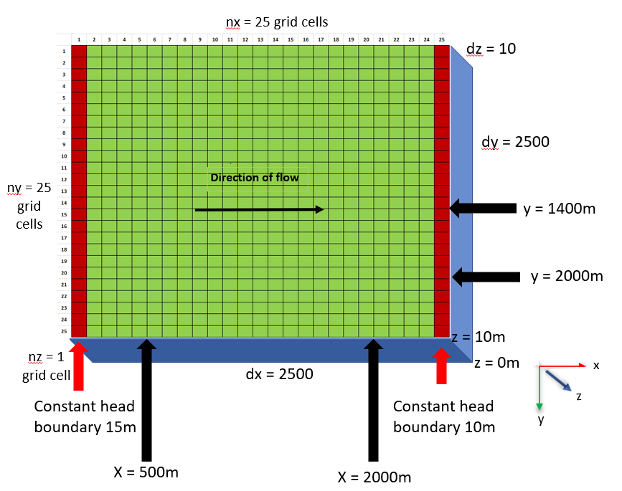

Figure 1. This conceptual diagram shows a 25x25 gridded box with two constant head boundaries on the left and right sides. The box is 2500m x 2500m x 10m. The time units are days. The length units are meters.

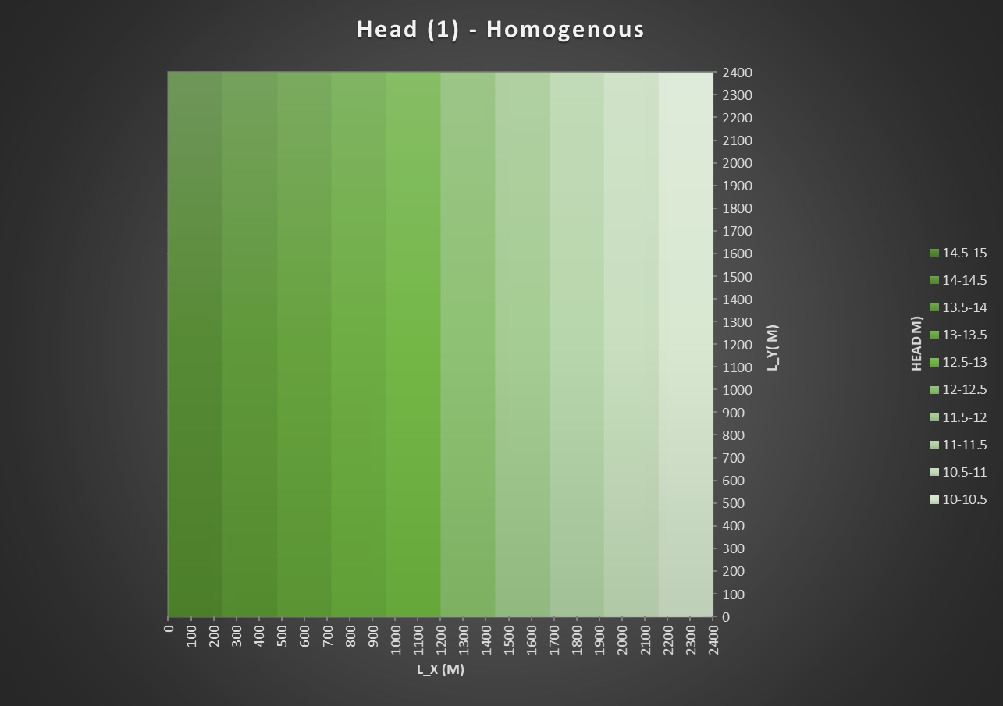

Figure 2. Head Distribution of Homogenous box with a K = 1 m/d

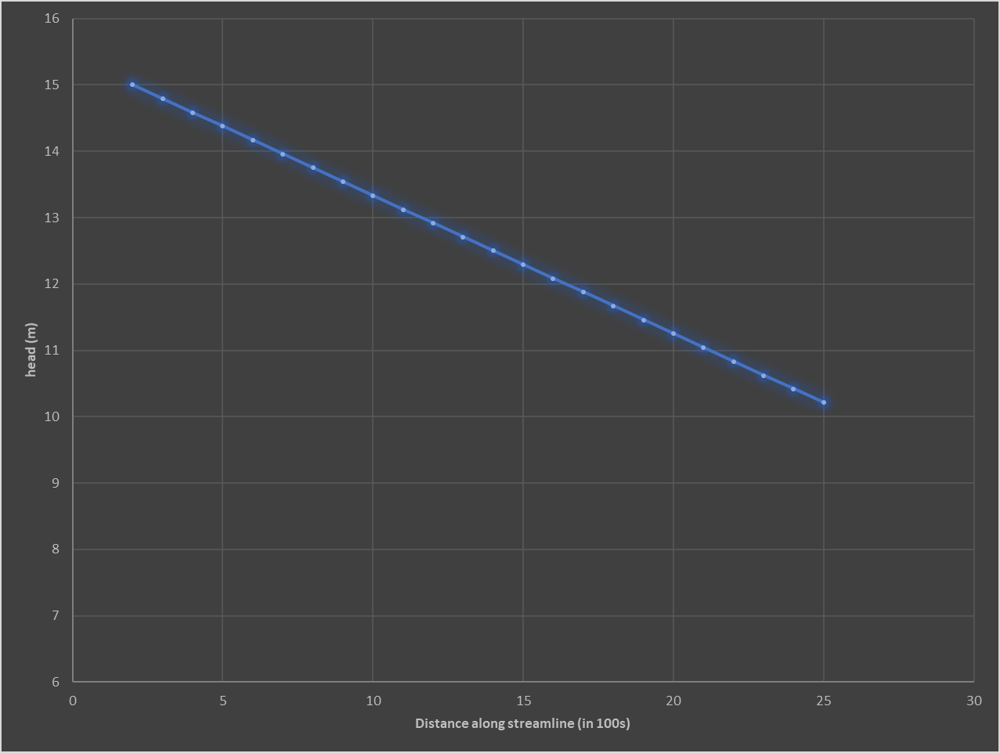

Figure 2.1 Cross Section of Hydraulic Head of Homogenous box

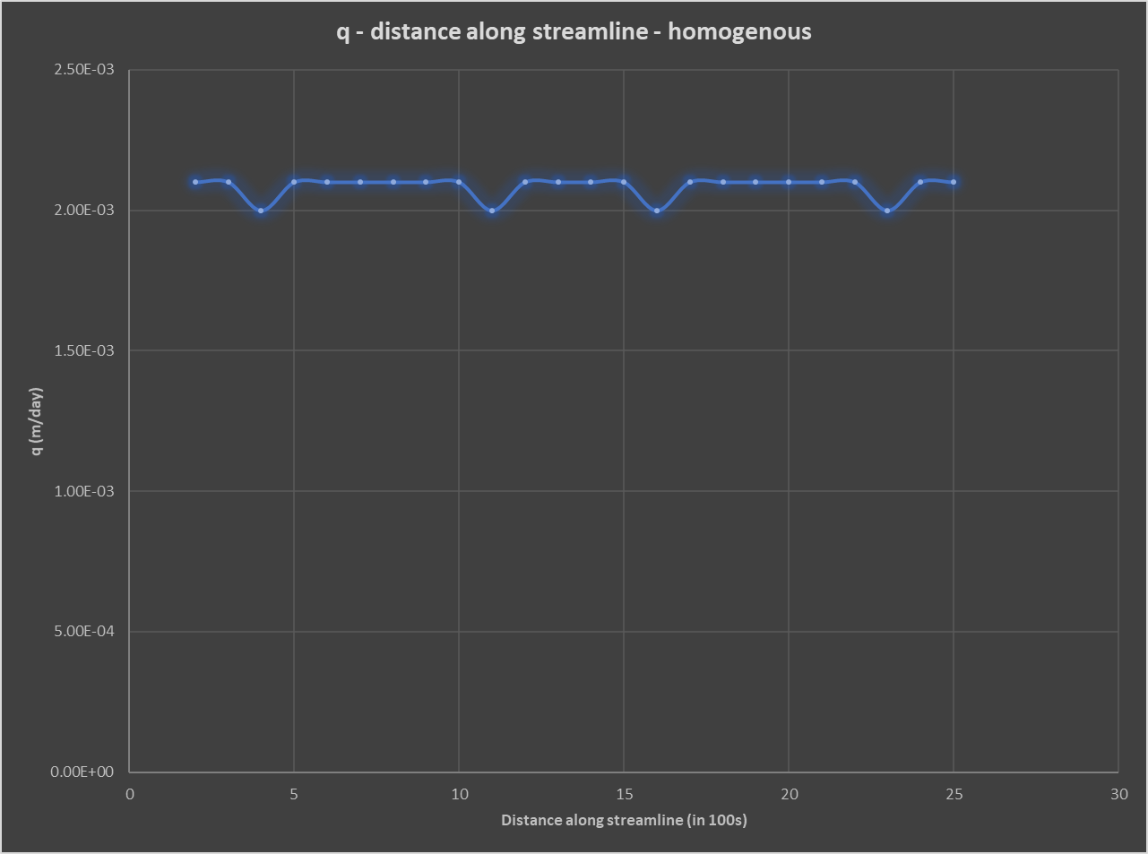

Figure 2.2 Cross Section of Flux in Homogenous box

Figure 3 Heterogeneous box with two columns (at 11 and 12) of high K (10 m/d)

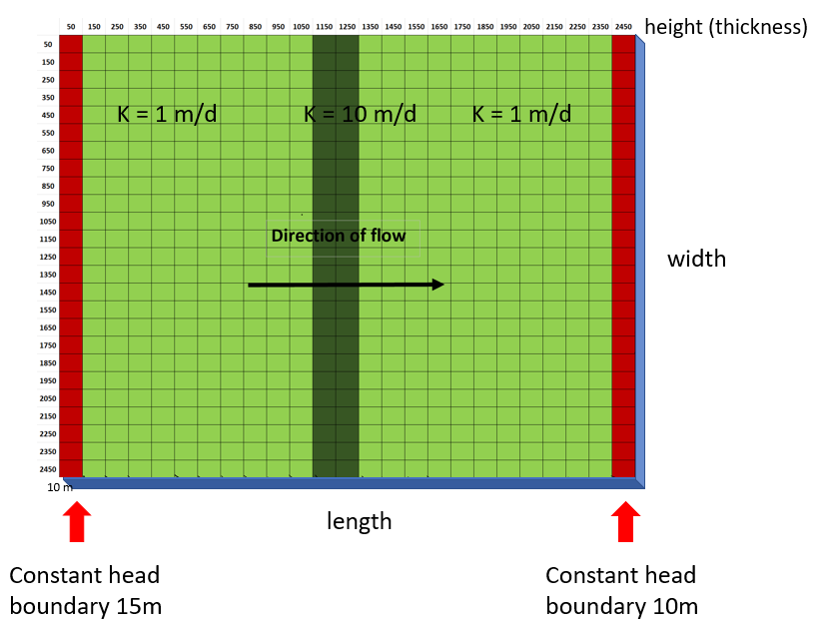

Figure 3.1 Conceptual diagram of Heterogeneous box with two columns (at 11 and 12) of high K (10 m/d)

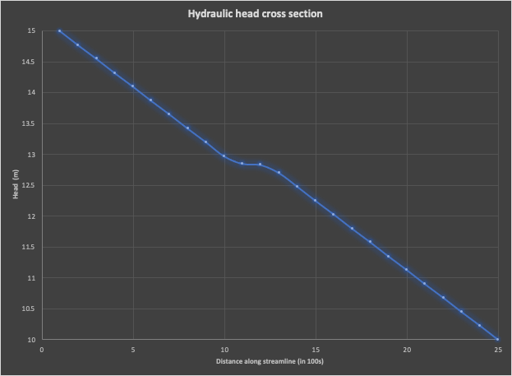

Figure 3.2. Cross Section of Hydraulic Head of Heterogeneous box with two columns (at 11 and 12) of high K (10 m/d)

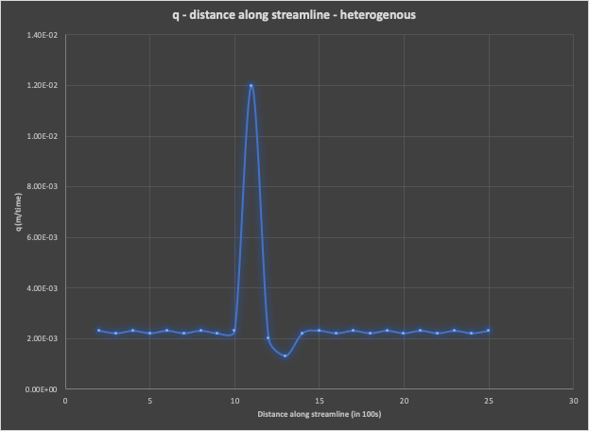

Figure 3.3. Cross Section of flux of Heterogeneous box with two columns (at 11 and 12) of high K (10 m/d)

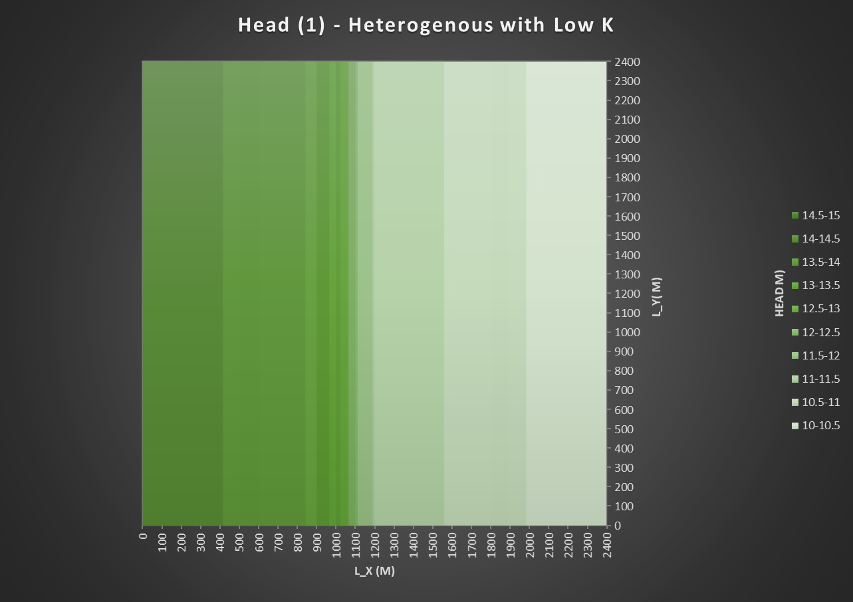

Figure 4. Heterogeneous gridded box with two columns (at 11 and 12) of low K (0.1 m/d). There is some resolution error with the plot.

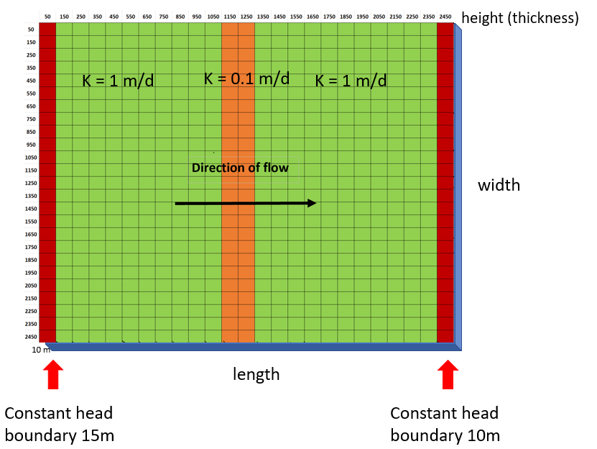

Figure 4.1 Conceptual Diagram of heterogeneous box with low K (0.1 m/d)

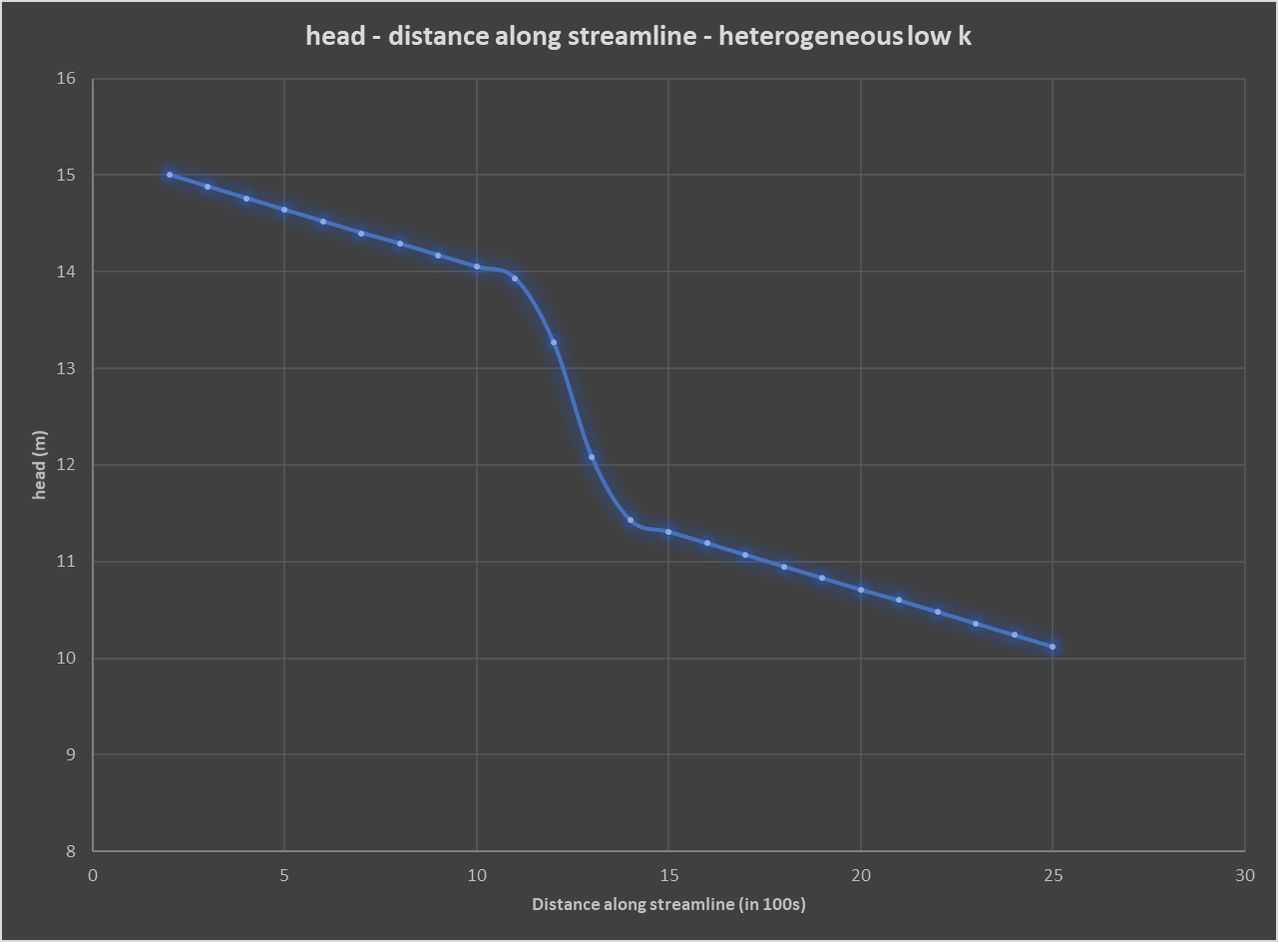

Figure 4.2 Cross Section of Hydraulic Head of Heterogeneous box with two columns (at 11 and 12) of low K (0.1 m/d)

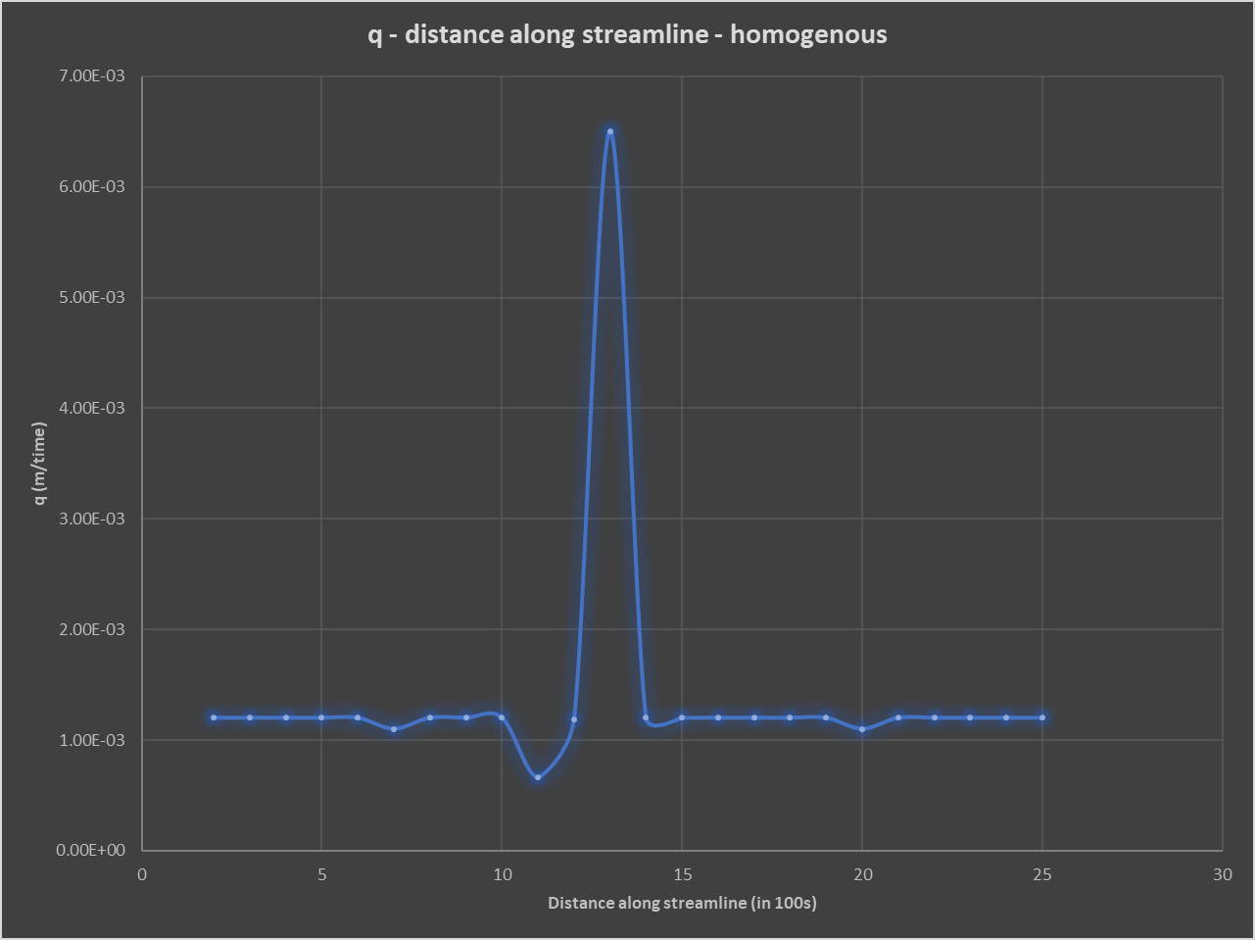

Figure 4.3 Cross Section of flux of Heterogeneous box with two columns (at 11 and 12) of low K (0.1 m/d)

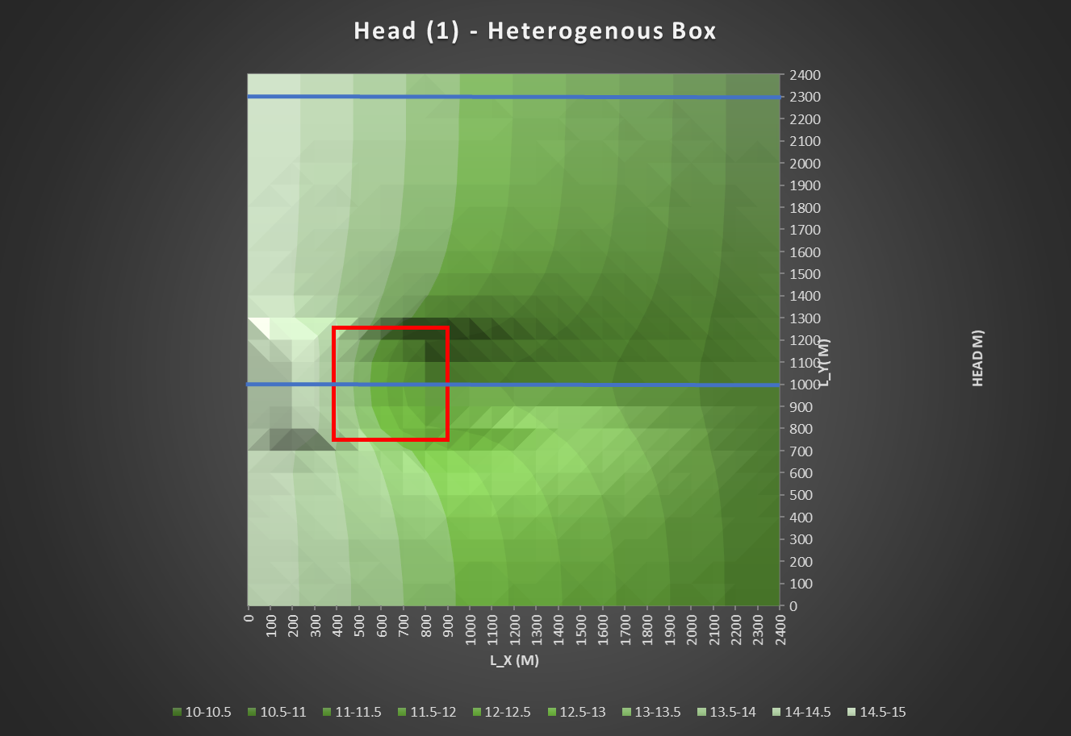

Figure 5. Heterogeneous box (5x5) with low K (0.5 m/d) at columns 4-8 and rows 7-12. Box shown in red, profile locations shown as blue lines

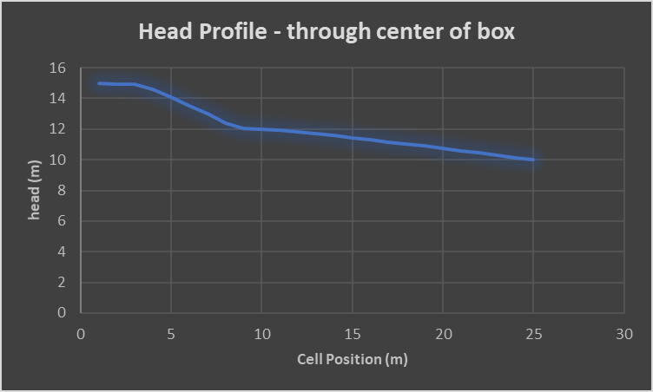

Figure 5.1 Head plot taken at cell 13, center of box

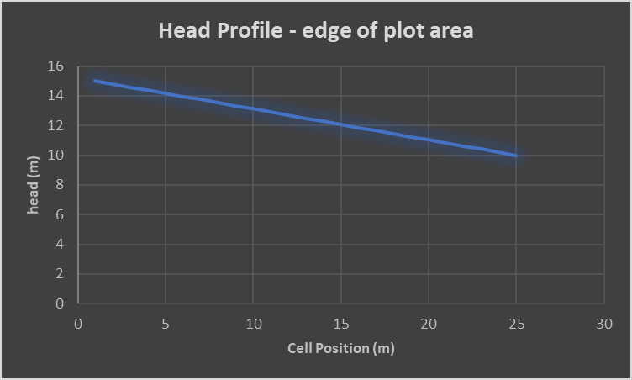

Figure 5.2 Head profile taken at cell 24

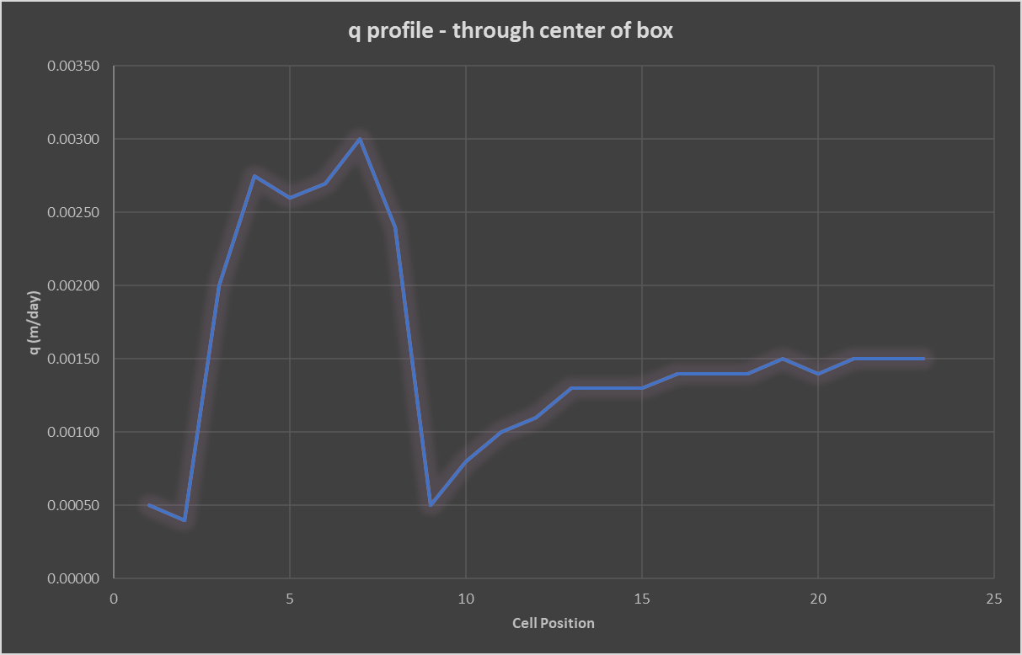

Figure 5.3 Q profile taken at cell 13, center of box

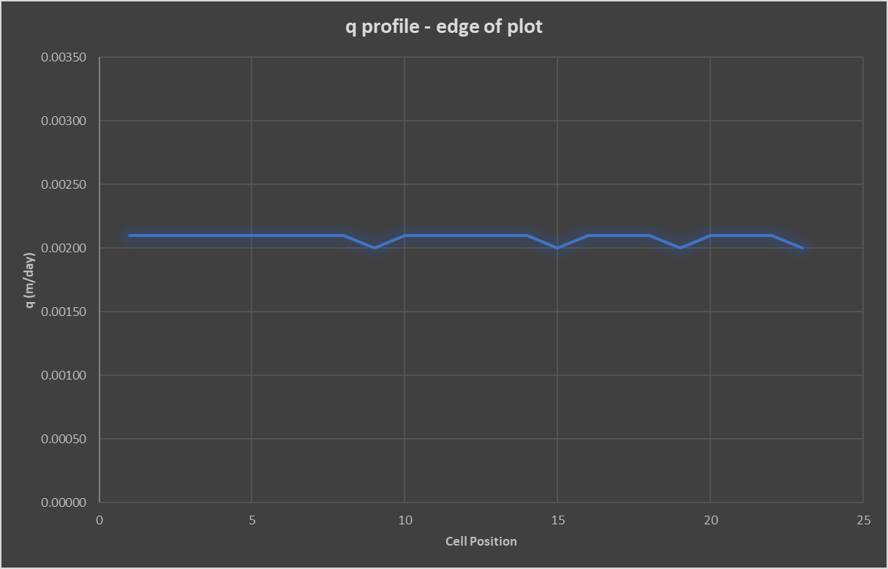

Figure 5.4 Q profile taken at cell 24