HW5 Challenge questions

The Challenge

1. Change the boundary condition heads to make this an unconfined model. You can pick whatever heads you would like but I recommend keeping both of them above zero (*Hint:these are the variables H_left and H_right in the starter code*). Run two simulations with the same head gradient across the model (i.e. H_lef-H_right being equal) but where one is confined and the other is unconfined.
   * Plot the equipotentials and flow lines for both simulations
   * Plot the head difference between the two simulations

*Confined Unconfined*

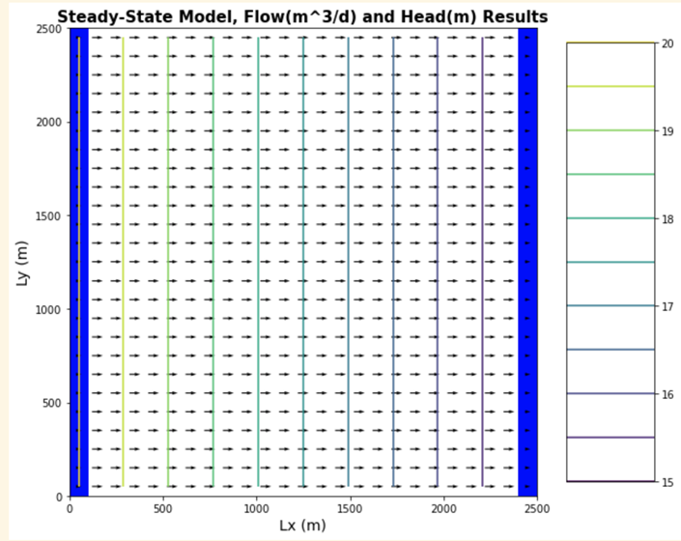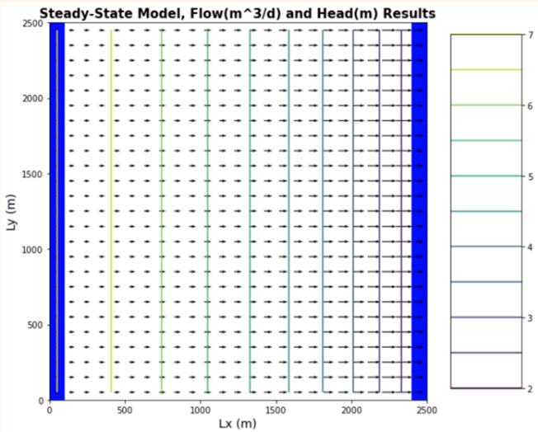

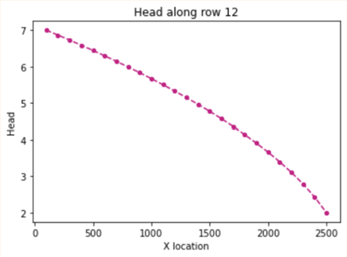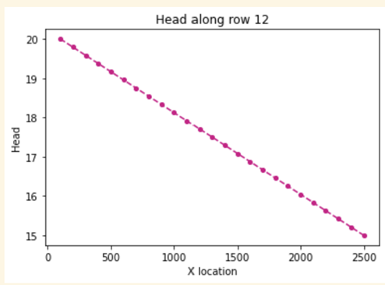

* + Describe how the two head profiles differ and explain why this is the case.

**The first head profile is the standard linear head gradient that we have seen in previous confined models. The major difference between the two is that there is no longer straight line for a head profile. In the unconfined case we see that head gradient increases with distance in (X). I think that the reason we see this contrast between the two is the non-linear nature of unconfined aquifer systems.**

* + Would your answer be different if you changed the overall head gradient (H_left-H_right), still keeping it the same between confined and unconfined cases though?

**I think that my answer would be the same. The only difference would be in the shape of the non-linear curve, but we would still see the same overall behavior of the two head profiles. The curve with a higher head difference would likely be more extreme.**

1. For the two runs above (1) plot the flux across the left and right boundaries and (2) calculate the total flux.
   * Compare these calculations and plots and provide an explanation for why you see the behavior you do.
   * The overall gradient is the same, as is the K of the medium. Is the flow the same for both boundary conditions? Why or why not?

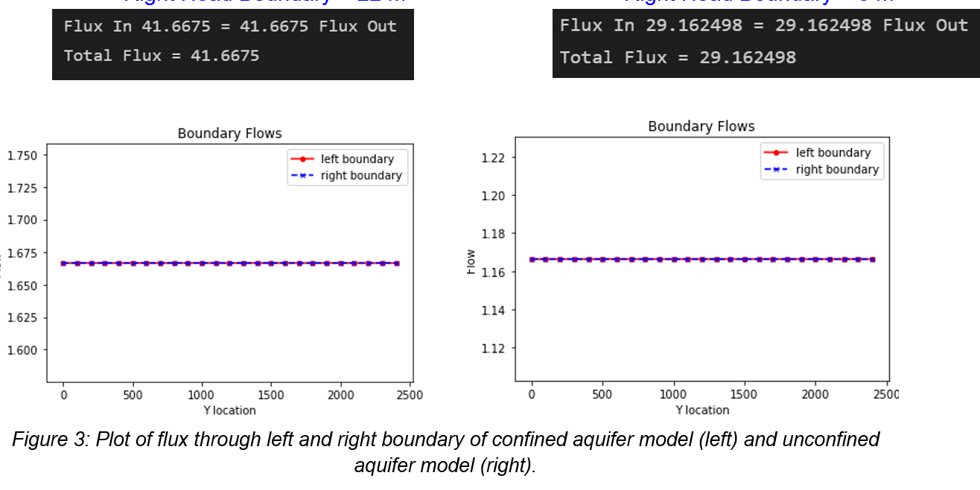

**We see that both models are still mass conserved, flux in the left equals flux out the right. However, we do see that the unconfined model does have less total flux going through the system. I think this is due to the larger heads present in the confined model, and the fact that the confined model is under pressure. We don’t have these greater heads impacting the unconfined case, resulting in lower total flux.**

1. Now add recharge at a constant rate of 1e-4 m/day over the entire top boundary to an unconfined case with the left boundary set 7m and the right boundary set to a 2m.

* Explain the head transect and boundary flows.

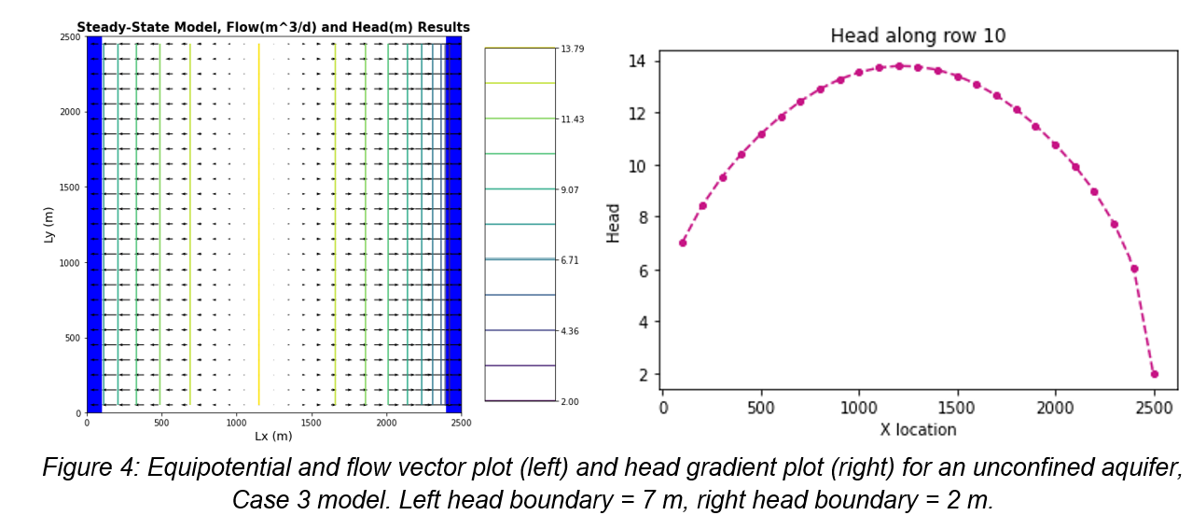

**The reason we see the upswelling of head in the middle of our model area is because we have a system based on strictly defined, constant head boundaries. Our model is now receiving an excess amount of water within our constant head boundaries, which cannot deviate from their defined values. In order to compensate for this influx of water, the head profile has to give in the center, so we see this excess water manifest as a swelling of our head transect, centered on roughly the middle of our x axis.**

* Is flow in this system 2D or 3D? Is it represented as 2D or 3D? Explain what you mean by your answers.

**Flow in this case is still 2D, we don’t have any water coming into the top or bottom of each cell, we still only have flux coming in from the left and right faces, and front and rear faces of every cell. We are applying the recharge at each cell individually when we apply recharge to the scenario, almost as if we have a well injecting water at each right face.**

1. Update your model from #3 to model a system with zero recharge except for a farm located in [6:10, 6:10]. Recharge beneath the farm is 1e-4 m/day due to excess irrigation.
   * Calculate the annual excess irrigation, in meters, that has been applied to the farm.

Excess irrigation = 1e-4m/day * 365 days = **0.0365 meters of water**

* + Assuming that the crop is cotton, it is located in southern Arizona, and cotton is grown all year (for simplicity), calculate the total irrigation rate on the farm that would be associated with this amount of excess irrigation.

0.0365m = 20% of irrigation, so 0.0365 = total*0.2 **total = 0.1825 m in a year**

* + Finally, use the flux diagram to identify the area within the domain that might be subject to contamination if the recharge water was somehow tainted (you can do this by saving the plot to powerpoint and annotating it there).

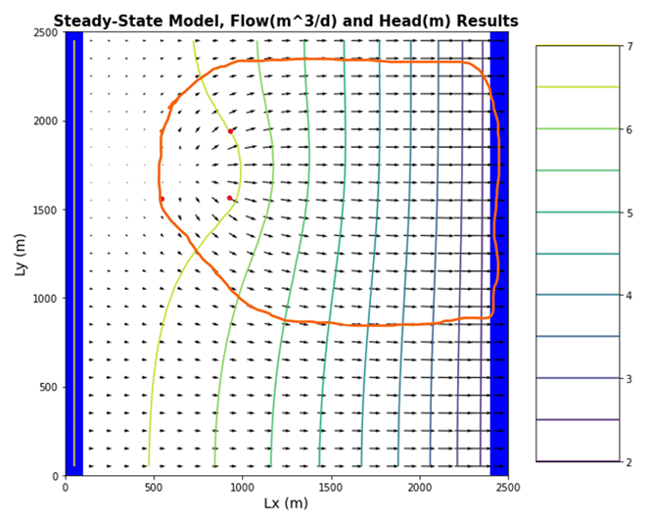

1. Lastly, start the well located at [10,15] pumping at a rate of 8 m3/day. Using one color, identify the capture zone of the well. Using a second color, show the area that might be contaminated by the irrigated farm fields (see not above you can do your annotations in powerpoint if that is easier. ).
   * Comment on the impact of the well on the pattern of potential contamination.

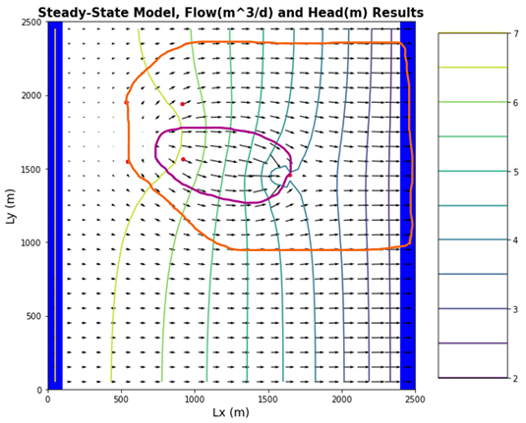

**The well will be drawing out some of the contamination plume, and I believe that the well will actually constrict the spread of the plume slightly in the y axis.**

* + How will the steady state capture zone of a model with recharge differ from that in the same model without recharge?

**I think that if we had a case like this without a recharge zone, the plume would almost entirely remain constricted to only the flowlines that pass directly through the contamination. There would be nothing to cause spreading in the y direction, unlike our case with the recharge of the farm irrigation.**

Glossary questions:

1. What does it mean for an aquifer to be unconfined? How does this impact how we calculate flow and how do we expect it to impact head gradients and fluxes?

**An aquifer is unconfined if the upper water surface is open to the atmosphere, or is at atmospheric pressure. In our case it doesn’t change how we calculate flow, we still have steady state, saturated flow and use Darcy’s Law. However, we do have an impact to head gradients, there is no longer a linear slope for our head profile along our x-axis.**

1. List each layer type available in the LPF and BCF packages. Provide a brief summary explanation for each. Explain how approaches differ.

**LPF package**

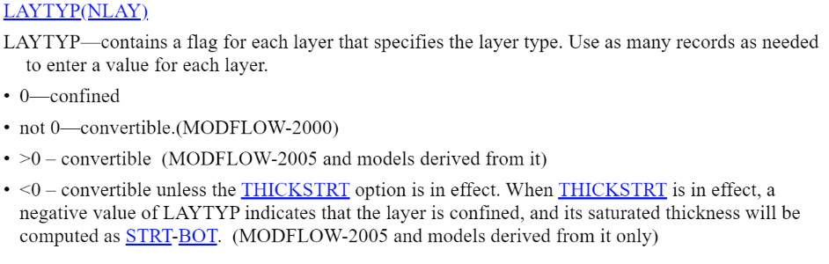

**BCF package**

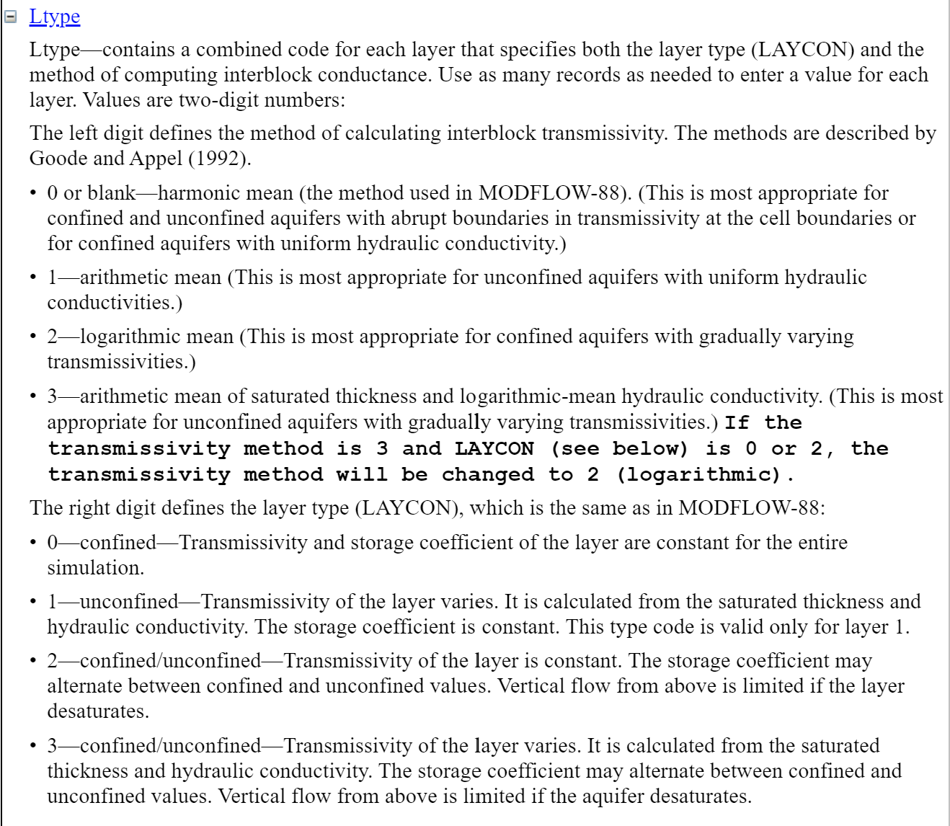

1. How can MODFLOW, which does not model unsaturated flow, represent an unconfined aquifer?

**We can still measure flow as long as the system is saturated, and the surface of an unconfined aquifer can still be set to atmospheric pressure within MODFLOW. As long as the hydraulic head is correct and the right pressures are involved, we can still model unconfined systems.**

1. Define recharge. How do we represent recharge in a MODFLOW model? What package do we use and what are the assumptions of this package? Where exactly is the top boundary of the model?

**Recharge is the replenishment of an aquifer through the absorption of water.**

**We represent this is MODFLOW using the recharge package. We can represent either point recharge within a specified area, or point recharge, or recharge to an entire layer of our model. We assume 2D flow still when we use the package in the way that we did for this model. I think of it as our layer recharge could also be implemented by a system of equal injection wells at each cell.**

**The top boundary of our model is whatever z value we define as (ztop)**