HW5 – Figures

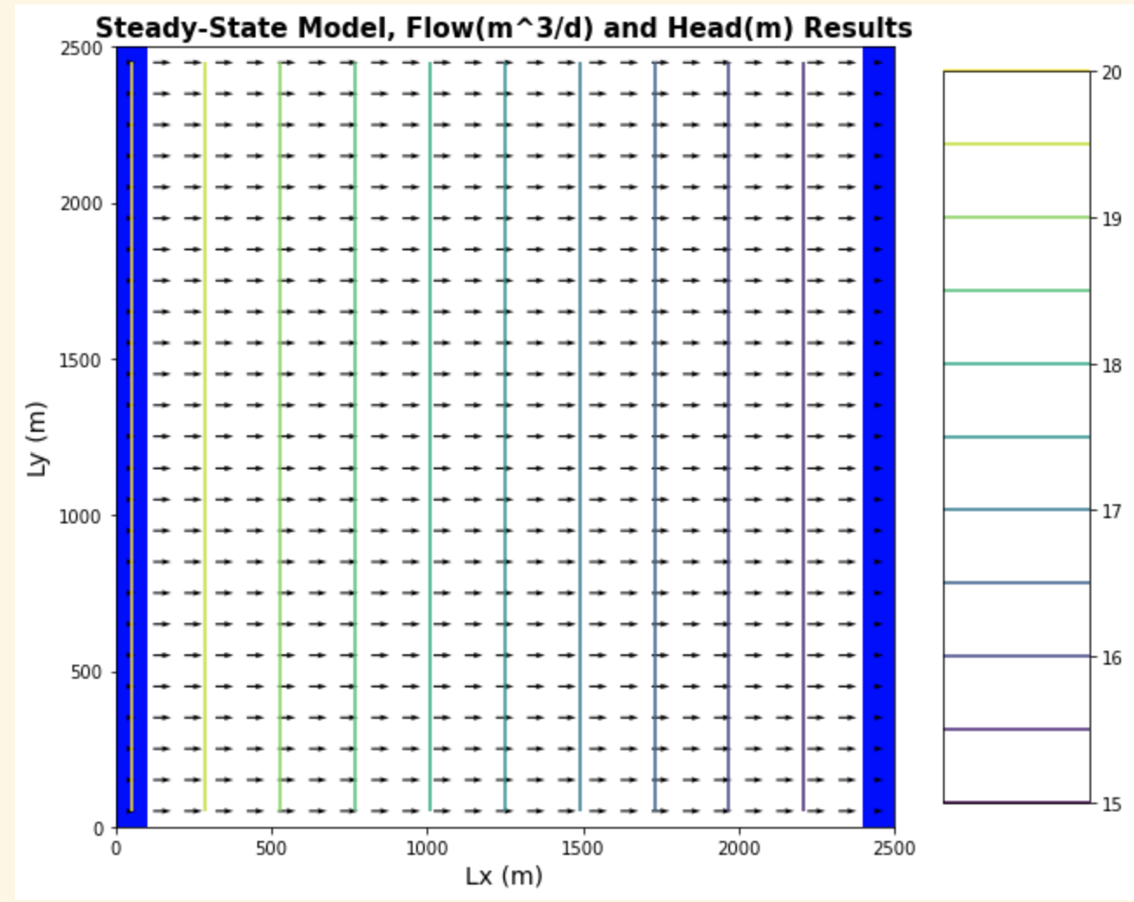

Head and flow map for confined case, 20 Hleft 15Hright, no recharge

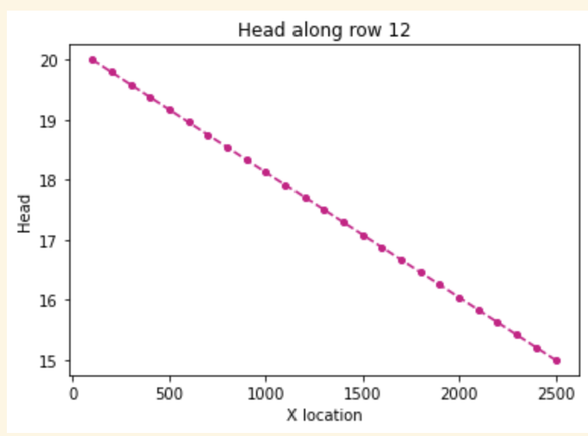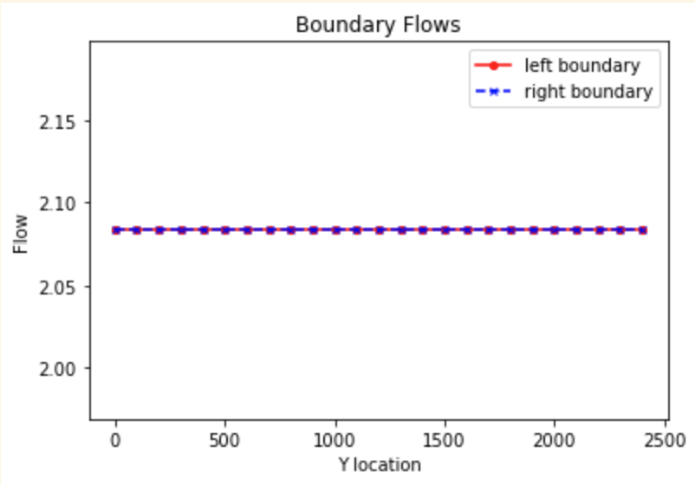

Head profile, confined case Boundary flux, confined case no recharge



Flux calculations, left and right boundary for confined case, no recharge

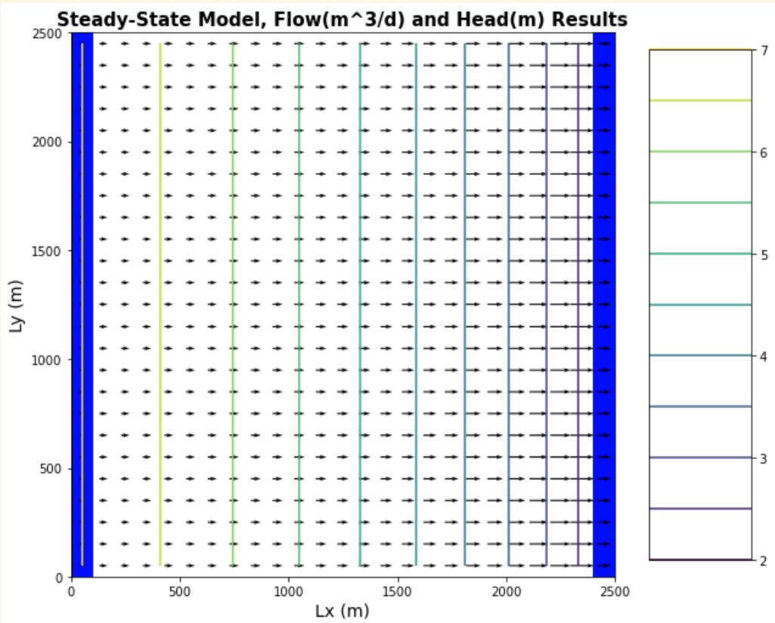

Head profiles and flow map for unconfined case, gradient .002

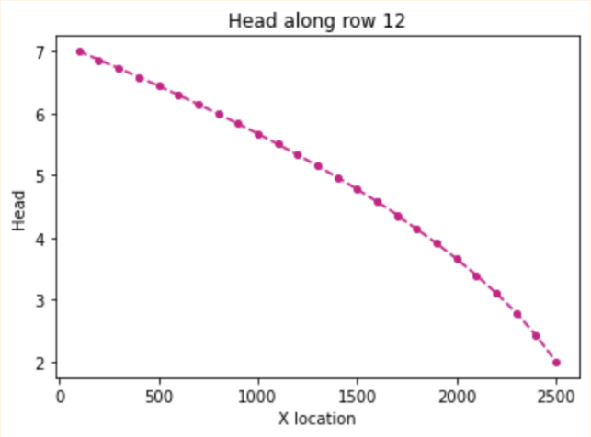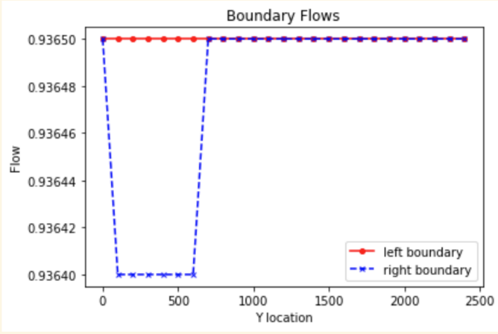

Head profile, unconfined, no recharge boundary flows, unconfined, no recharge



Flux calculations, unconfined, no recharge

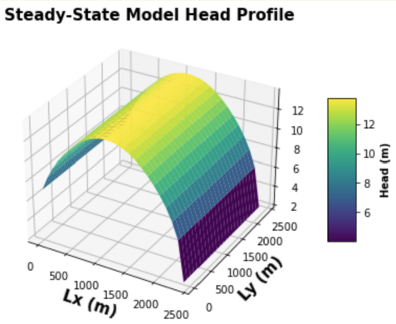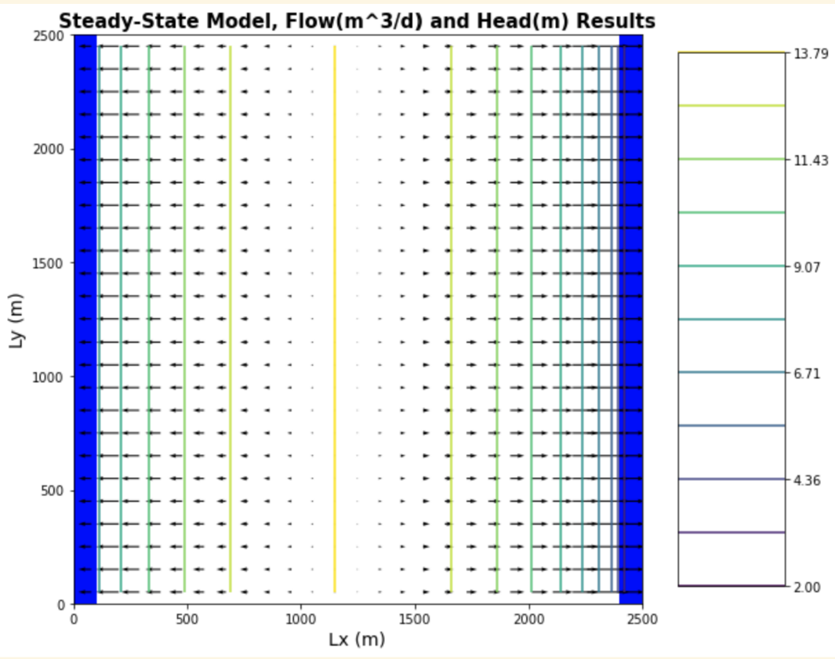

Flow map\head profile plots for unconfined case, 0.002 head gradient unconfined, with layer recharge

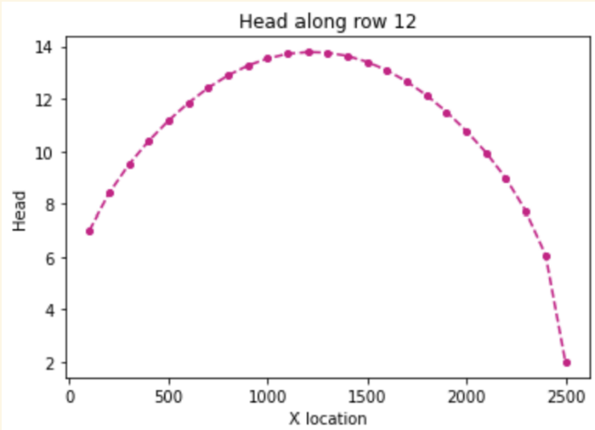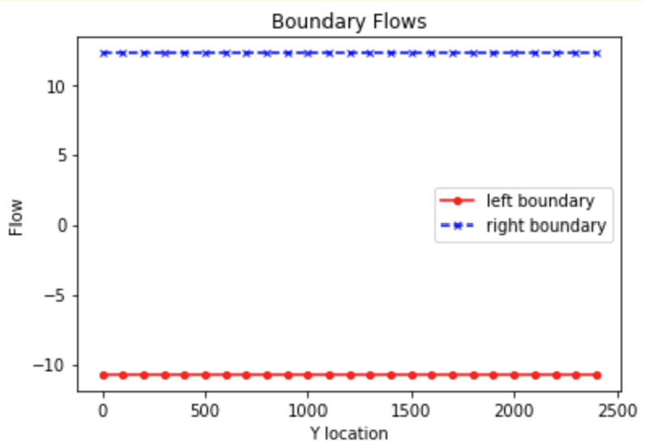

Head profile and boundary flows for unconfined case with layer recharge applied



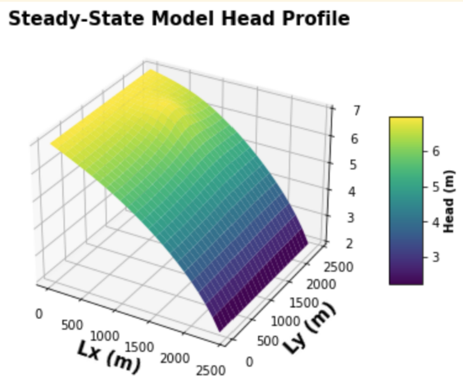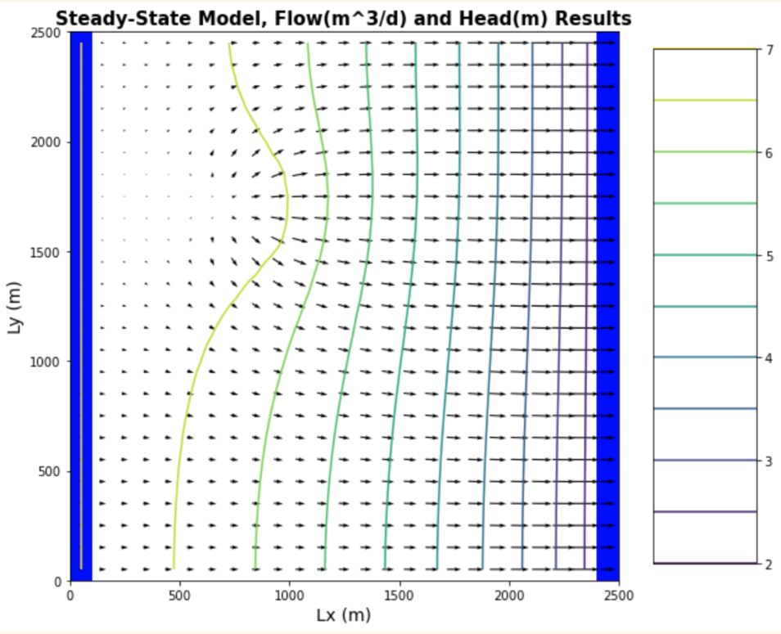



Head profiles and flow map for unconfined, farm recharge case, with potential plume in yellow

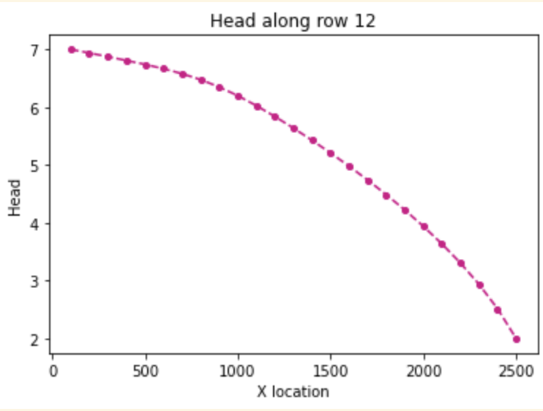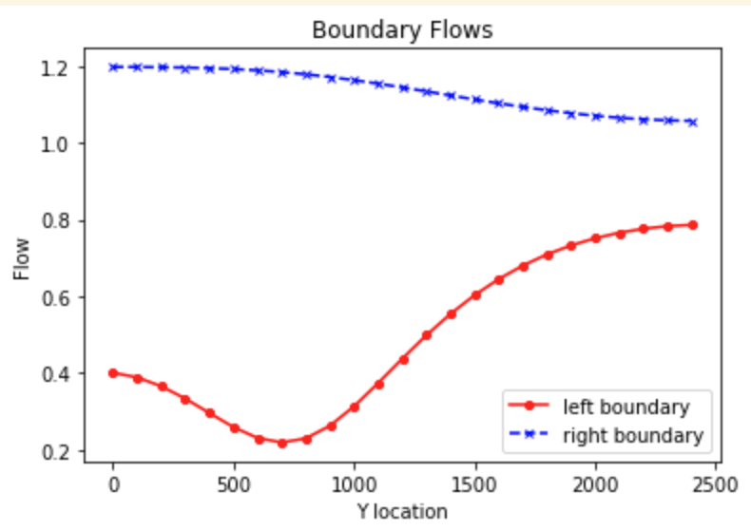

Head profile and boundary flow plots for unconfined case, farm recharge case



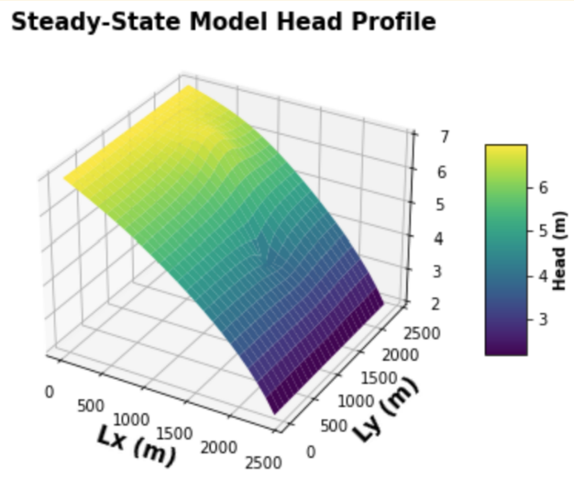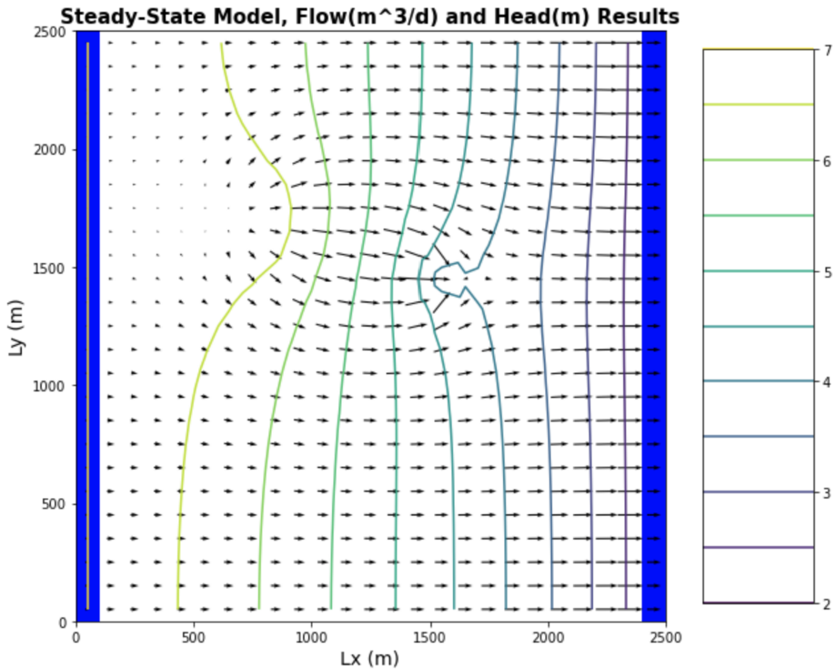

Head and flow profiles for unconfined case, farm recharge and well pumping case

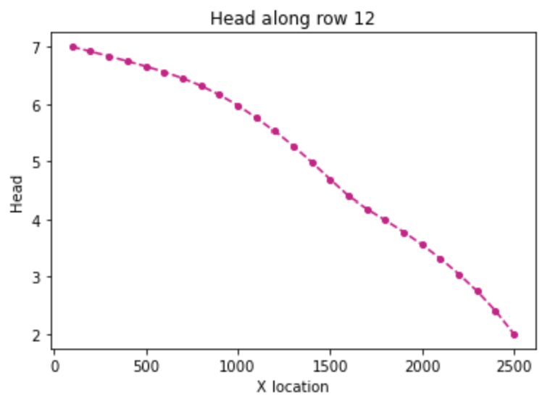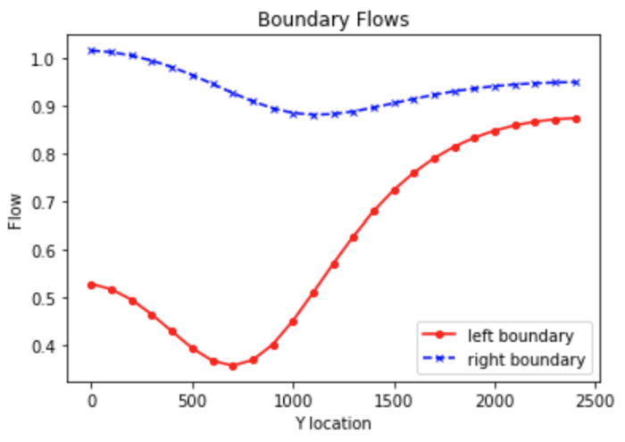

Head profiles and boundary flows for unconfined case, with farm recharge and pumping well case

