The Challenge

1. For the initial boundary head values and recharge and ET rates:

* 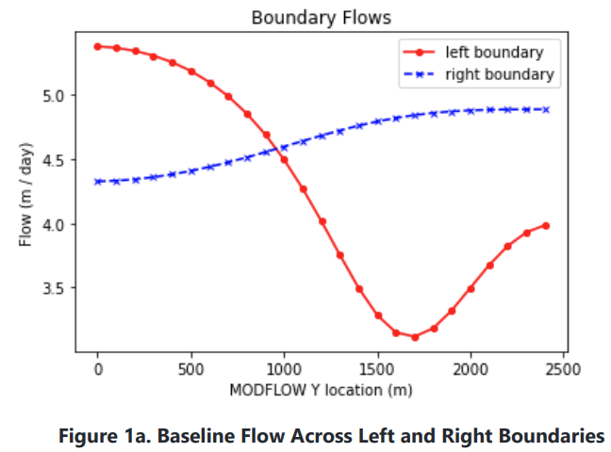plot the flow across the left and right boundaries. Explain what you see and why it makes sense.

**It makes sense that we would see flow slowing down around the recharge zone on the left boundary, because the incoming flux creates a semi-flow barrier, and as a consequence the model will route more flux through the unimpeded portion of the domain to maintain constant head. We see a swell on the right side because of the extra flux added by the recharge as it joins with the baseflow of our model.**

* Plot the equipotentials and flow vectors in plan view and outline (hand draw) the area that would be affected by recharge (i.e. if it were contaminated). Explain what you are seeing and why.

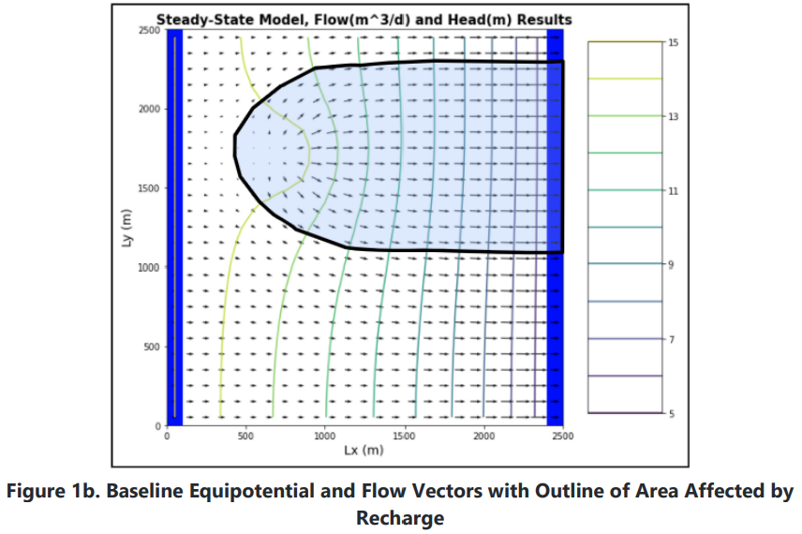

**We see a reduction in head around the recharge zone as a response to the increased flux, as this is the typical give-take relationship we see in darcy’s law. The recharge zone will serve to increase the footprint of our contamination zone in the Y-axis.**

* Plot ET, Recharge and Water Table depth and explain why we see the patterns we do.

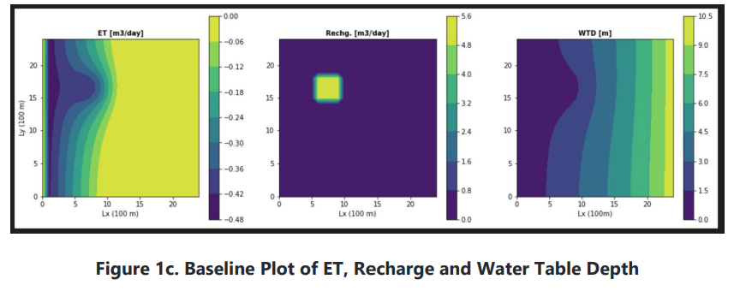

**The ET will likely be higher in the lower flow zone before the well as there is water backing up in this area, and there is more water available for ET. Once the water moves below the extinction depth, we will see less ET occurring. Recharge makes sense, as this is the only area we are injecting water into. The head profile is a result of injecting higher flux, the model responds by reducing head gradient because of the Darcy’s Law relationship between these two variables.**

1. Calculate the water balance for the model
   * Report all of the inflows and outflows with units and show that mass is being balanced.

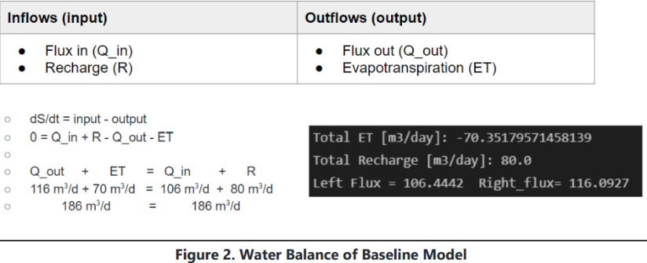

* + Explain what controls each term in your water balance.

**Flux in and out are controlled by ET and head gradient and recharge. Recharge is simply what we set it to be in the recharge package. ET is controlled by the extinction depth and is also sensitive to flux.**

1. Change the extinction depth in your model.
   * Report the new water balance numbers

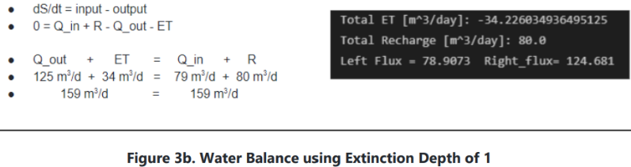

* + Provide a plot of the new head countours and fluxes

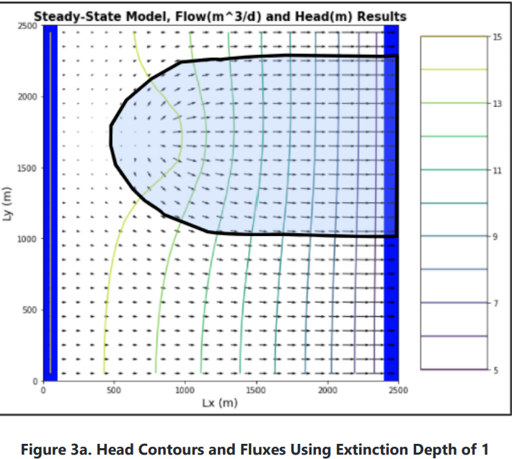

* + Explain what changed and why.

**We see that ET dramatically decreased, this is due to the shallower extinction depth, as ET is limited to the top 1m of our model, as opposed to 3m in the prior example. The water reaches 1m of depth pretty quickly, so there is limited opportunity for ET to happen now. We see an increase in flux as well, as now less water is being lost due to ET, it must remain within our saturated thickness.**

1. Now start the well pumping, extracting 20 m3/day.
   * Plot the equipotentials and flow vectors in plan view and outline (hand draw) the area that would be affected by recharge (i.e. if it were contaminated).

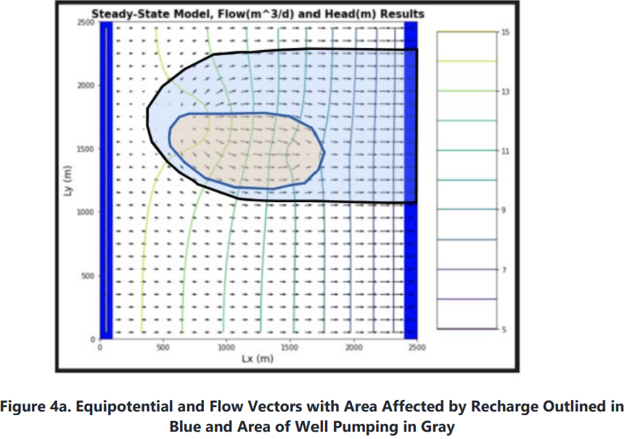

* + Plot ET, Recharge and Water Table depth and explain why we see the patterns we do.

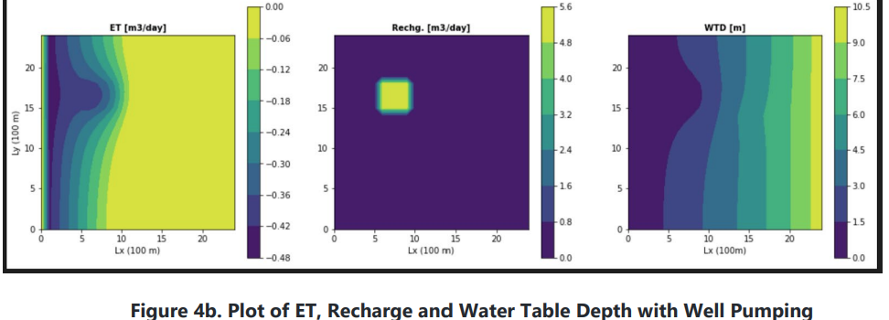

**We see no significant change to the ET map because our water table reaches extinction depth before we reach the well location. Recharge stays the same as before, we made no changes. The only change we see to the head profiles is the decrease in flux from the well removal increasing the head gradient around the site of the well.**

* + How does the well change the zone that is affected by the recharge area?

**The well actually captures part of the chemical plume, in a roundabout way reducing the potential footprint of the plume.**

* + How does it affect the ET map?

**Our ET map isn’t affected, as the water table depth exceeds extinction depth before we reach the well site.**

1. Write a mass balance for the well.
   * How much water is coming from a boundary? How much is originating as recharge? How do you account for the impact of ET on this mass balance?

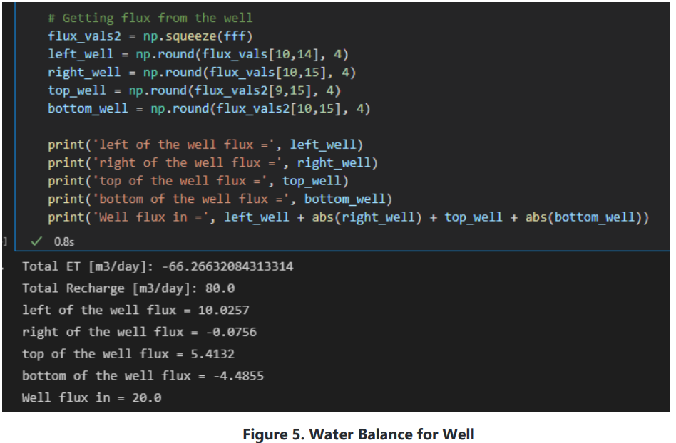

**There really isn’t an ET occurring at the well due to our extinction depths**

* + At steady state, what are the effects of 'capture' by the well?

**Capture will draw some of the recharge from our injection into it, and be largely pumping out this excess water. It also changes the footprint of our recharge further down in our model.**

Glossary questions:

1. Define Evapotranspiration. Explain in the real world (1) the components of evapotranspiration (2) where this water is pulled from and (3) the physical drivers and controls that determine evapotranspiration rates.

**ET - the process by which water is transferred from the land to the atmosphere by evaporation from the soil and other surfaces and by transpiration from plants.**

* 1. **Components of ET are both transpiration (water vapor escaping through vegetation) and evaporation (water changing to gas at the ground surface)**
  2. **Water is being pulled from the subsurface, where the soil is moist.**
  3. **The physical drivers are plant water demand, temperature, and water table depth, as well as soil moisture in the vadose zone.**

1. Describe how the evt package in MODFLOW models evapotranspiration. List the assumptions and simplifications that this package is making.

**The evt package is simulating head-dependent flux out of the model by removing water from the top layer defined by our extinction depths. An assumption or simplification this model makes is that ET is only occurring on the very top layer of our model. Depending on thickness of layers, this may or may not be true to reality.**

1. What is a land surface model? What are the differences between groundwater models like MODFLOW and land surface models that also simulate the shallow subsurface? When is each preferred over the other?

**A land surface model is something that captures flow above the sub-surface. This is different in that it’s usually not concerned with the water table, and focuses more on aspects of the vadose zone. Surface models are typically modelling river systems or engineered channels for stormwater mitigation. The shallow subsurface is typically unsaturated, which is not ideal for a program like MODFLOW, which relies on Darcy’s Law and not Richard’s equation.**