HW6 – figures

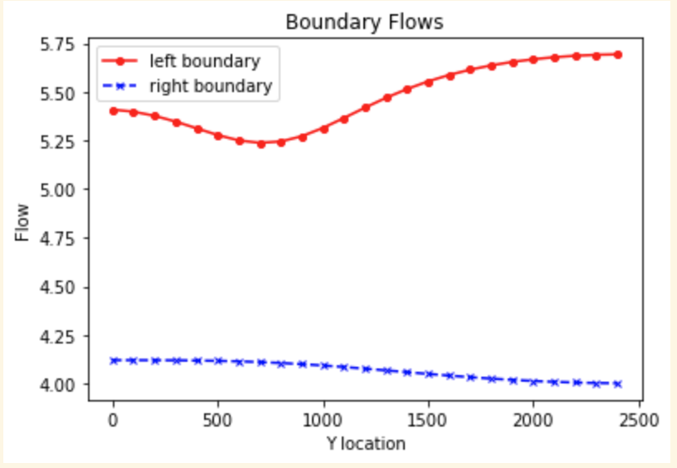



Boundary fluxes – base case

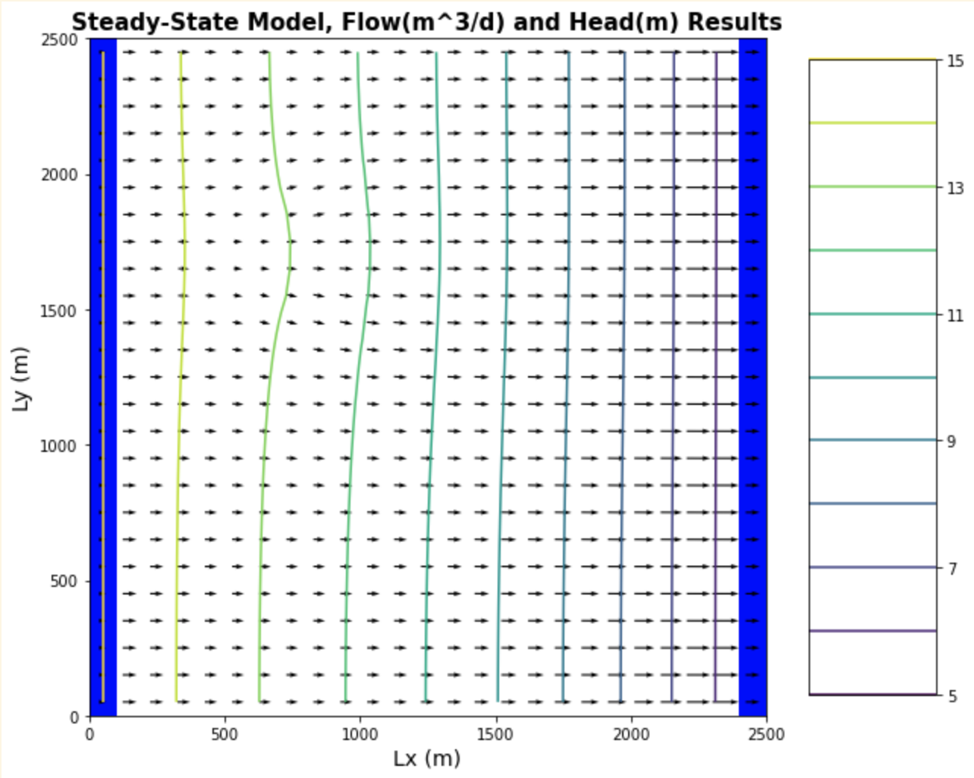



Head profiles and flow map – base case – area affected by recharge contamination

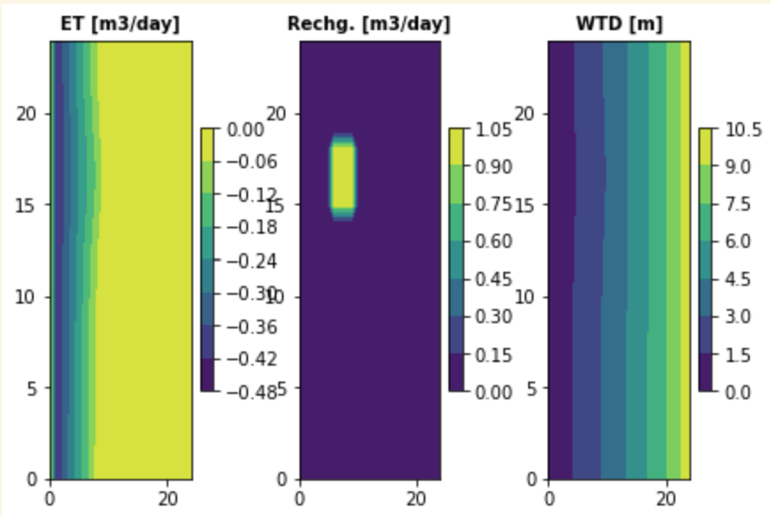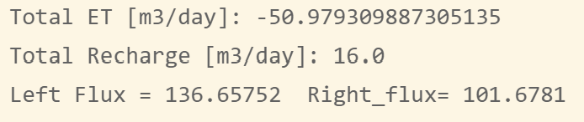

Plots of ET, recharg and water table depth for base case.

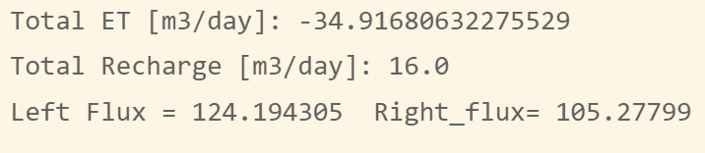

Fluxes and ET after extinction depth changed to 2 instead of 3

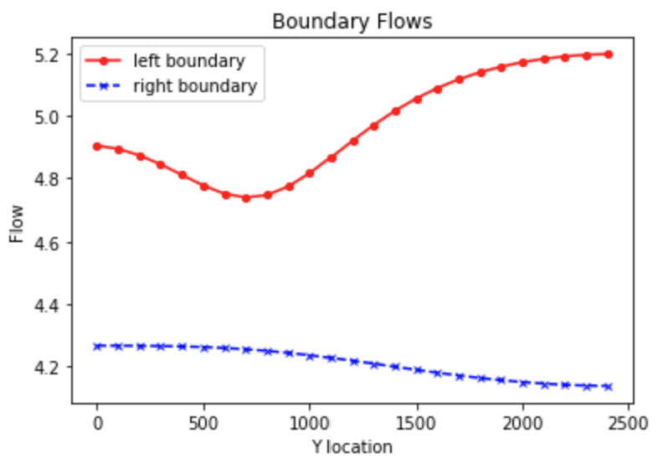

Boundary fluxes after extinction depth changed to 2

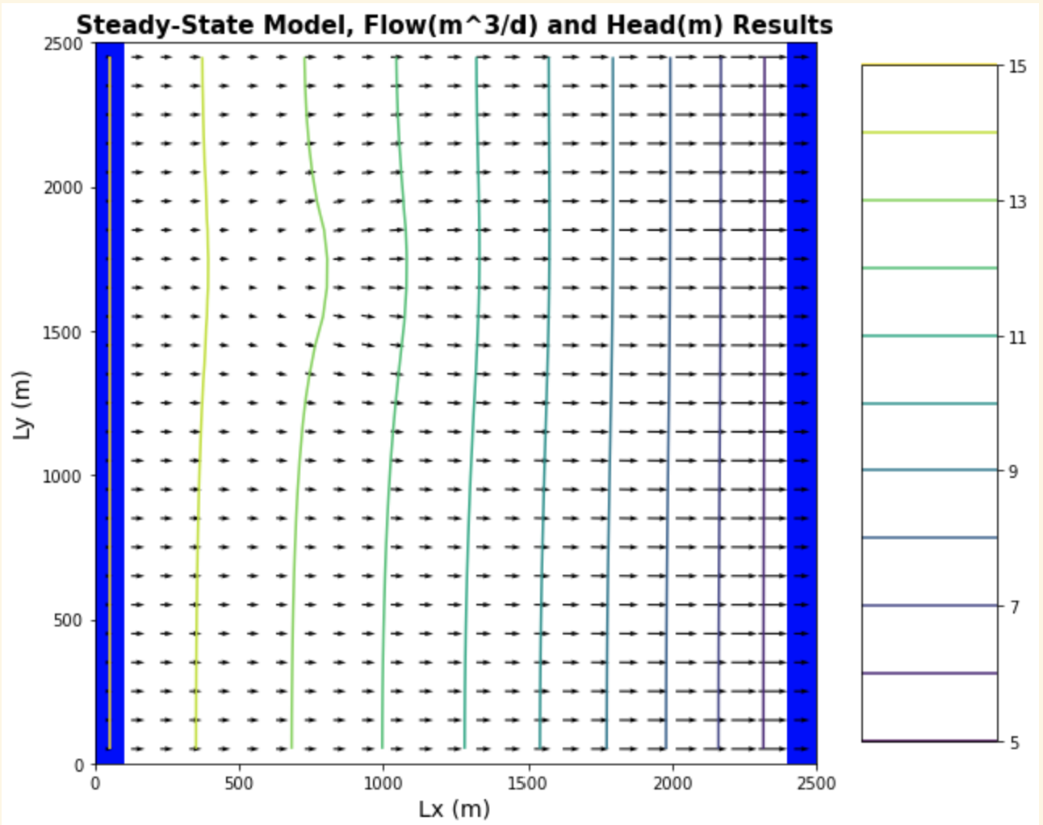



Head countours and flow map for extinction depth of 2

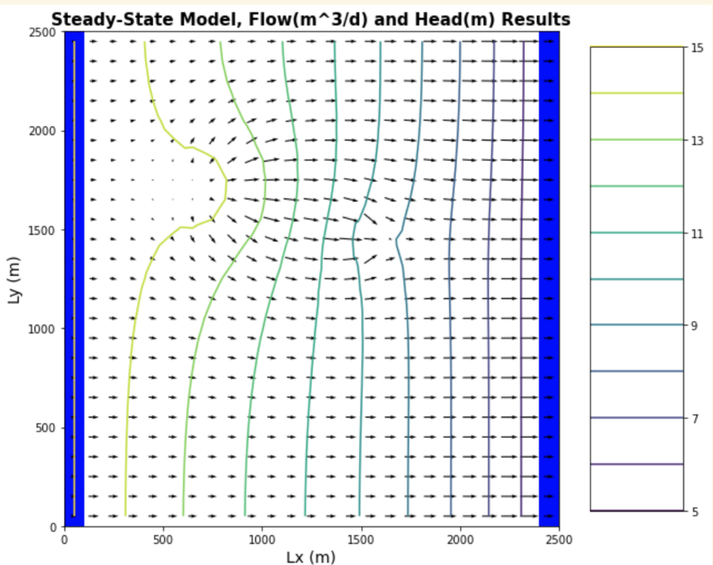



Head profile and flow map for well pumping case – contamination zone highlighted.

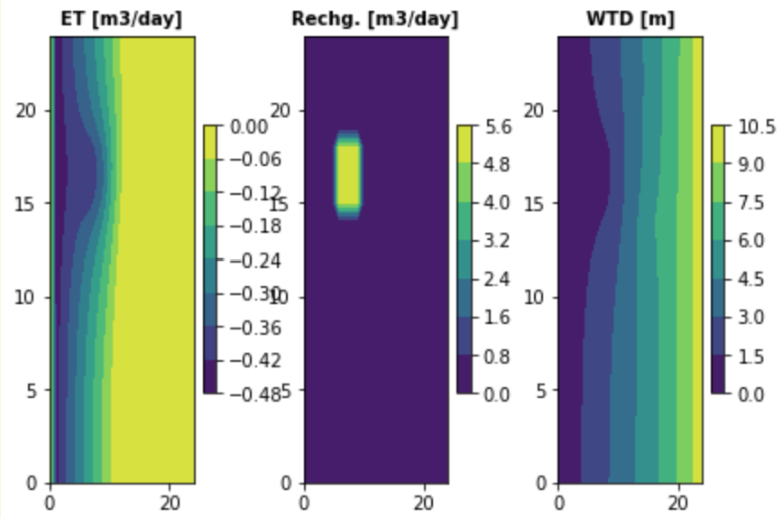

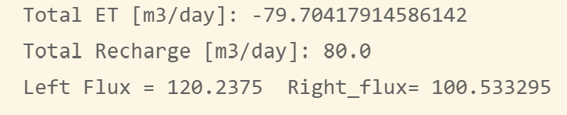

ET, recharge, and WTD for well pumping case

Water balance numbers for well recharge case.