HW8_transient

The Challenge

1. Plot the heads (or WTD) of the initial steady state condition. The gradient is not uniform for the initial steady state conditions - discuss the influences of recharge and the unconfined condition on this nonlinearity

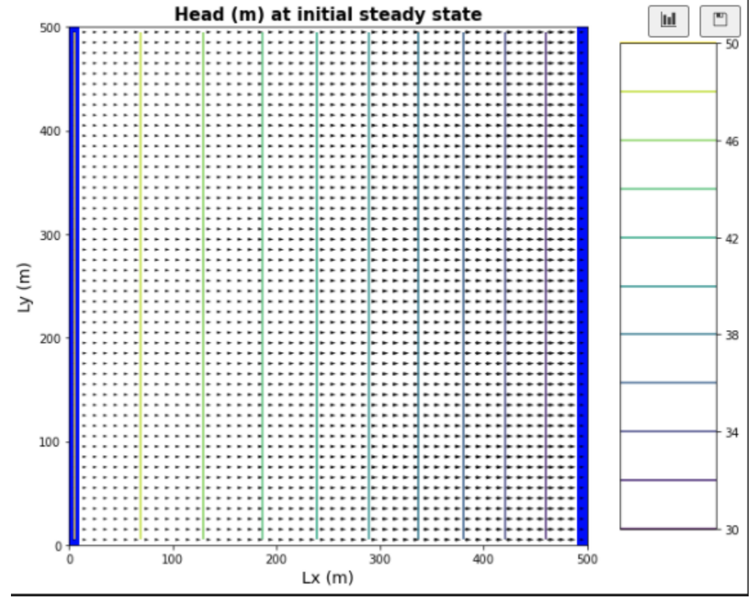

Init conditions head and flow profiles (10 year simulation)

**The unconfined condition is what is causing this non-linear behavior. Unlike our confined system, our saturated thickness in Darcy’s Law (dz) changes as water flows from left to right. Our flow has to increase more and more to compensate for this reduction in thickness in order to maintain conditions for our constant head boundaries. The recharge is likely not changing the linearity of our model, as the recharge is applied evenly everywhere, and the model would show similar behavior with no recharge.**

1. Determine if the system has reached steady state after 10 years - consider a point at the well and another at the center of the domain.

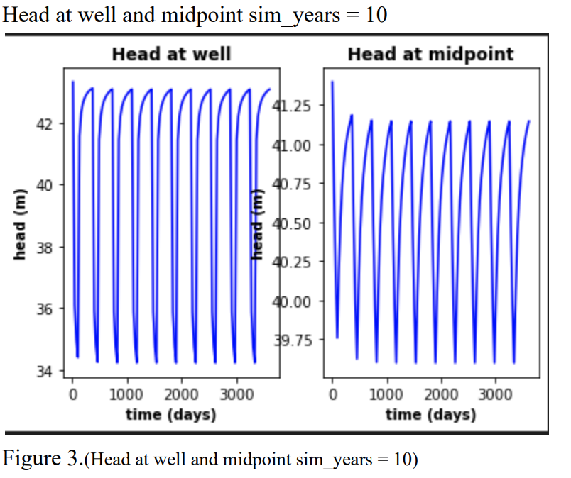

**It would appear that after 10 years of pumping the drawdown has reached a stable point It no longer dips below a certain value after each pumping period. However, since the head still fluctuates slightly at the end of pumping, it’s hard to say for certain if true steady state is reached, but I would say yes. We can also see that it takes longer for this steady state to be reached further away from the well.**

1. Repeat your run this time for 100 years and reconsider question 2 again.

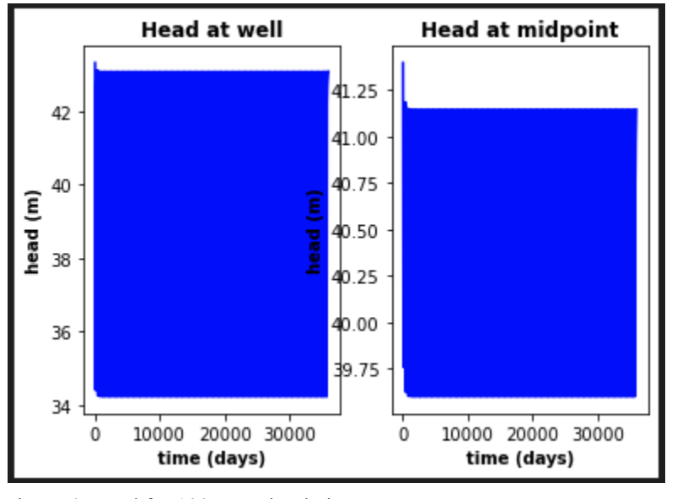

**Here we can clearly see that after 100 years of pumping drawdown is no longer changing over time. We have reached steady state early into the 100-year period. Adding more time to the simulation under these conditions would change nothing about the way our model terminates.**

1. Find the zone of influence of the well defined in two ways:
   * Based on the drawdown from the initial steady state to the end of simulation time (end of final no-pumping stress period).

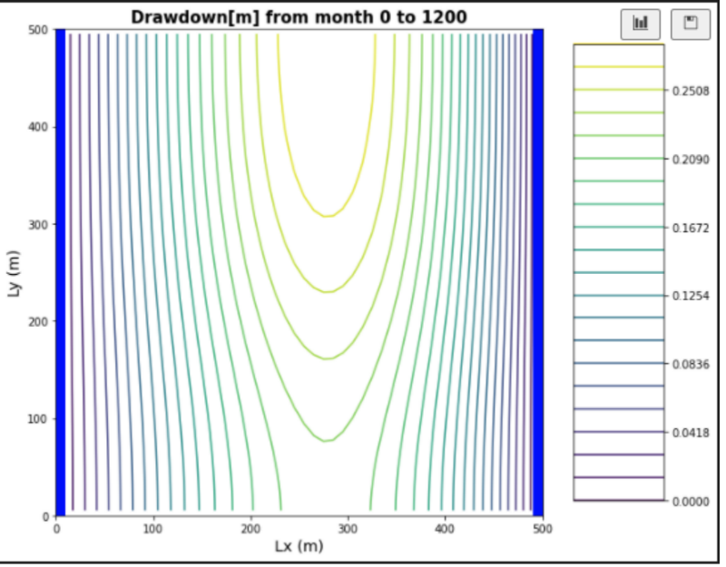

* + Based on the drawdown from the end of the last pump-on stress period to the end of simulation time.

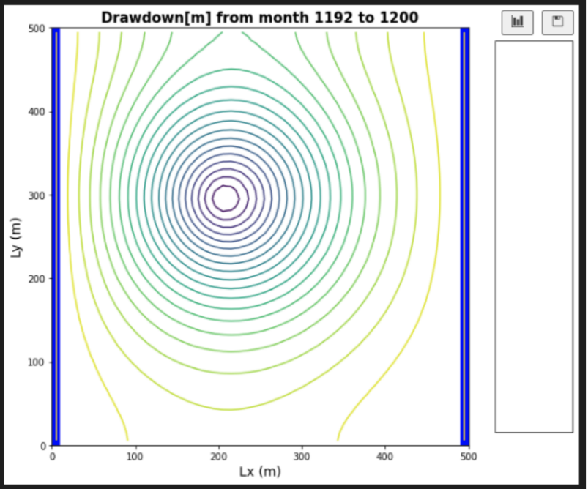

Glossary questions:

1. Explain the concept of stress periods in MODFLOW. How should you determine stress periods when setting up your model? How do they differ from timesteps?

**Stress periods in MODFLOW are time intervals during which the inputs to the model remain constant. For example, they could be pumping periods. Times steps are when you want the model to actually calculate outputs, and are independent from stress periods.**

1. What is the period length in MODFLOW? How does the meaning of the period length differ for a steady state vs non steady state solution?

**This variable controls the length of stress periods within the model. For steady state conditions, the solution isn’t time dependent, so the period length doesn’t matter. For transient flow, the stress periods have a lot of bearing over our model results, as it controls things like pumping periods.**

1. What does the nstep variable signify in MODFLOW and how does it relate to the stress periods and period lengths? List the pros and cons of taking large timesteps vs. small timesteps. Is there any limit to how large a time step you can take and if so what determines this limit?

**Nstep is effectively the timestep with which we are asking MODFLOW to solve our outputs. It is independent of our stress periods and period lengths, but can often be based off of them. Large timesteps allow the model to be simpler and faster to solve, but we lose a lot of the resolution between our timesteps. We are able to see less change, and might be missing out on some of the nuance of our drawdown. Short timesteps have the advantage of allowing us to see with high resolution model change over time, but also vastly increases computational demand and solving time for our model.**